**What is Machine Learning?**

Motivating example

• I am interested in finding out which UTD students get internships (or jobs).

• Think of it as a function: f: X -> Y **(the best function for entire UTD)**

X is an instance (student), Y is Boolean.

X has certain attributes X = <X1, X2, X3, … ,Xn>

X = e.g. X1= GPA, X2=Taken CS 6375?

X3=Years’ experience, …

It’s **a binary classification** problem. You will see lots of such cases in this course.

Learning Scenario

• You are given access to some training data: {(X1, Y1), (X2, Y2), …, (Xn , Yn)}

• Using this training data, you try to approximate the function f. This approximation is also called a **hypothesis** (h).

• Our aim is to design a learning model that can approximate f closely.

• If Y is Boolean (or has a fixed number of values), this is called a **classification** problem.

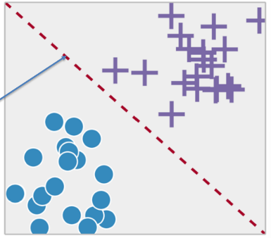Classification

• Learning to differentiate between two or more classes.

• Learning the **separating boundary**

• Most common problem in ML

e.g. classes could be - spam or not spam - family or sports car - apple or orange

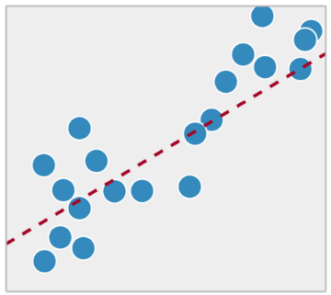Regression

• Classification is different from regression.

• Regression is trying to fit the best model to approximate some real valued data.

• Common in statistics, not ML.

Difference in output type

• If the output was real-valued, this problem can be solved by **statistics**.

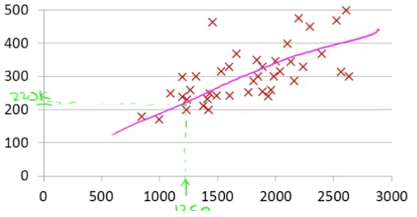Statisticians love regression – linear or non-linear. It can be used to fit a curve to data points.

**Classification**

• Computer scientists love all things Boolean

• So, we have Boolean attributes, Boolean output.

• How do we handle this scenario??

Components of ML (Task, Experience, error)

• What do you for a ML project?

• A well-defined **task** - what are you trying to teach to the machine?

• Training data that will be used by the machine – also called training **experience**.

• A way to check the performance of the machine – called **error** metric.

• A smart machine **learns** from the past errors and improves its performance.

What is ML?

• There is **a task** – generally involving prediction

-e.g.

. Will a student at UTD get internship?

. Will a stock go up?

. Will you play tennis?

. Will a person be approved for credit card?

. What is the price of a house?

. Which digit does a handwritten image represent?

• It has an associated **performance** measure i.e. how close is your prediction to actual value

• Error metric: If your hypothesis doesn’t match the actual value, penalize the model.

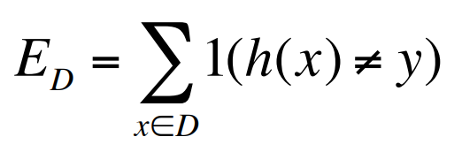The above is the simplest error function.

**h(x)** denotes your hypothesis and

**y** is the actual value.

**D** is the dataset.

• The model learns from **experience** i.e. data.

- More data => Better performance - **Is it always true?** Only if data is meaningful i.e. it’s not **noise**

• If you could see the **entire population** (entire dataset), you would get the best learning model. - **Is it possible?** Can you poll the entire US population? Probably Not!! In this class, we will work with samples of data.

Definition “A computer program is said to learn from **experience E** with respect to some **task T** and some **performance measure P**, if its performance on T, as measured by P, **improves** with experience E.”

-- Tom Mitchell, Carnegie Mellon University

Simpler Definition

• Design of algorithms that **learn from data** and improve performance on a predictive task.

• Development of computational methods **using experience** to improve performance.

Common Theme of this class:

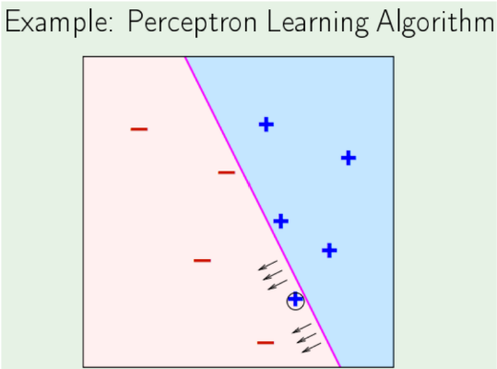- **More training** data is always good Provided data is **meaningful** and is **labeled** (in case of supervised learning). Think: Why does Google work so well?

When is ML a good choice?

• Learning used when

- A pattern exists

- There exists a correlation between predicted variable and features.

- We have data

•Supervised learning

- Unknown target function y = f(x) - You get data & labels (x1, y1) (x2, y2) ,…

- Learning algorithm picks a function g ≈ f (approximation)

Simple, but not obvious

• When can we use ML?

- There is some definite relation/correlation between X and Y.

i.e. there is a deterministic or highly probable function f

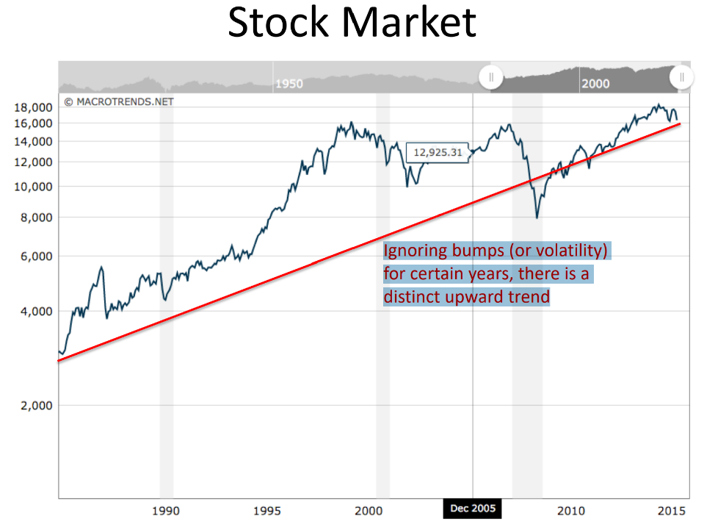- X comes from a well-defined distribution (we don’t need to know the details yet)

**=> X is not a set of random variables**.

Simple, but not obvious

• When can we NOT use ML?

- There is no correlation between X and Y. - There is no clear function f

- X is a set of random variables

=> Can ML predict the lottery? => Can you use it at the casino?

- Can we use it to predict the stock market?

Traditional Programming

. Getting computers to program themselves

. Writing software is the bottleneck, let data do the work

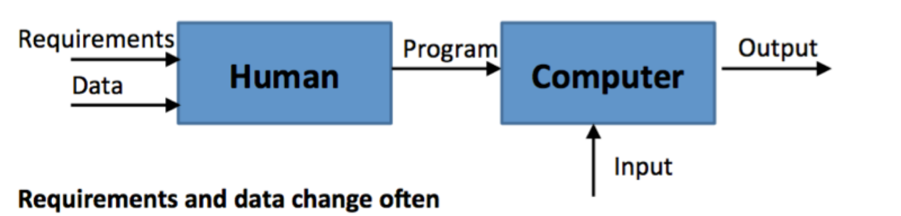

Machine Learning

. In ML, The algorithm learns from data and outputs a program. For example, a self-programming robot.



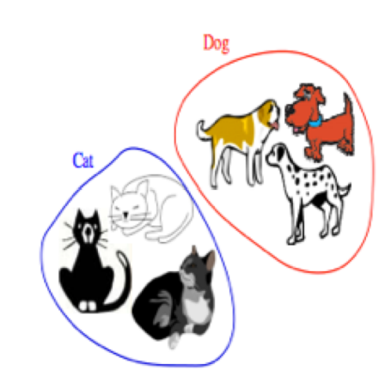Types of Learning

. **Supervised (inductive) learning**

* Training data includes desired outputs

. **Unsupervised learning**

* Training data does not include desired outputs.
* Find hidden/interesting structure in data.

. **Semi – supervised learning**

* Training data includes a few desired outputs

. **Reinforcement learning** (Học tăng cường)

* The learner interacts with world via “actions” and tries to find an optimal policy of behavior with respect to “rewards” it receive from the environment.

Supervised Learning - Inductive

• **Inductive:** Tries to discover general concepts from a limited set of training examples. => Generalization

- Based on search of similar characteristics in different classes of examples. - e.g.

Given labeled examples, you find features that are common within each class.

• **Inductive**: goes from specific to general

- tries to obtain new knowledge. - new data points may force you to change old hypothesis

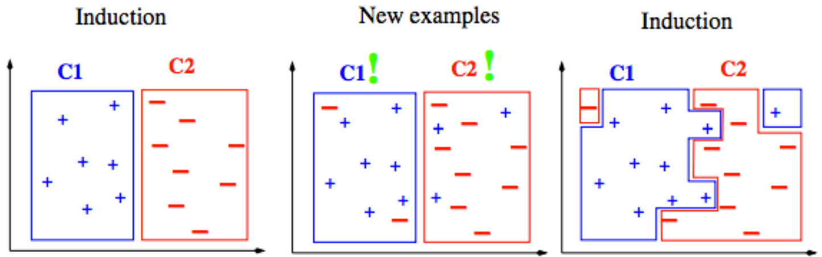

Inductive vs Deductive

• **Deductive**: uses given premises and logical arguments to infer conclusions.

• tries to obtain knowledge that is implicit in original knowledge.

• Classic example:

* All men are mortal. (**major premise**)

* Socrates is a man. (**minor premise**)

* Socrates is mortal. (**conclusion**)

• In this class, we will focus on **inductive** learning.

• Can you see any **issues** with **inductive** approach?

- What do you expect the data to be?

- How do you expect the learner to behave?

- When you make a conclusion, are you 100% sure or are you probably sure?

- Is it even possible to obtain 100% accuracy on training and test data? - …

Learning

• Inductive learning is **supervised learning** because the training data has the **class labels**.

=> That’s what you are trying to learn.

=> So you create an algorithm that separates the two classes based on features.

• What if you just want to find patterns in data i.e. how can you find similar items based on their attributes.

=> **Unsupervised learning**

=> **No labeling provided or you don’t care for labels**.

=> You want to create a natural grouping of people based on shared interests on FB.

Types of Learning task

. **Supervised**: correct output known for each training example

* Learn to predict output when given an input vector

. Classification: 1-of-N output (Speech recognition, object recognition, medical diagnosis)

. Regression: real – valued output (predicting market prices, customer rating)

. **Unsupervised** learning

* Create an internal representation of the input, capturing regularities/structure in data.
* Example: form cluster; extract features

. How do we know if a representation is good?

. **Reinforcement** learning

* Learn action to maximize payoff

Supervised Learning

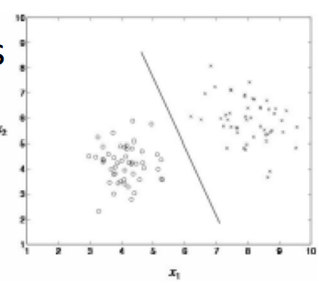. **Classification**

You have N choices for output, learner needs to find best

. Outputs are categorical (1 -of -N)

. Inputs are anything

. Goal: select correct class for new inputs

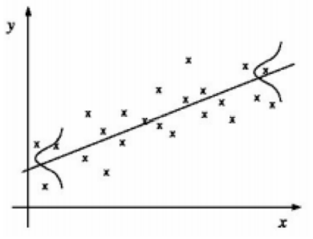. EX: speech, object recognition, medical diagnosis

. **Regression**

You have infinite output choices

. Outputs are continuous

. Inputs are anything (typically continuous)

. Goal: predict output accurately for new inputs

. EX: predicting market prices, customer rating of movie.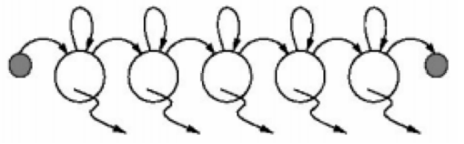

**. Temporal Prediction**:

. Goal: perform classification/ regression on new input sequence values at future time points

. Given input values and corresponding class labels/ output at some previous time points.

Applications of ML

• Pattern Identification: - facial, fingerprint, gene sequence

• Differentiation: spam or non-spam cancerous or non-cancerous cells normal traffic or hacker traffic

• Finding association rules • Recommender Systems • … Many more

The machine learning framework

• Apply a prediction function to a feature representation of the image to get the desired output:

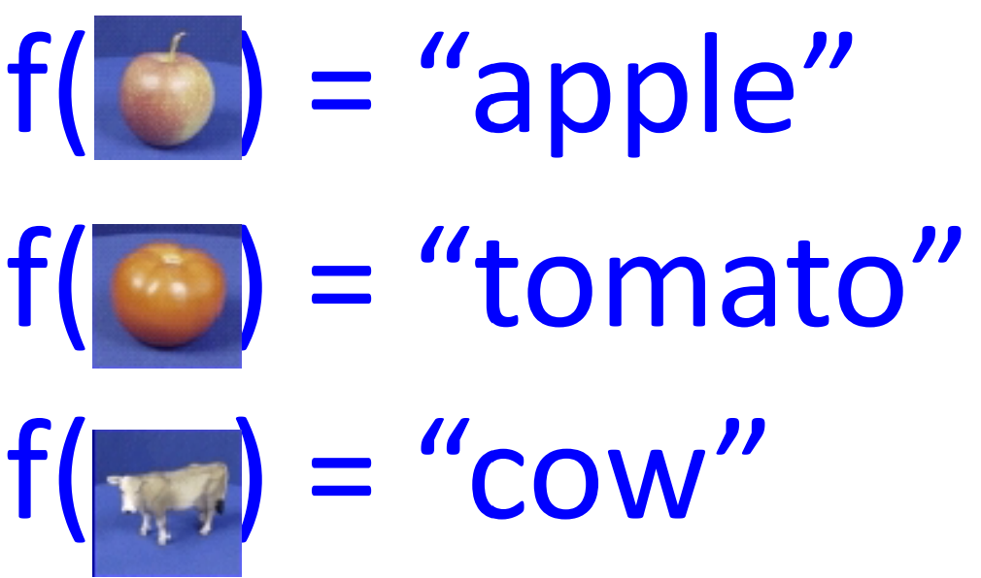

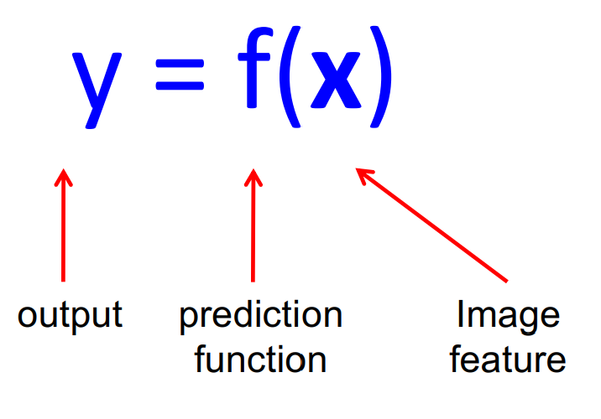The machine learning framework

• **Training**: given a training set of labeled examples **{(x1,y1), …, (xN,yN)},** estimate the prediction function **f** by minimizing the prediction error on the training set

• **Testing**: apply **f** to a never before seen test example **x** and output the predicted value **y = f(x).**

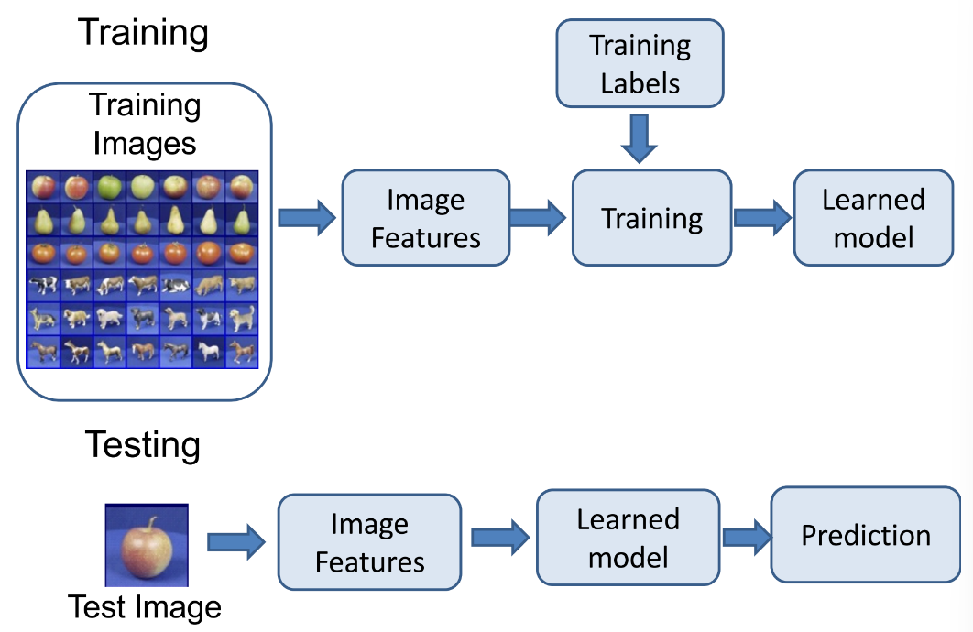

Steps

Formal notation of learning

• You own a credit card company.

• You get a lot of applicants, your job is to design the best classifier for approving them.

• You have some historical data to rely upon.

x j = (x1, x2,..., xn ) T Input vector for customer xj

X = {x 1 , x 2 ,..., xN } set of all customers

y = {0,1} Binary Output

f : X− > Y **Ideal** target function i.e. if you **had entire** data in front of you

(x 1 , y 1 ),(x 2 , y 2 ),...,(xn , yn ) You have this data

H = {h1, h2,..., hN } The set of all possible hypothesis. Doesn’t matter if they are meaningful or not

g : X− > Y,

g ∈ H The best hypothesis you can come up with given the data

Can you really know f?

- **No**, you can only try to approximate it by **g**

- Your approximation is only as good as the data that you see.

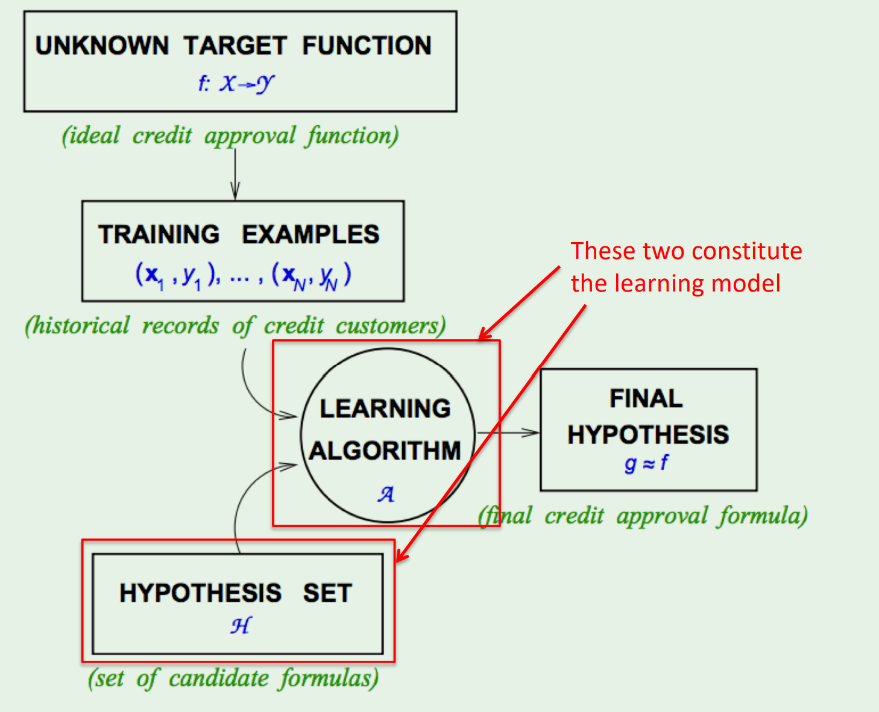

Really simple, right?

• All you have to worry about is the type of learning model and how to generate (and eliminate hypotheses)

• In this class, we will focus on these types:

- Linear separators (**Perceptron**:a computer model devised to represent the ability of the brain to recognize and discriminate.)

- Extension of linear to non-linear (**SVM, ANN, etc**)

- Tree-based classifiers (**Starting with decision trees**)

Linearly Separable Data

• Suppose you have following data: (This is a toy example J )

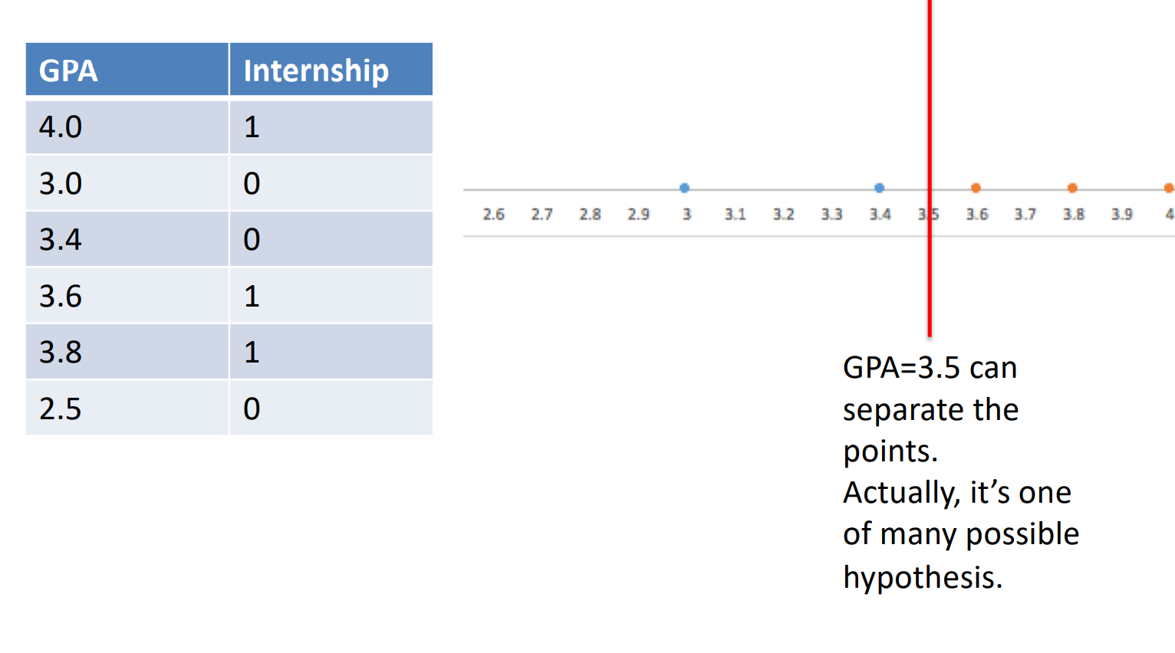

• 2-D case

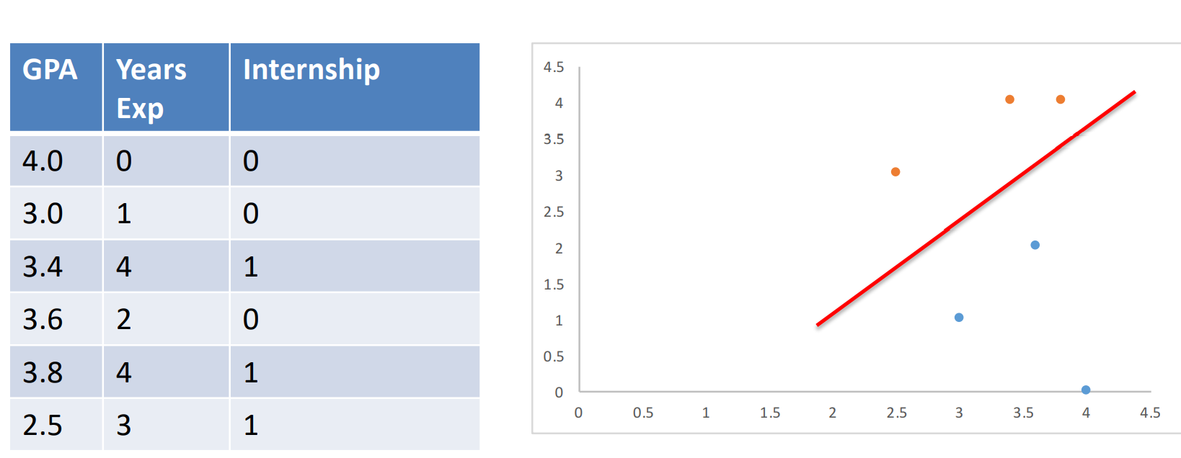

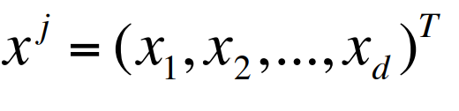Perceptron

• It’s a simple linear classifier -> straight line in 2-D and a plane in higher dimensions.

• Suppose each instance is represented by the vector xj

Example of instance can be a student, a customer, etc. Attributes are x1, x2, …, xd

• Each attribute can have different weights w1, w2, …, wd.

• Equation of separator is:

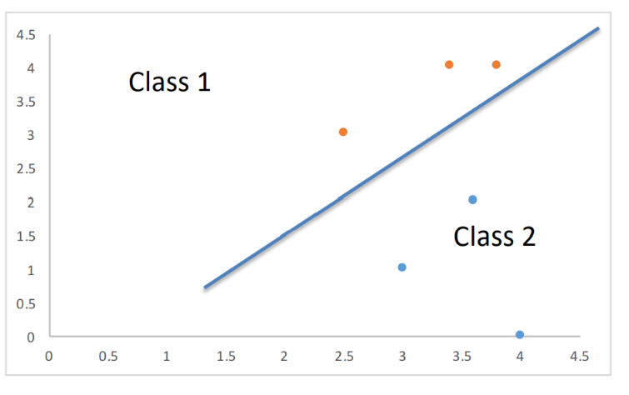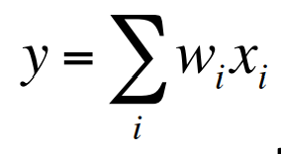

An easy way to separate classes is:

If 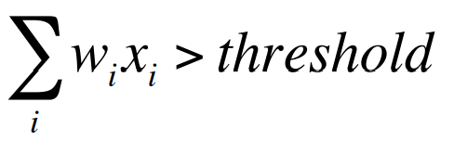assign class1

else assign class 2.

**Perceptron** : a computer model or computerized machine devised to represent or simulate the ability of the brain to recognize and discriminate.

• An easier way to present this is:

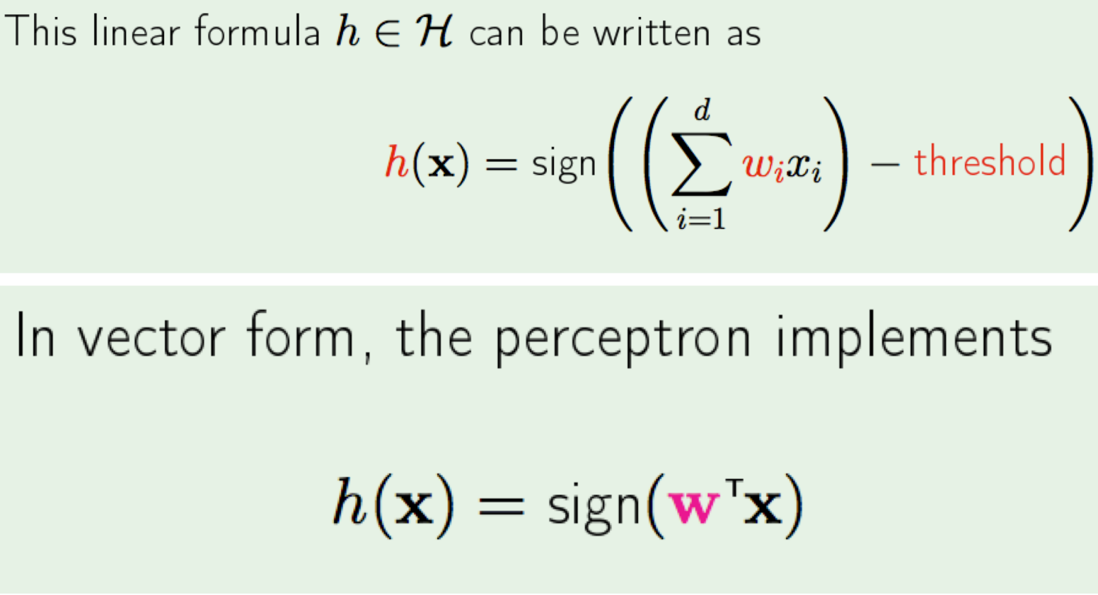

Learning

• Let us look at another way of classification. • Decision Trees.

Decision Tree

• Toy example again

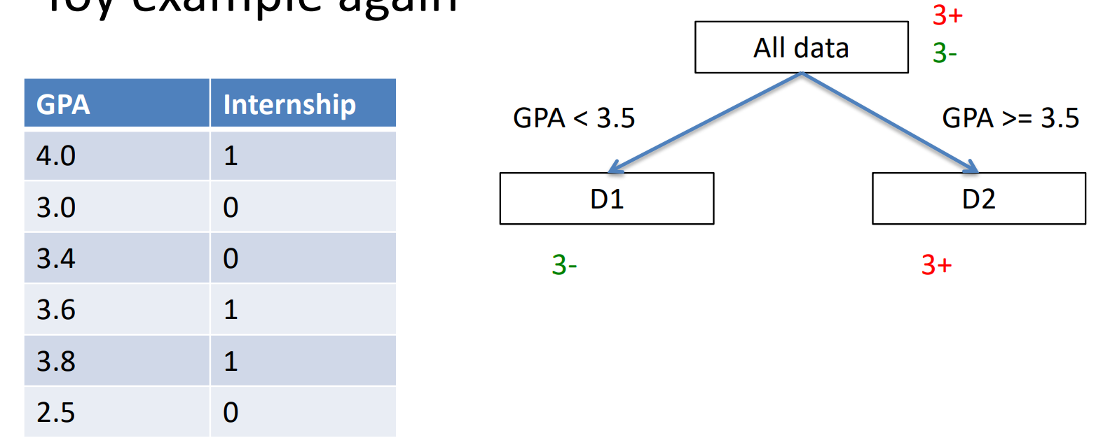

• 2-D case

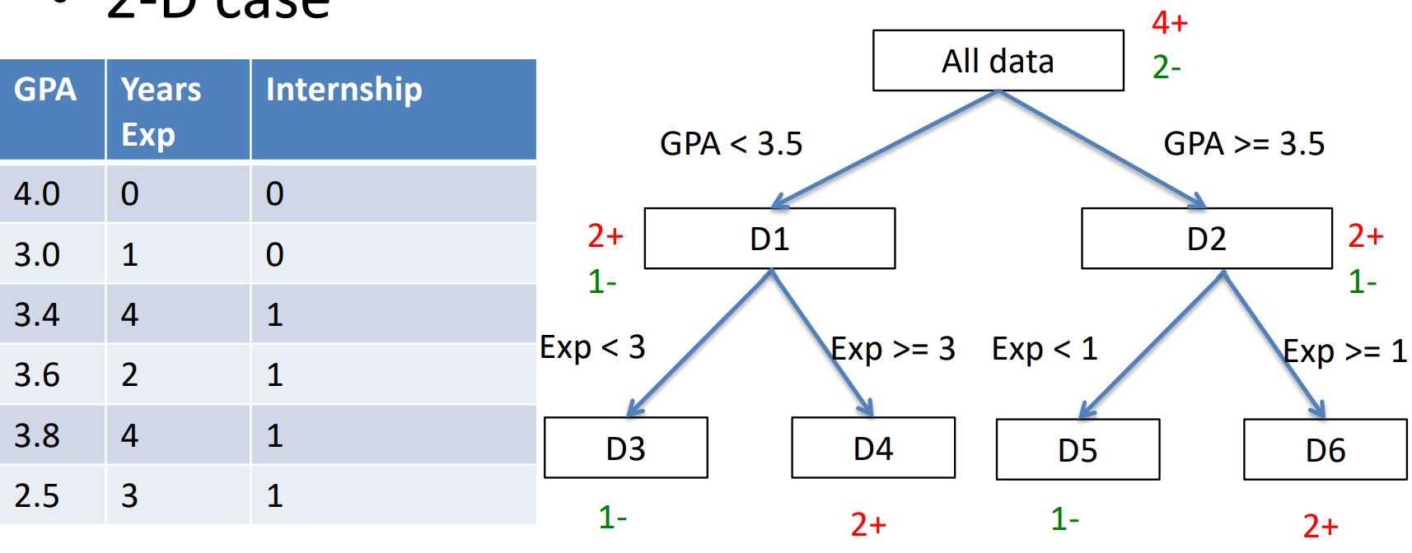

• What can you infer?

• Think about decision trees as a way to learn **classification** function.

• Can also be thought of as rules:

eg: X1 ^ X2 -> 0 where x1 is Boolean GPA and x2 is Boolean exp<3

• OK…but which attribute should I choose to be at the top i.e. how do I choose attibutes??

Sounds great, but …

•Can you make some guarantee about the **unknown** data / parameters?

Let’s do an experiment. You have a bin and want to estimate the **probability of** **red marbles (μ)**. You draw **N samples** and observe **fraction of red marbles = ν** Is there any relation between μ, ν, and N?

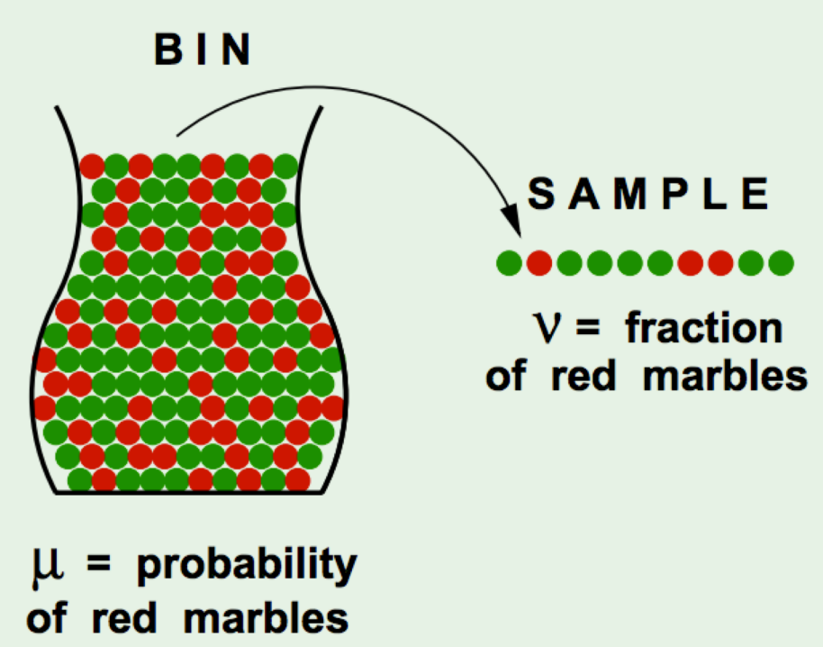

Hoeffding's Inequality

• It turns out there is a relation: For **large values of N**, the **probability of large error (difference)** between **ν and μ is bounded**.

Think: What happens when N becomes large, and when N is small?

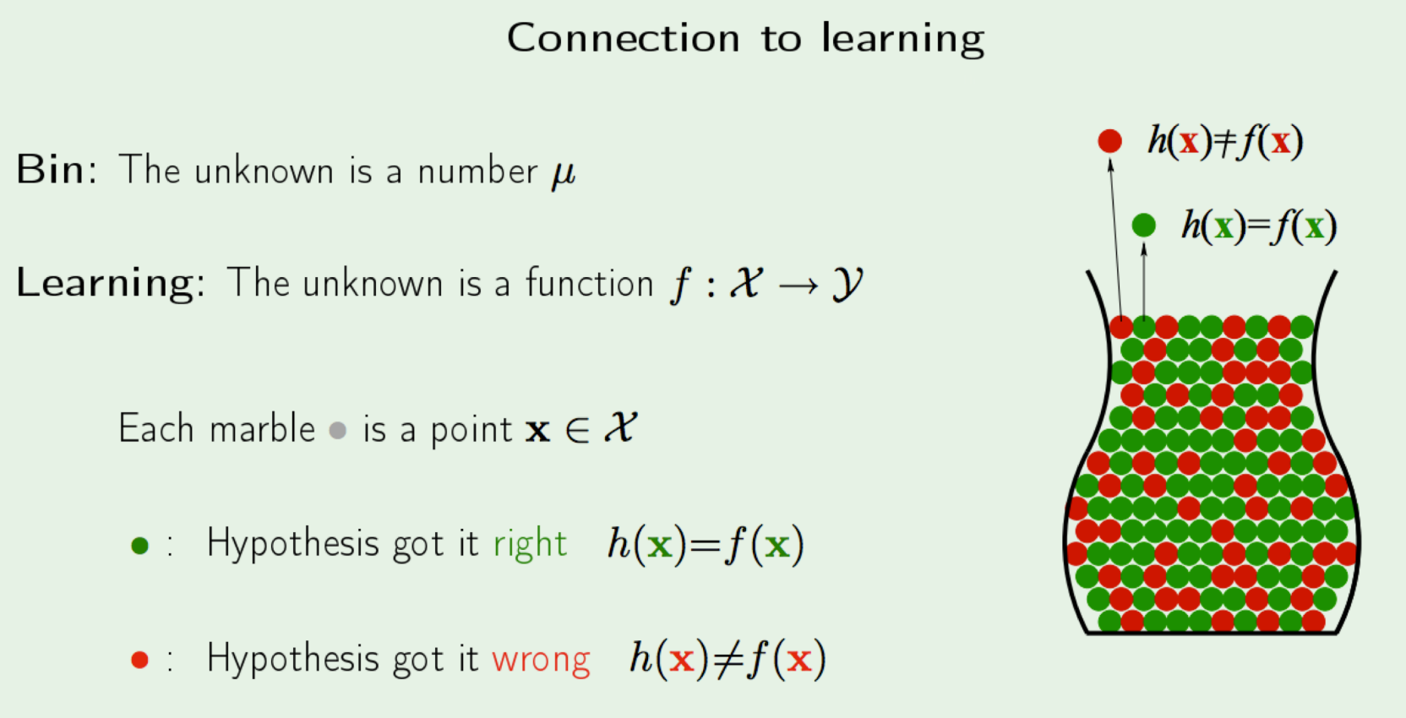

**Inductive Learning**

• Inductive learning - **generalize** from a limited set of training data

• Training data is labeled

• You would like to estimate true separating function f

• Attributes of data (i.e. features) are important.

Learning from data

• Given: a set of labeled training examples: <x,f(x)>

Global f(x) is unknown to us - Distribution of x is unknown to us

• Find: An approximation of f(x)

Appropriate situations

• **Credit risk assessment**

x:properties of the customer and proposed purchase

f(x): approve purchase or not

• **Disease diagnosis**

x: Properties of patient (symptoms, lab, tests)

f(x): Disease (or maybe, recommended therapy)

• **Face recognition**

x: bitmap picture of person’s face

f(x): Name of the person.

Learning

• Improving with experience (E) at some task (T) with respect to some performance measure (P).

• **Experience** = Training data

**Task** = Any classification task (for this class, at least)

**Performance Measure** = Error value -> difference between true value and predicted value.

Model Representation

**What are you given in supervised learning?** A set of training examples and their labels (x(i) , y(i) )

** It is assumed y(i) is generated by a true function f(x) **

**What do you do with the training data?** Feed it to a learning algorithm that learns a function h, that is an approximation to f

Learning Process

use it as a guide After each training instance, refine h so that value of error metric goes down.

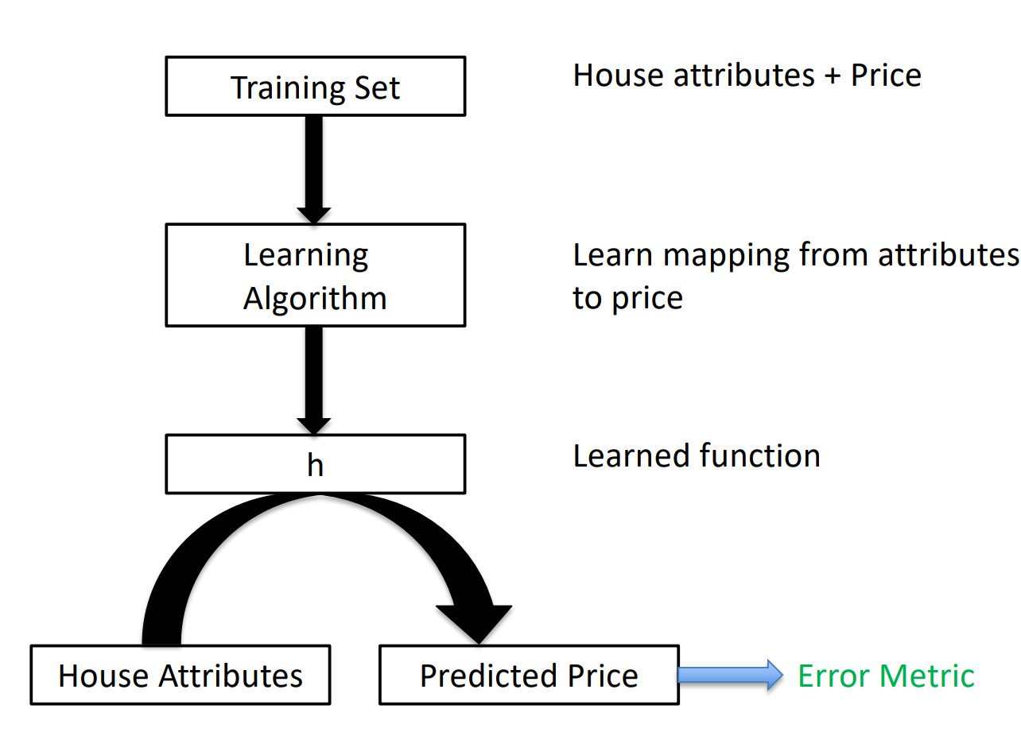

Model Representation

**How do you know if h is good?**

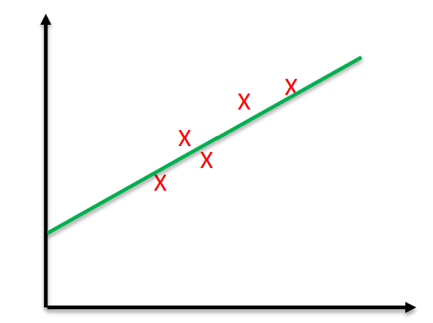We measure the error (overall) by using h Example:

Error = | f(x) – h(x) | or Error = 1/(2m)* (f(x) – h(x))2 Think: Is more training data good? Always?

**LINEAR REGRESSION**

Learning a linear function

• Suppose we want to learn a function of the form:

ℎ θ (x) = θ0 + θ1x

to represent house price. Let's say it's a one-D problem and only independent attribute is house size x.

Linear Regression

• Linear Regression – find best model that fits a continuous (i.e. real valued) output

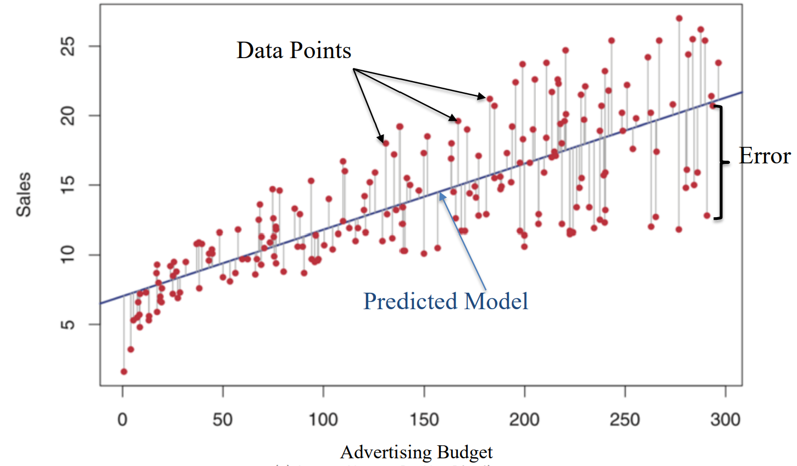

Error Function

• Our aim can be stated as: Choose parameters θ0& θ­1 ( such that our hypothesis ℎ θ (x) is as close to y for our training examples.

• Mathematically, choose parameters such that the following is minimized (called error or cost function). m is the number of training instance

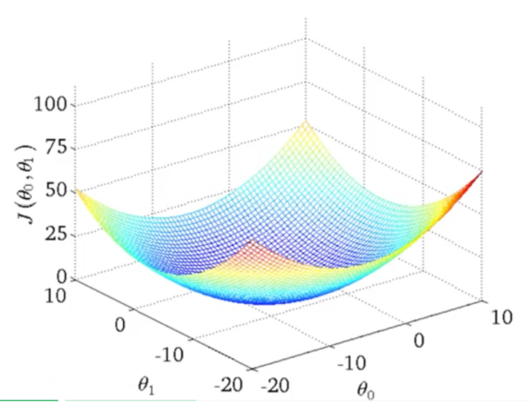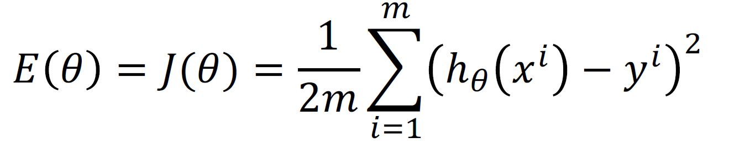

Error function

• How does J vary wrt the parameters

• Contour plot

• We are looking for the minima

• How do we get there?

Gradient Descent

• Given a function J of parameters ϴ, how do we find its minimum or maximum.

• Gradient Descent is a very powerful and popular algorithm.

• Widely used in machine learning

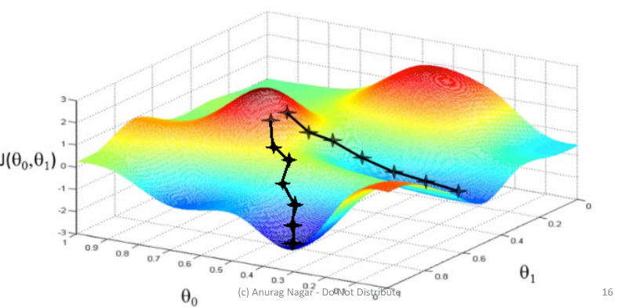• In many cases, analytical solution is not possible, so we have to randomly take steps in search of minimum.

• Aim: We have a function 𝐽 (𝜃0, 𝜃1) , and we want

argmin 𝐽( 𝜃0 , 𝜃1)

𝜃0 𝜃1

**STEPS:**

• Start with some random values

• Keep changing these values such that you achieve a reduction in J

• Imagine a man at a random point on the mountains.

• He needs to reach the city by walking randomly

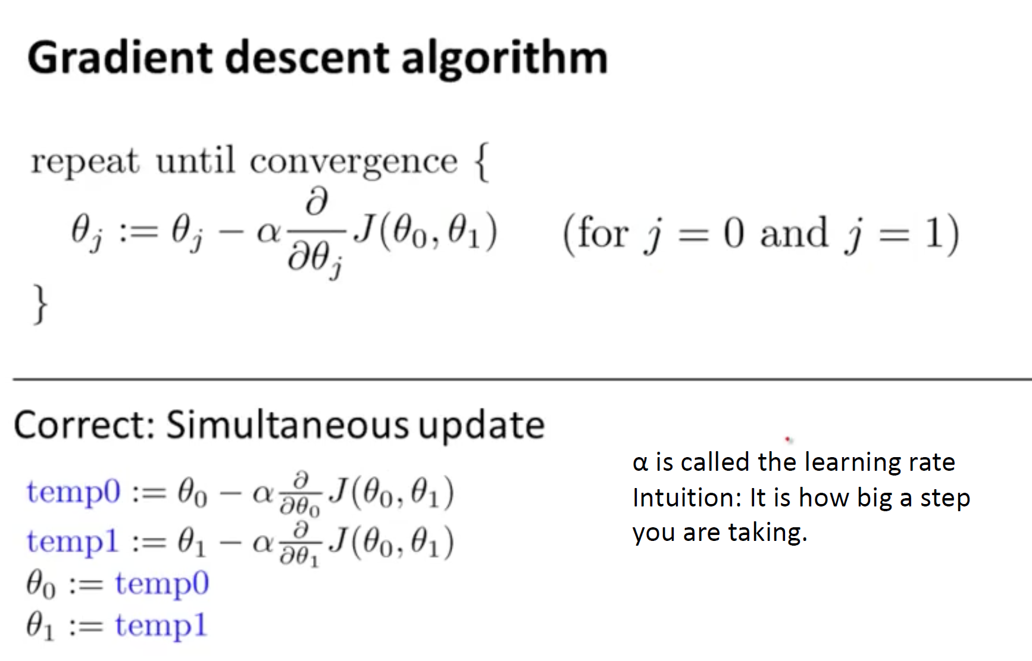

α is called the learning rate Intuition: It is how big a step you are taking.

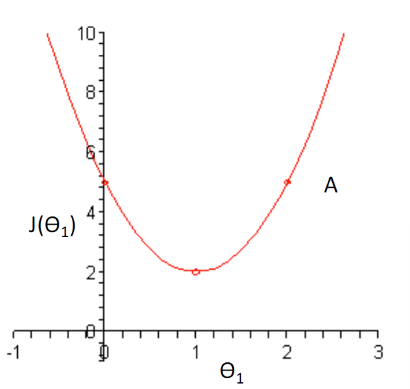Illustration

• In the curve on the right, imagine you are at point A

• The slope there is positive

• Update rule:

𝜃1 = 𝜃1 – 𝛼* 𝜕𝐽/𝜕𝜃1

since 𝜕𝐽/𝜕𝜃1 is positive and α is always positive, we would move towards left.

Local Minima can be a problem

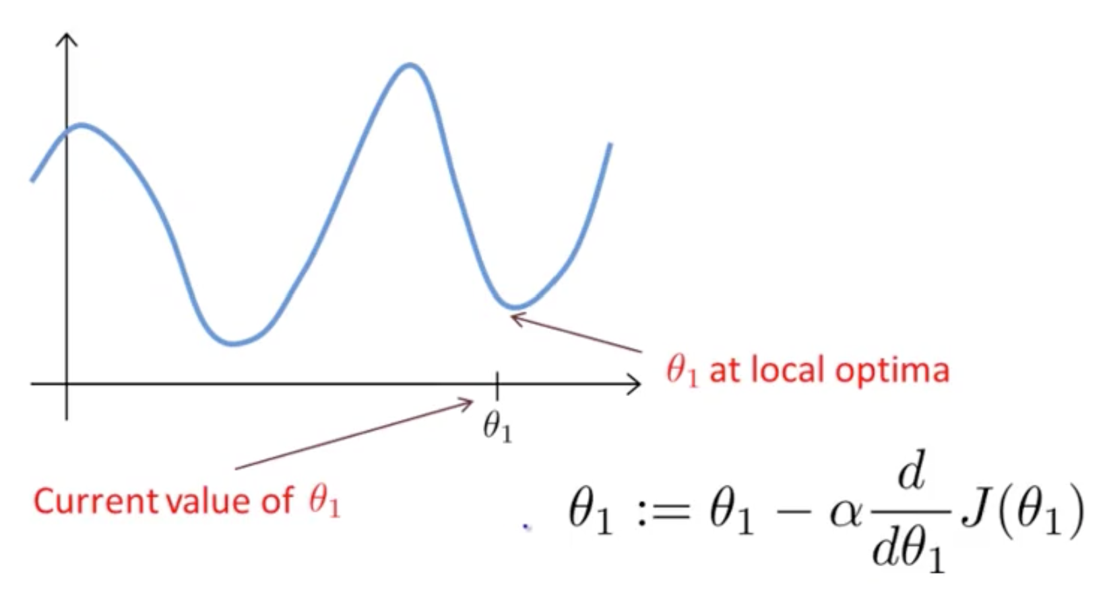

Gradient Descent for Linear Regression

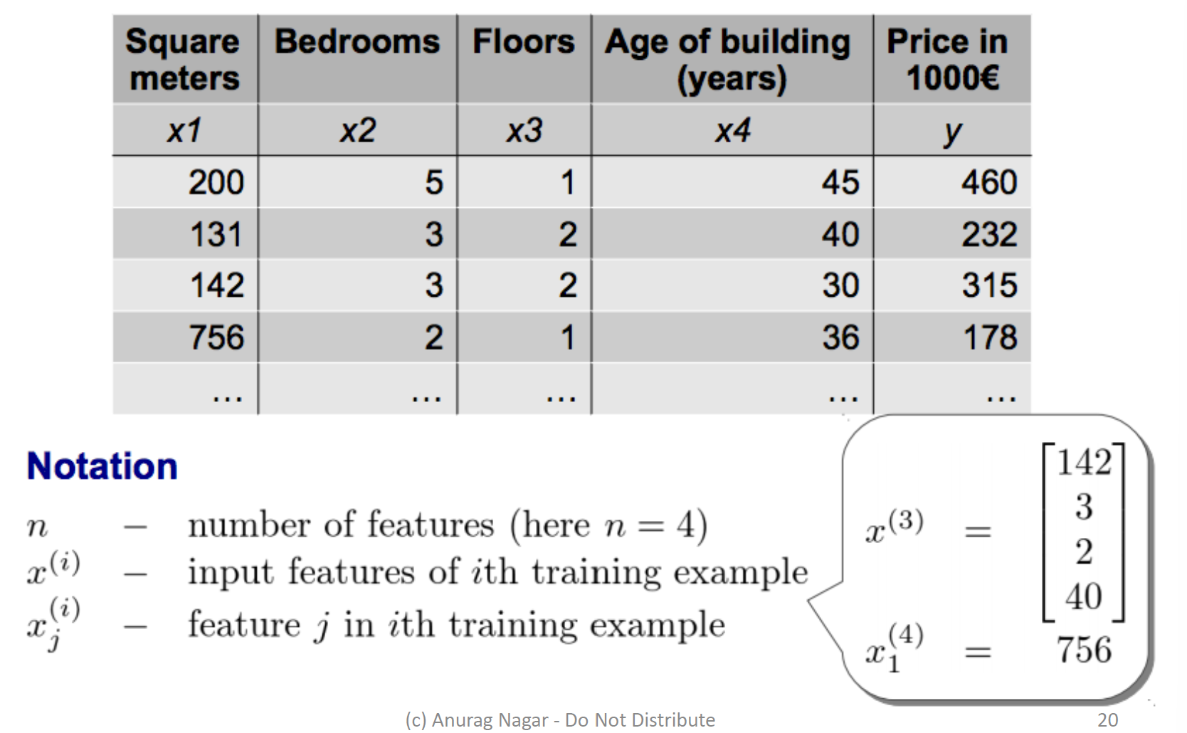

Gradient Descent for Linear Regression

**Hypothesis representation**

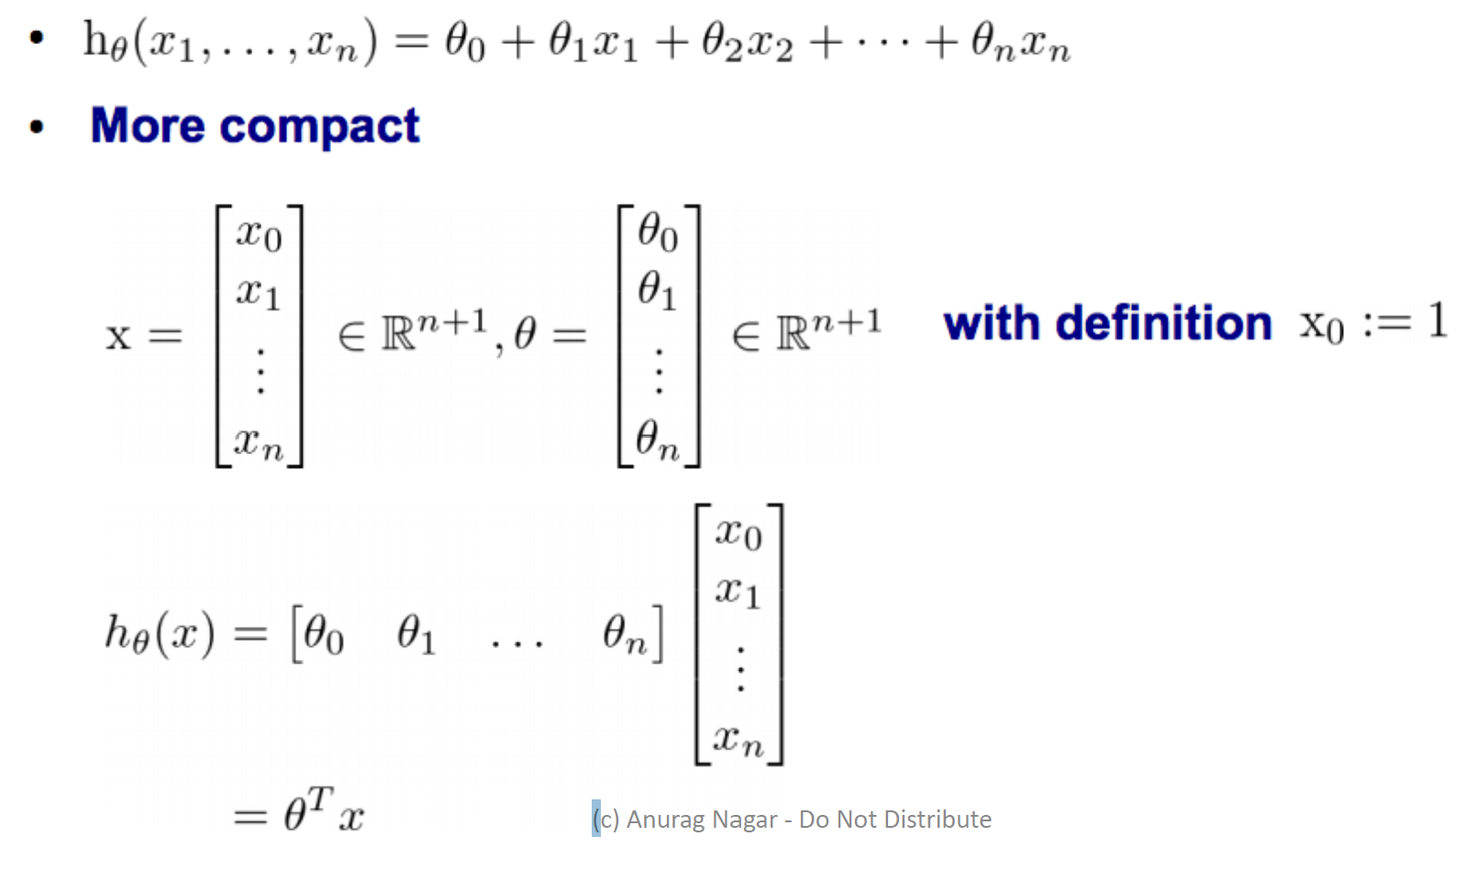

**Gradient Descent for multiple variables**

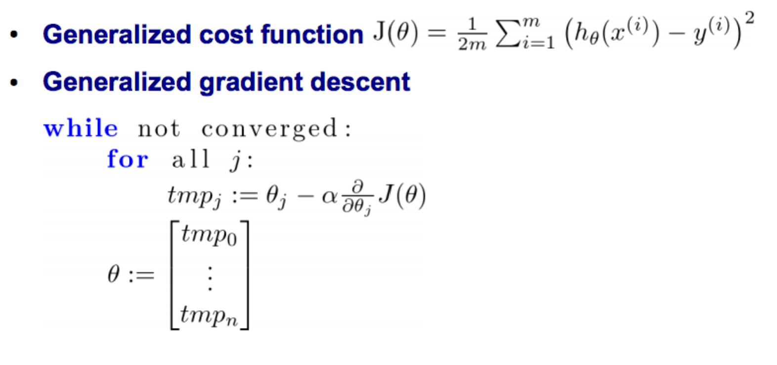

**Partial derivative of cost function for multiple variables**

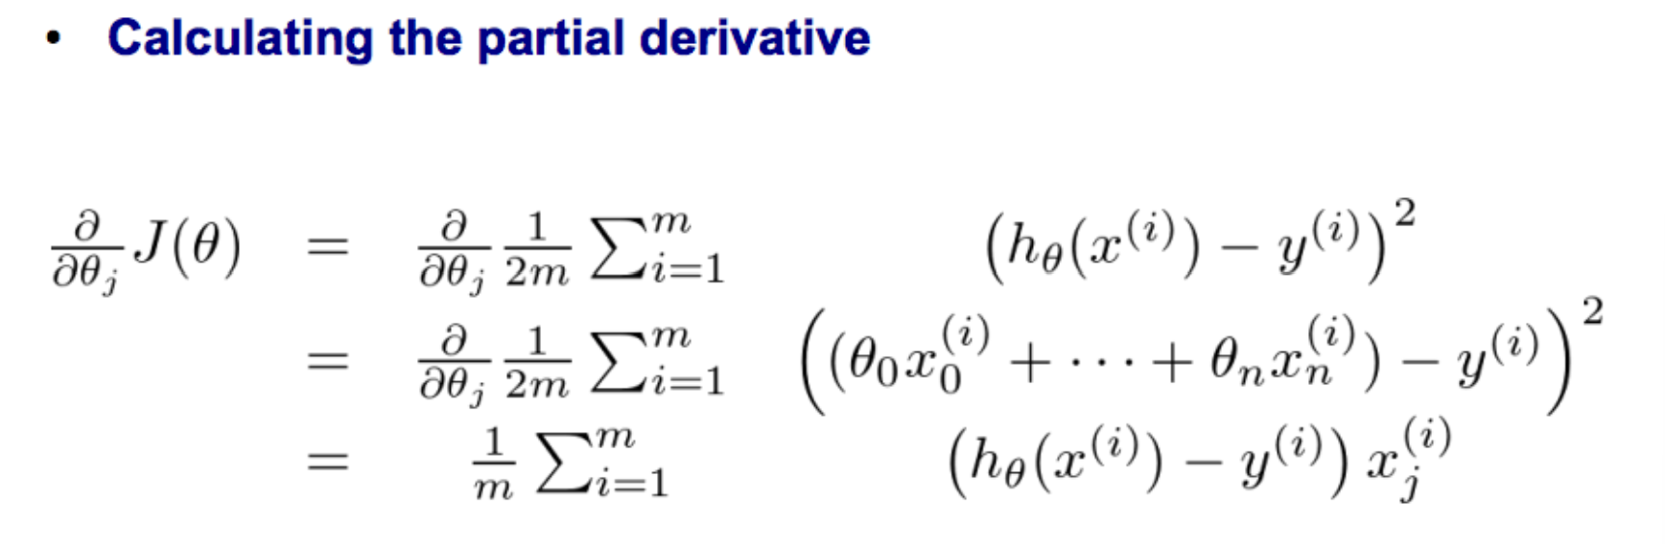

**Gradient descent for multiple variables**

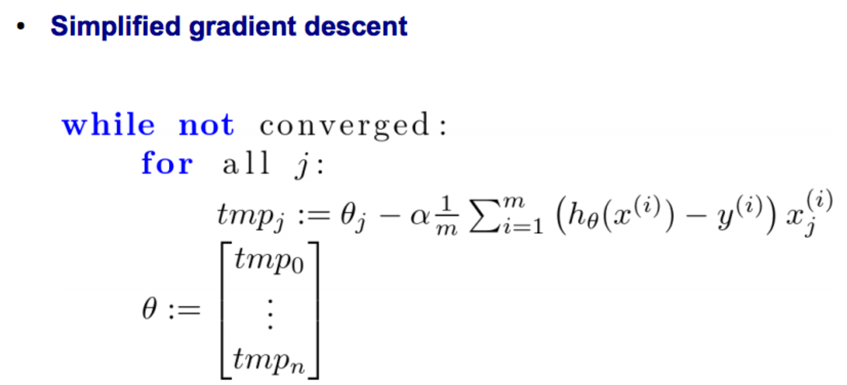

Regression Evaluation Metrics

• Suppose we propose a linear model:

𝑌 = 𝛽0 + 𝛽1X + ϵ where 𝜖 represents the error.

• The coefficients 𝛽0 and 𝛽1 need to be estimated from the data (using gradient descent or other computational techniques).

• Let’s suppose our estimates are ^𝛽0 and ^𝛽1 ( , then the predicted value would be: ^𝑦 = ^𝛽0 + ^𝛽1 𝑋

• 𝑒i = ^y­i − yi represents the residual or error for the ith data point.

• Residual sum of square (RSS) is defined as:

𝑅𝑆𝑆 = e12 + e22 + …. + en2,

• By minimizing the RSS, we can arrive at the estimates ^𝛽0 and ^𝛽1.

Another evaluation metric

• We would like to check what fraction of data variance is explained by the model.

• R2 statistic measures this:

R2 = 1 – RSS/TSS

where **RSS** is the **residual sum of squares** (defined earlier) and **TSS** is **the total sum of squares**:

𝑇𝑆𝑆 = 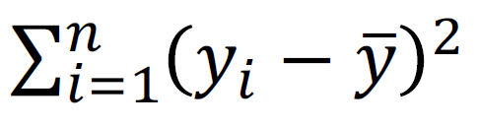

Practice question:

. Consider the problem of predicting the number of A grades that a student a UTD will obtain in second year of M.S. based on the number of A grades obtained in the first year of M.S. course.

Below is the data:

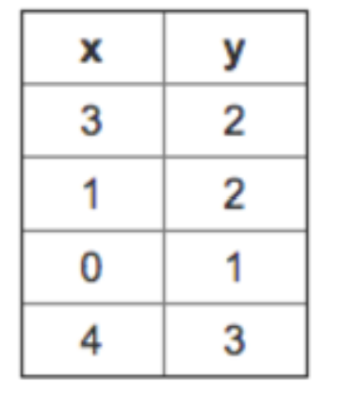

x represents the number of A grades in 1st year

y represents the number of A grades in 2nd year

You decide to use a hypothesis of the form ℎ θ (x) = θ0 + θ1x where θ0 = 0 and θ1 = 1 . Find the value of the square error? <https://www.coursehero.com/qa/wait/43823259/>

**DECISION TREE**

**What is a DT?**

.

Decision Tree

■ 2-D case

Of course, you could start with Exp as the first sorting or splitting criteria and get a different tree.

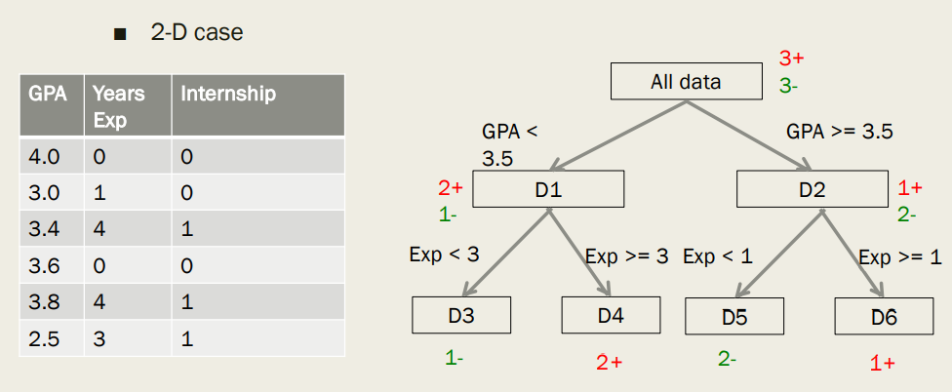

Decision Tree - Representation

■ In this class, DT is a way to represent concepts & hypothesis about a target concept

■ Can be written in form of rules

IF exp > 3 and GPA > 3.5 THEN internship = 1

■ **Leaf nodes** decide values of output variable

■ **Internal nodes & edges** represent splitting (sorting) criteria.

■ We will consider Boolean attributes and output.

■ Given instances with n Boolean attributes i.e. each Xi is of the form:

Xi = (x1, x2, …, xn) e.g. Xi = (0, 1, …, 0)

How will you represent one hypothesis => A binary tree

Properties of Binary Trees

■ A complete binary tree of height h has 2h+1 -1 nodes

■ Number of nodes at depth d is 2d

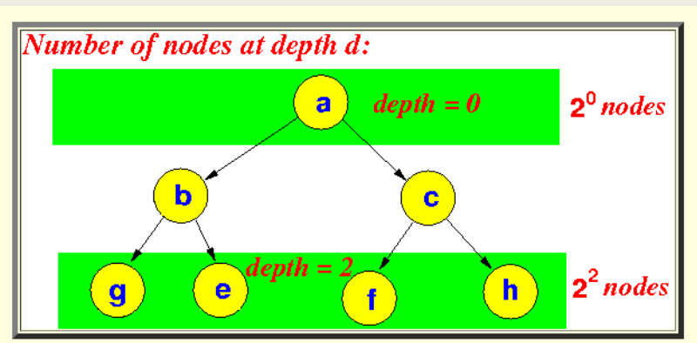

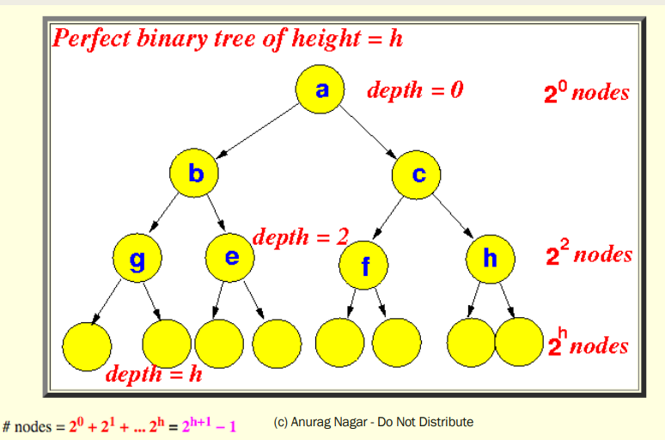

**Learning a DT.**

Use of DT in learning

■ Use the training examples and their labels to construct decision tree

■ For example, (X1, y1) could be ((0, 0, 0), 1)

■ You can use DT to model knowledge from training data.

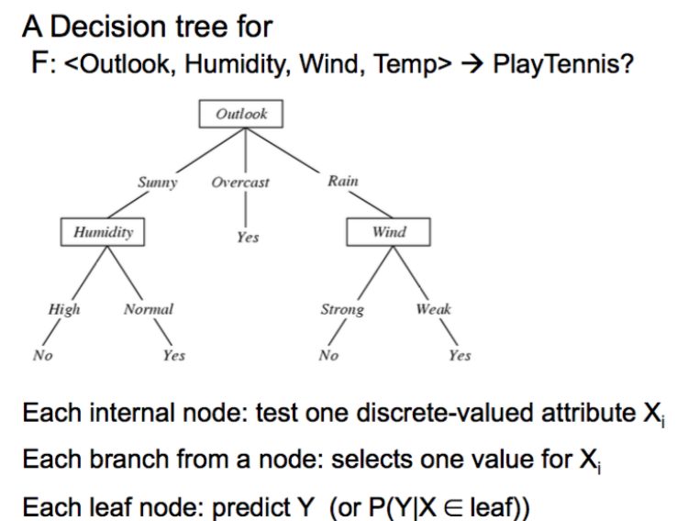

Using DT to represent hypotheses

.

.

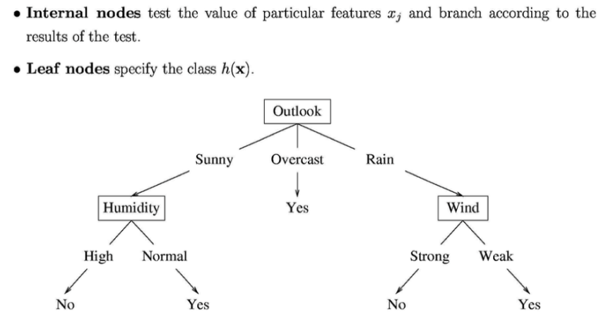

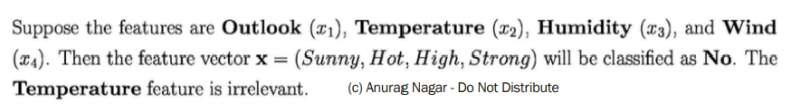

Classification Boundary of a DT

.

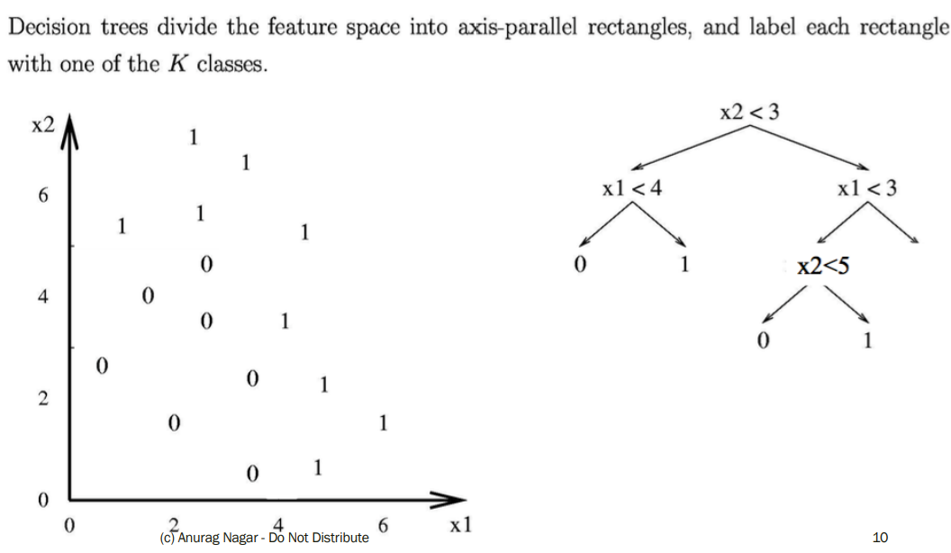

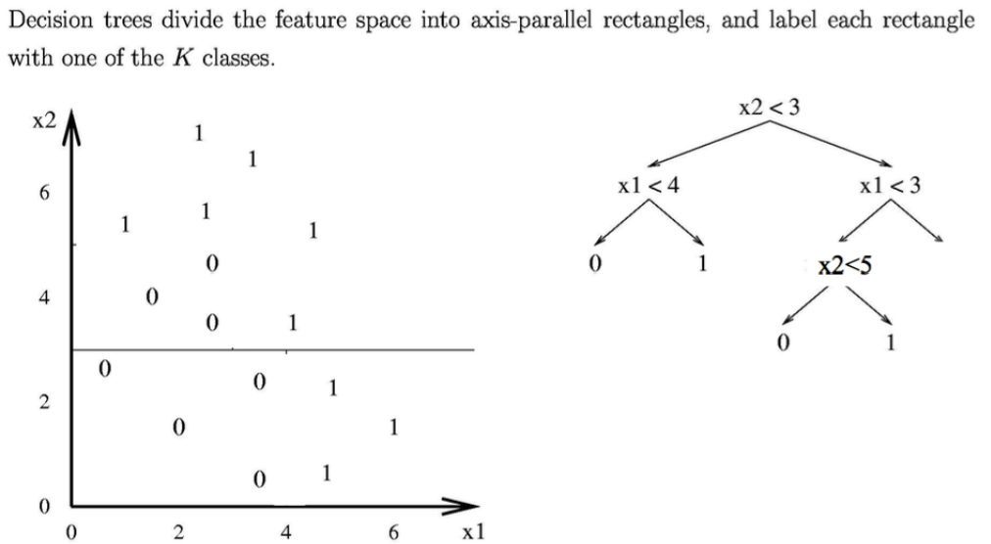

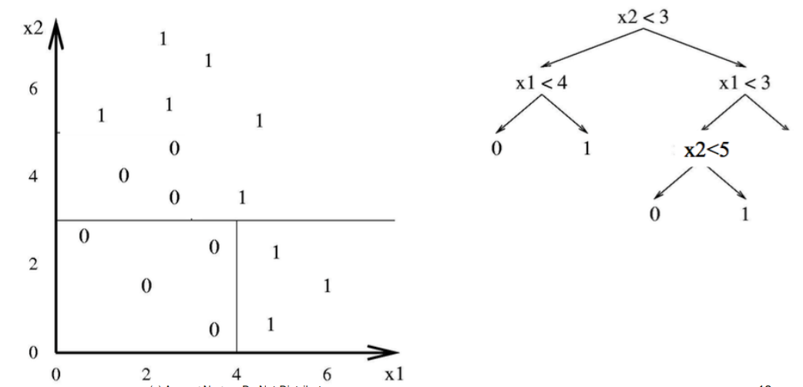

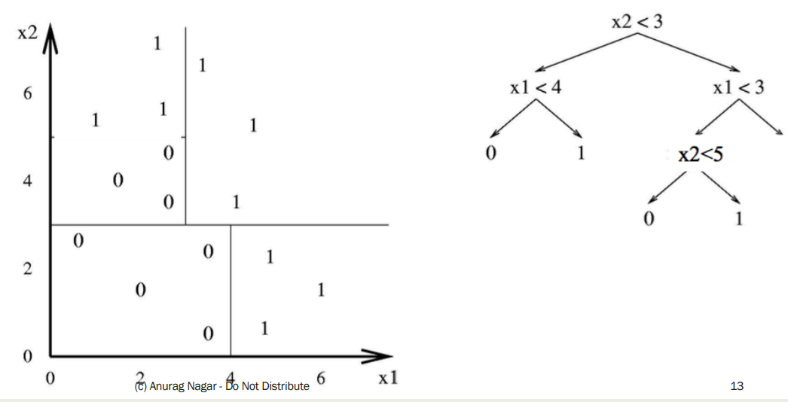

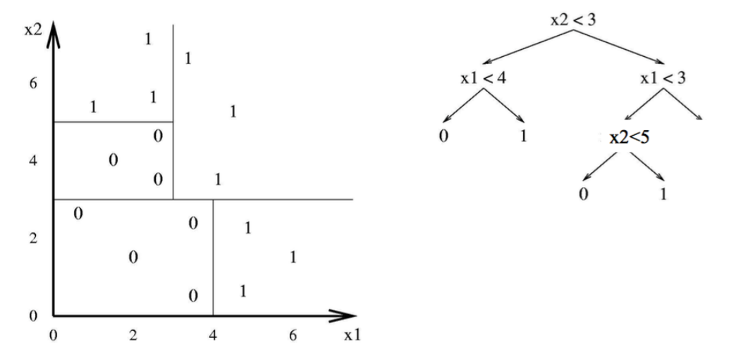

Hypothesis Space of DT

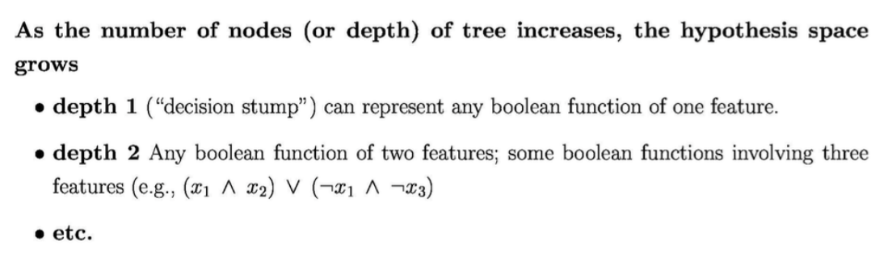

**Finding the best split (also called sort)**

DT – How to find best sorting?

■ Which attribute should I sort (split) on first? - It DOES make a difference.

■ Informally, we want that split that gives maximum purity at each node i.e. split such that all instances are of a single class (or close to it).

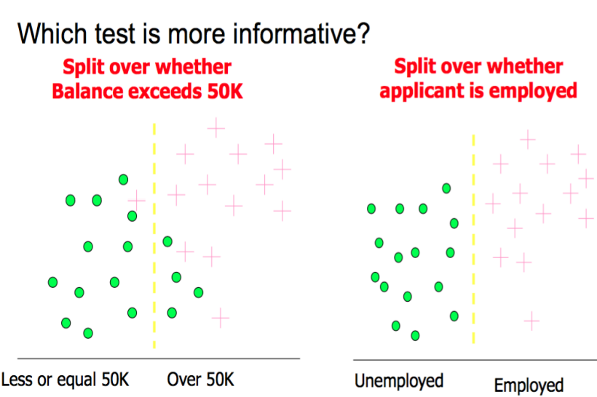

Entropy

Entropy is a measure of Information Content (IC)

. 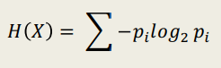

where pi is the probability of the i th class. If you think deeply, it is the **expected value** of –log 2 pi or log(1/p i )

. This quantity is also known as information of an attribute. Also, H(x) can be thought of as the number of bits needed to encode a dataset

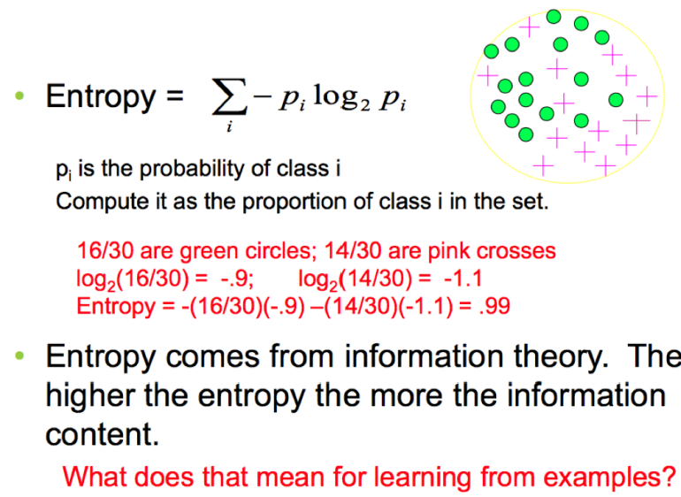

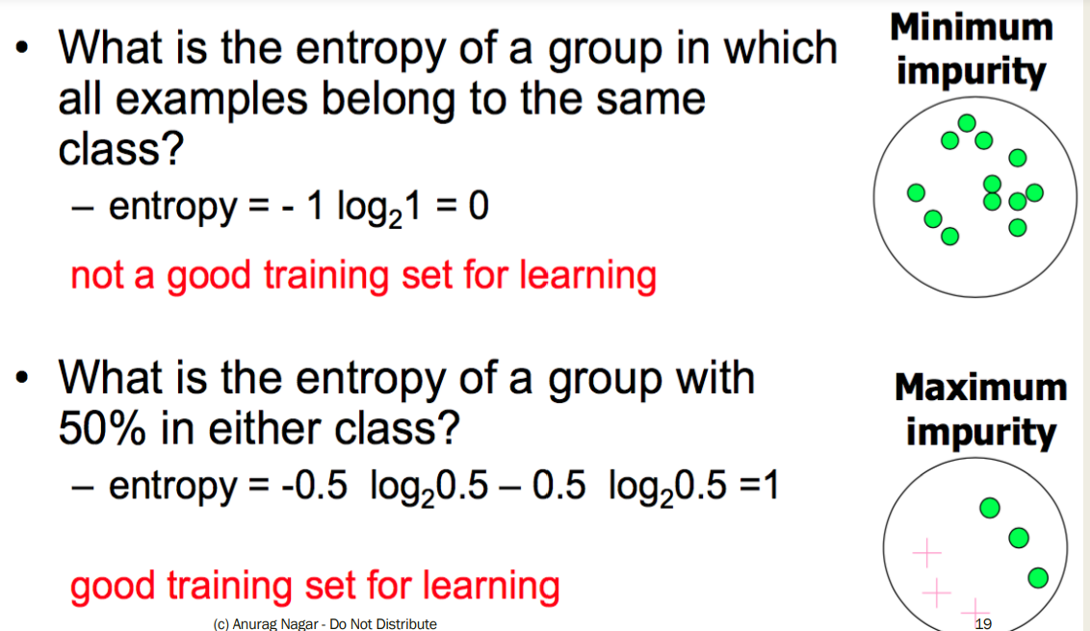

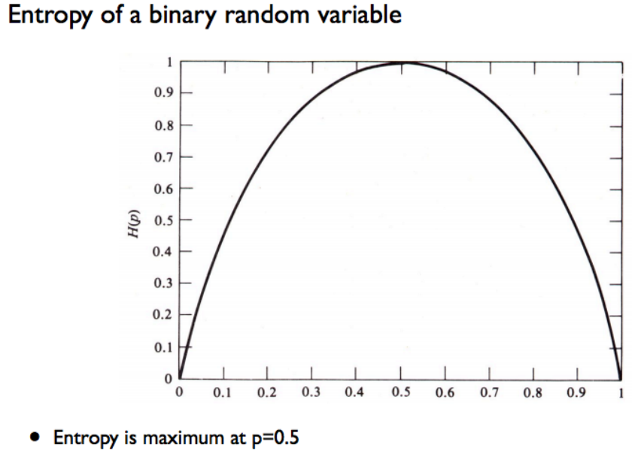

Information Gain

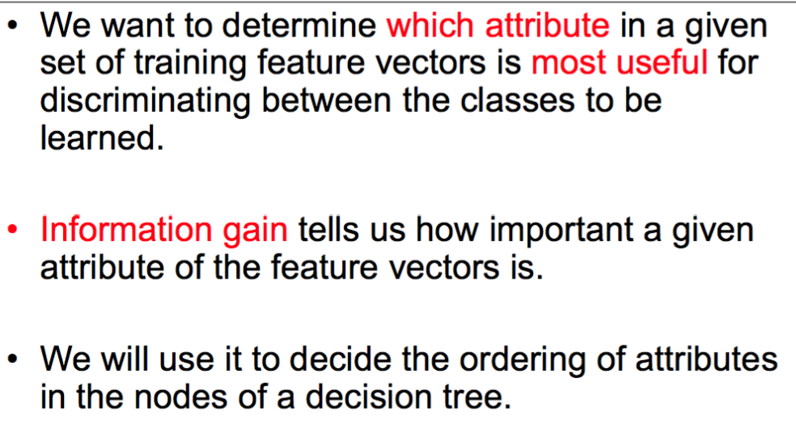

Information Gain

■ Suppose you just know the class labels initially.

■ Then you know one of the attributes. (Mean the same thing)

=> Does it really help you?

=> Do you get any information gain or reduction in entropy?

=> Do you get any increase in purity of the classes by knowing an attribute?

Information Gain

■ Information Gain (IG) is defined as: IG = Parent Entropy – Average Entropy of children

■ Average entropy of children: Probability weighted entropy of all the child nodes

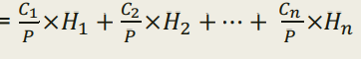

■ Information Gain (IG) =

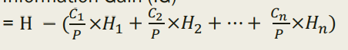

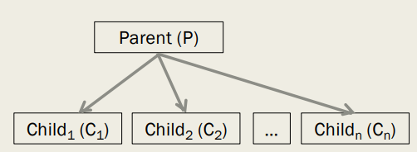

Parent has P data instances and entropy of H After splitting into n child nodes:

Child1 has C1 data instances and entropy of H1

Child2 has C2 data instances and entropy of H2 ….

Child­n has Cn data instances and entropy of Hn.

Example

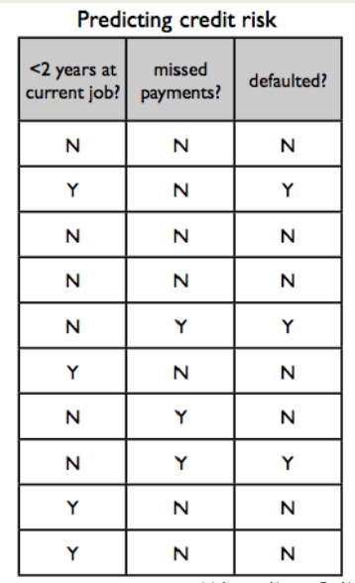

of IG Class attribute is **defaulted**?

Independent Attributes - **the first two**.

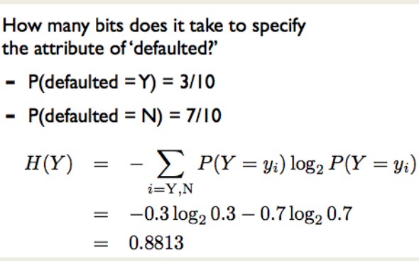

IG

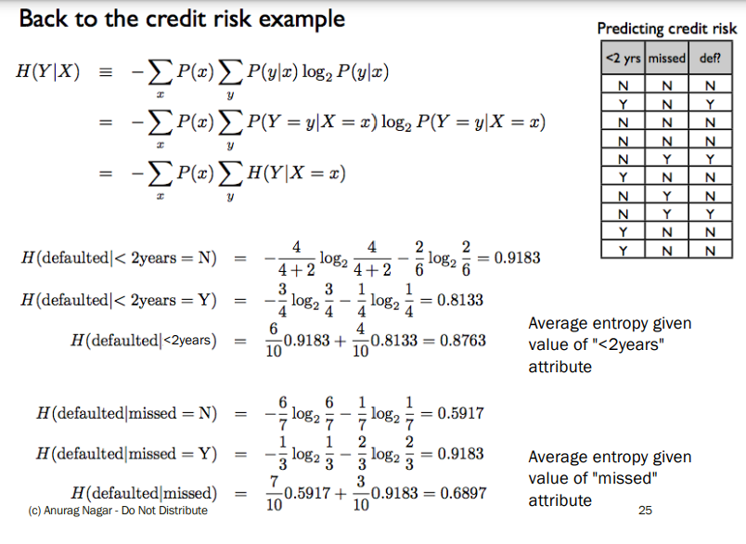

So… which attribute should I split on?

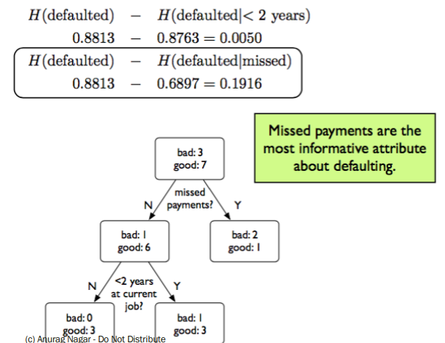

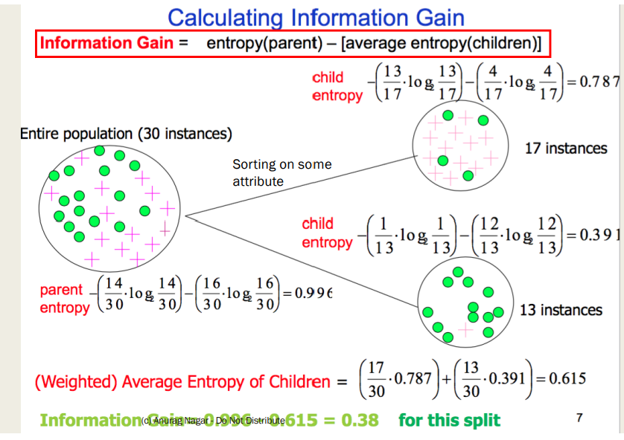

Calculating IG E(S) = E(29, 35) E(X1) = E(21, 5) E(X2) = E(30, 8) IG = E(S) – [26/64 * E(X1) + 38/64 * E(X2)]

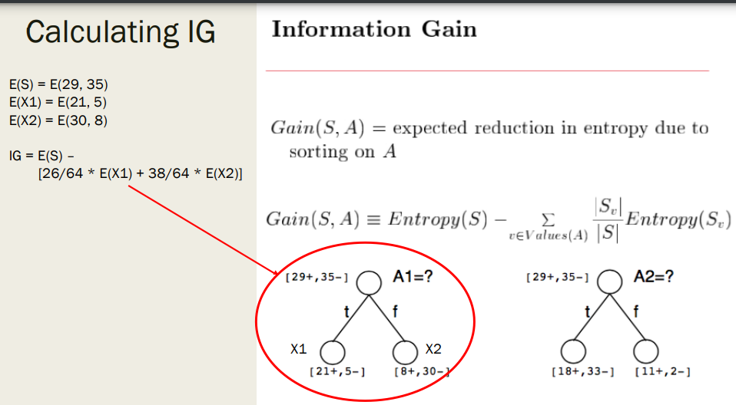

Use IG to build a tree

■ Start at the root of the tree (N1) and choose the best attribute according to IG. Let's say it is a1

■ Create its children according to possible values of a1. If a1 is Boolean, it will have 2 values 0 and 1.

■ These two nodes will be the leaf nodes for now -> since we haven't constructed whole tree yet.

■ Also, these two nodes will have only less attribute to choose from. Their available choices will be {a2, …, an}

■ Similarly create the rest of the tree, choosing the best attribute at each step.

■ Terminating Condition: - The node is pure in terms of class label. - There are no more attributes remaining.

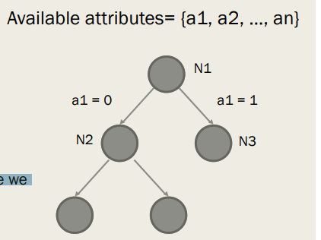

ID3 algorithm

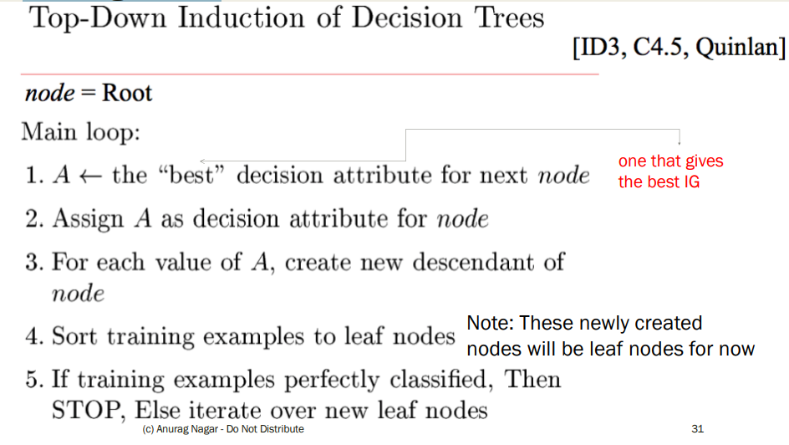

ID3 algorithm

■ Simpler version ID3 (node, {attributes})

1. Let A = best attribute among {attributes} according to IG

2. Sort according to A and create child nodes (which will be leaf nodes for now)

3. For all the child nodes

If it is pure or {attributes} is empty,

STOP

else call ID3(childNode, {attributes} – A) /* Recursive Call */

Worked out example

■ Please see the handout/notes for a worked out example using ID3

■ Remember:

- For each node, you have to find the best attribute

- You can only use an attribute once along a path. So, a node needs to inherit a list of attributes from its parent class -> You have to program this. J

- At the leaf node, find the majority class (by count). Use that for the prediction rule

Does it really matter which attribute comes first?

■ ID3 helps us in selecting the shortest i.e. most compact tree

ID3 is a greedy algorithm Top-down induction of trees.

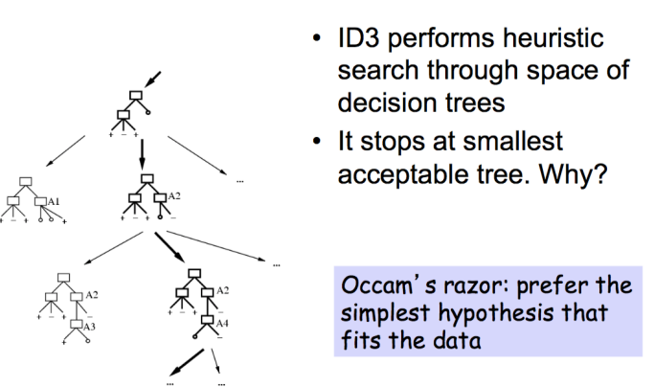

Problem with DT

■ Over-zealous learner -> learns all features

■ What if there is noise?

■ DT will try to change everything??

■ Consider tree below: What would happen if you get noisy data point

Sunny, Hot, nOrmal, Strong, Play Tennis = no

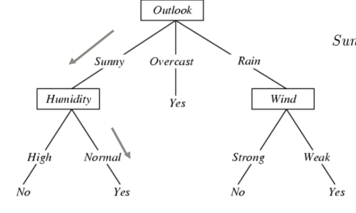

Overfitting

■ You train on the training dataset The data that the learner trains with. => It is possible to design a DT that gives 100% accuracy on training data. Think how?? e.g. each instance gets its own leaf node

■ But is that a good thing? => NO! Because you are in fact memorizing (rote learning) the training data => No room for generalization, it's a case of Overfitting

■ So, you have to find a balance between underfitting (learning very little) and overfitting.

■ Notation: Training error of hypothesis h = etrain(h) True error (on unseen data) of hypothesis h = etrue(h)

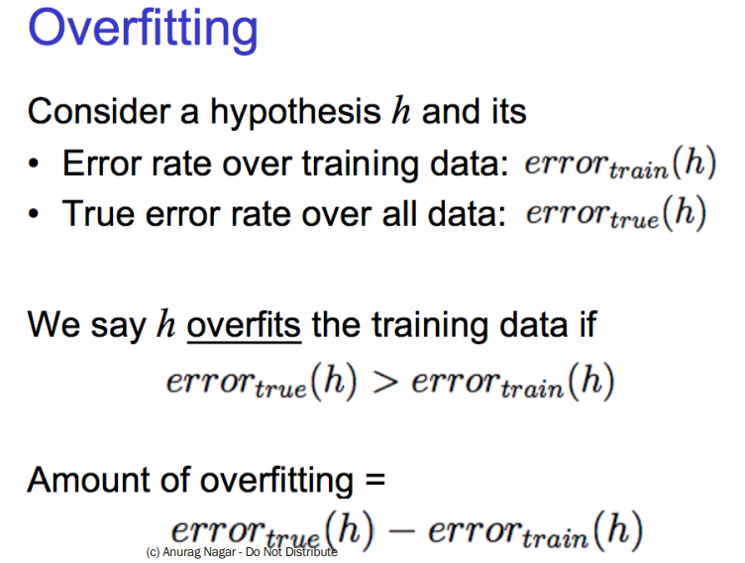

Overfitting in decision Tree Learning.

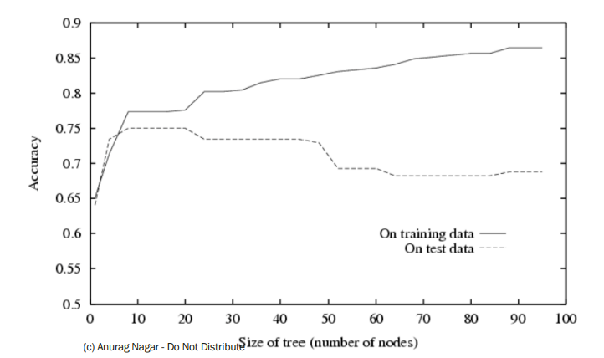

How to avoid overfitting?

1. Stop growing when splits are not statistically significant (TOUGHER PROBLEM)

OR

1. Grow full tree then post-prune i.e. remove nodes and see if true error decreases (EASIER PROBLEM)

How to avoid overfitting?

■ Keep another dataset -> validation dataset

■ Build model on training, test accuracy on validation

■ Learn model from training dataset.

■ Randomly remove nodes and see if validation accuracy improves

Reduced- error Pruning

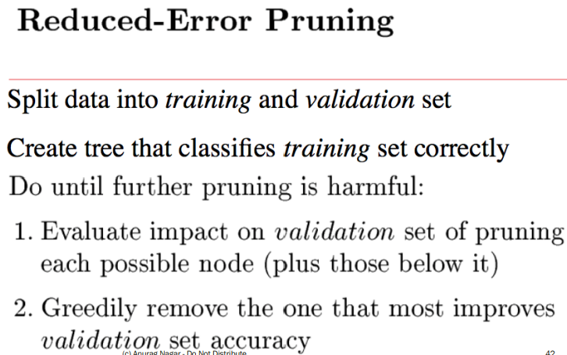

Post-pruning

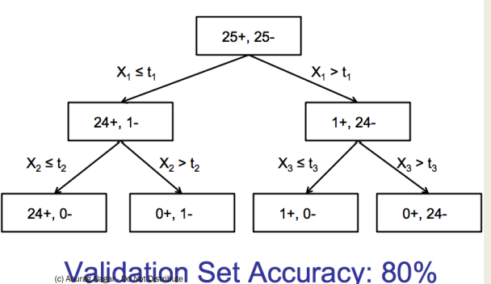

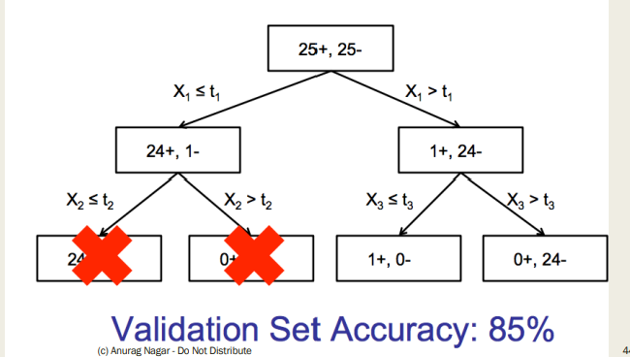

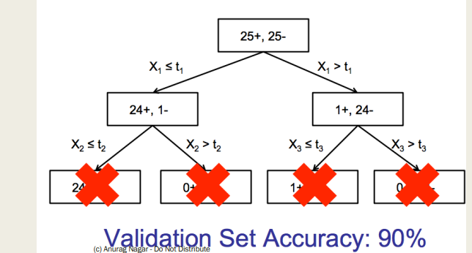

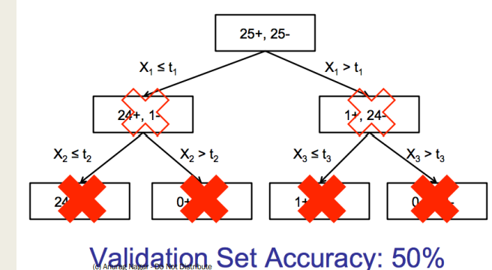

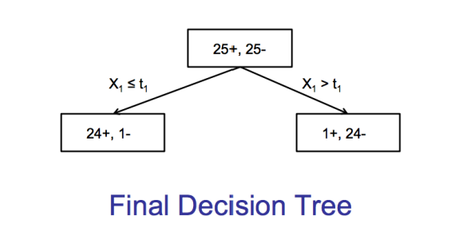

What have we learnt?

■ Idea of DT

■ Number of instances (leaf nodes) and hypotheses

■ How to choose best sorting attribute for each node

■ How to induce top-down tree using ID3

■ What is overfitting

■ Avoiding overfitting

Linear Classification Perceptron

. Imagine you have data as shown on the right and you want to propose a class separating hypothesis

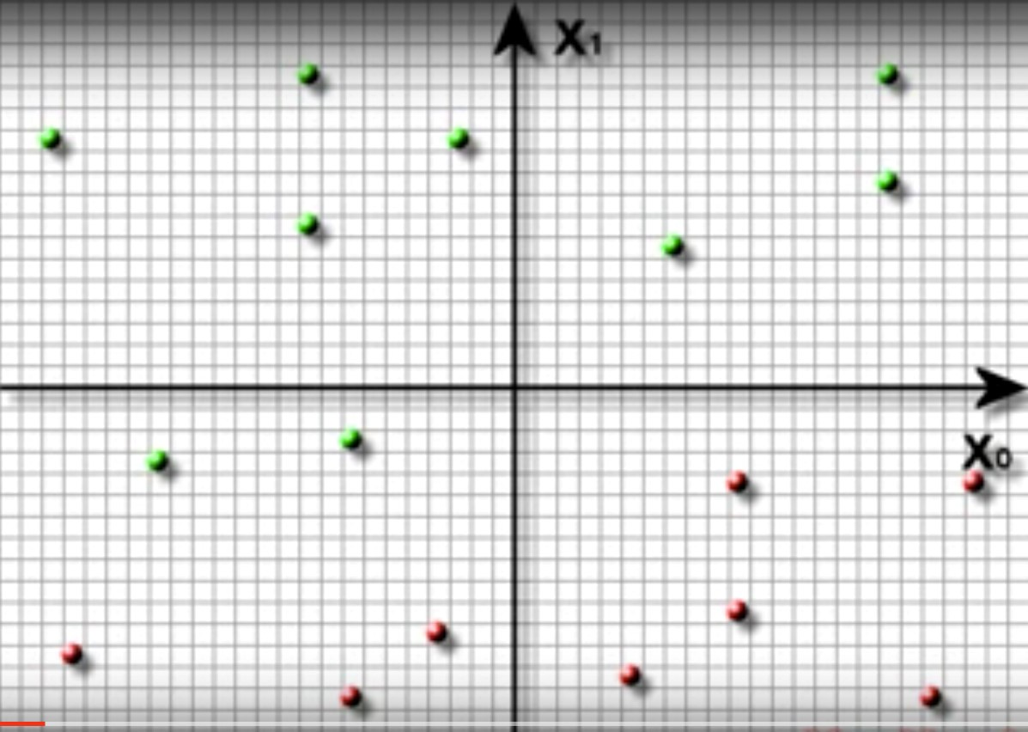

Your hypothesis

(

h

)

• Since data is linearly separable, you can propose a straight line

• Your hypothesis divides the plane into two parts

• Aim: Get those parts as pure as possible

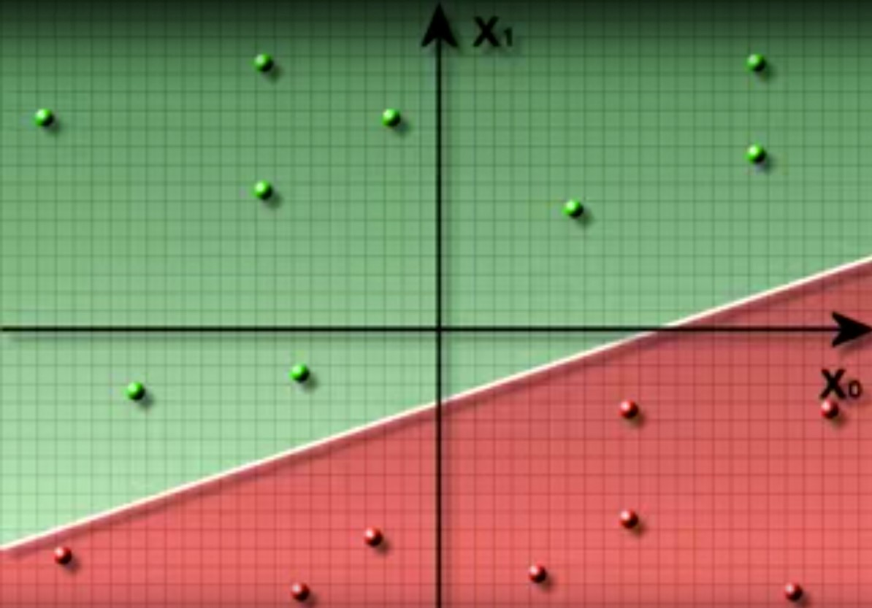

• OK, sounds simple enough

•Just draw a straight line and partition the plane into two parts.

• Limitations:

- Works with linearly separable data only.

•I can draw many lines that separate the data perfectly, which one do I choose?

•Good Question

Let's do some Math

• Equation of a straight line in a plane with two dimensions x1 and x2:

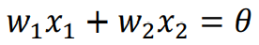

• There are three parameters in the equation above w1, w2 and ϴ.

• By changing these, you can get a different line.

• Let's call the hypothesis as:

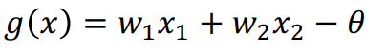

• What's the value of g for points that lie on the separating line? 0

Math

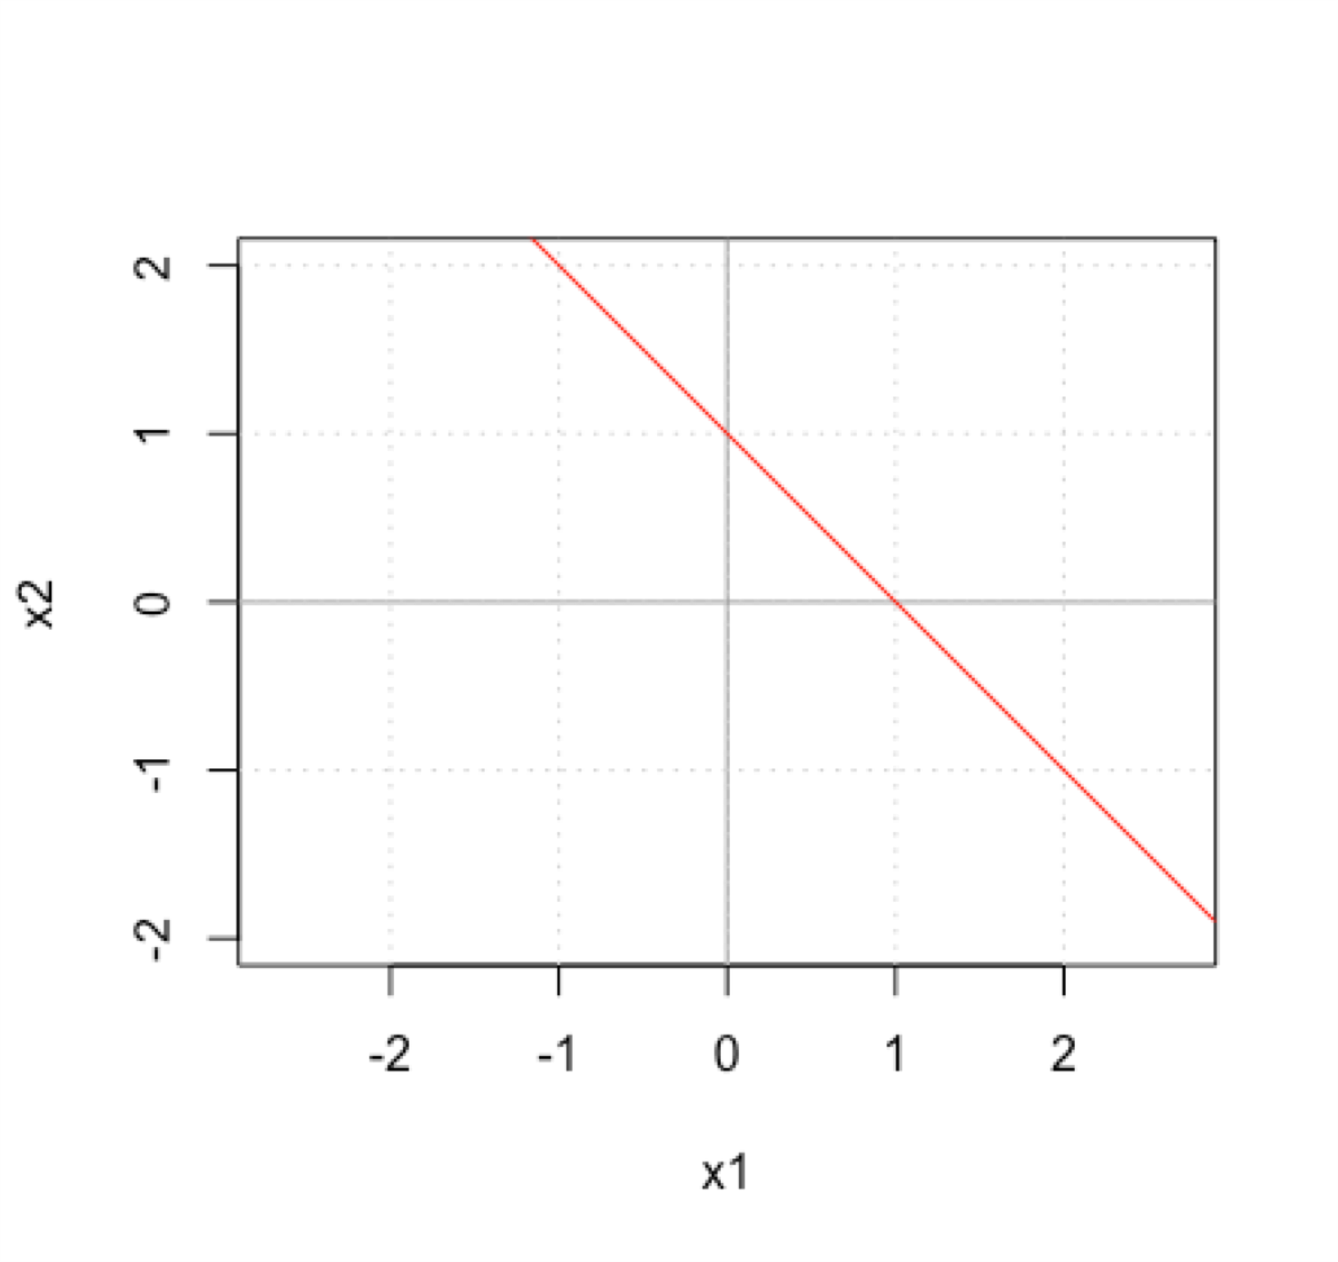

• Let's draw a line with w1 = 1, w2 = 1 and ϴ = 1.

• We are trying to draw: x1 +x2 =1

• Thus, g(x) = x1 + x2 - 1

• What are some points on this line: (1, 0), (0, 1), (½, ½), (-1, 2), …

• All the above points satisfy g(x) > 0

• Let's see what happens to points in green area.

• What is g(2, 1) ? g(2, 1) = 2 + 1 – 1 = 2

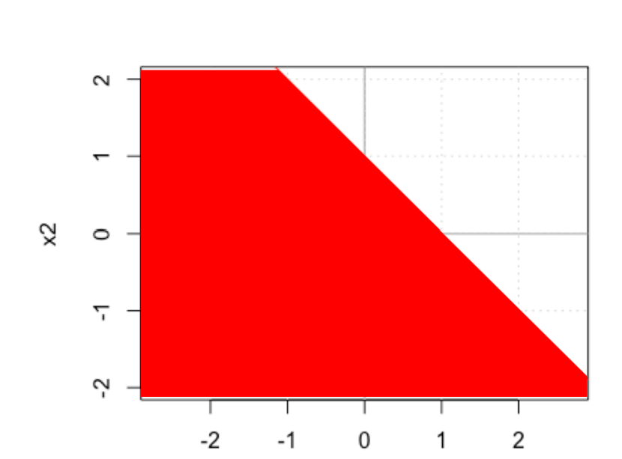

• Let's see what happens to points in red area.

• What is g(-1, -1) ?

g(-1, -1) = -1 - 1 – 1 = -3

• So, what can we use as a classification rule:

• Check sign of hypothesis for test data point:

if sign(g(xtest)) > 0 call it class +1 else if sign(g(xtest)) < 0 call it class -1

Classification Rule

• Let h(x) denote the sign of g(x) h(x) = sign(g(x))

sign(x) function is defined as +1 for x >= 0 and -1 for x < 0

• Predicted class label:

Class = h(x)

Linear Classification

• If there are n input attributes x1, x2, …, xn, our task is to find appropriate set of weights w1, w2, …, wn, such that correct classification can be performed.

We would like if 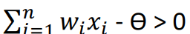 then class = +1 otherwise class = -1.

for some threshold value ϴ.

• This can be states as: If wTx > ϴ then class= +1 otherwise class = -1 where w is the weights vector and x is the attributes vector.

**Note: i starts from 1 => We don't have any artificial attributes**

Linear Classification

• Can be written as: w1x1 + w2x2 + … + wnxn > ϴ for class +1

Or - ϴ + w1x1 + w2x2 + … + wnxn> 0 for class +1

or w0 + w1x1 + w2x2 + … + wnxn> 0 for class +1

where w0 is referred to as the bias term.

**You will find both these form used in textbooks.**

Linear Classification

• Two equivalent ways:

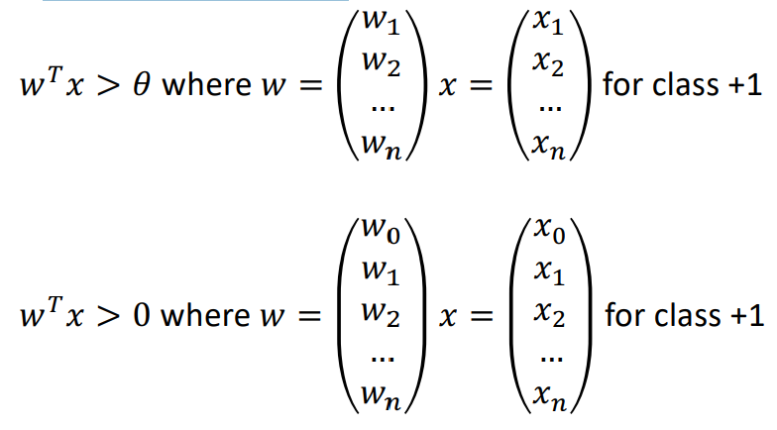

Graphical Meaning of Terms

• What do the terms (w1, w2, ..) and ϴ mean graphically.

• w's correspond to the slope and ϴ is a measure of intercept of the line.

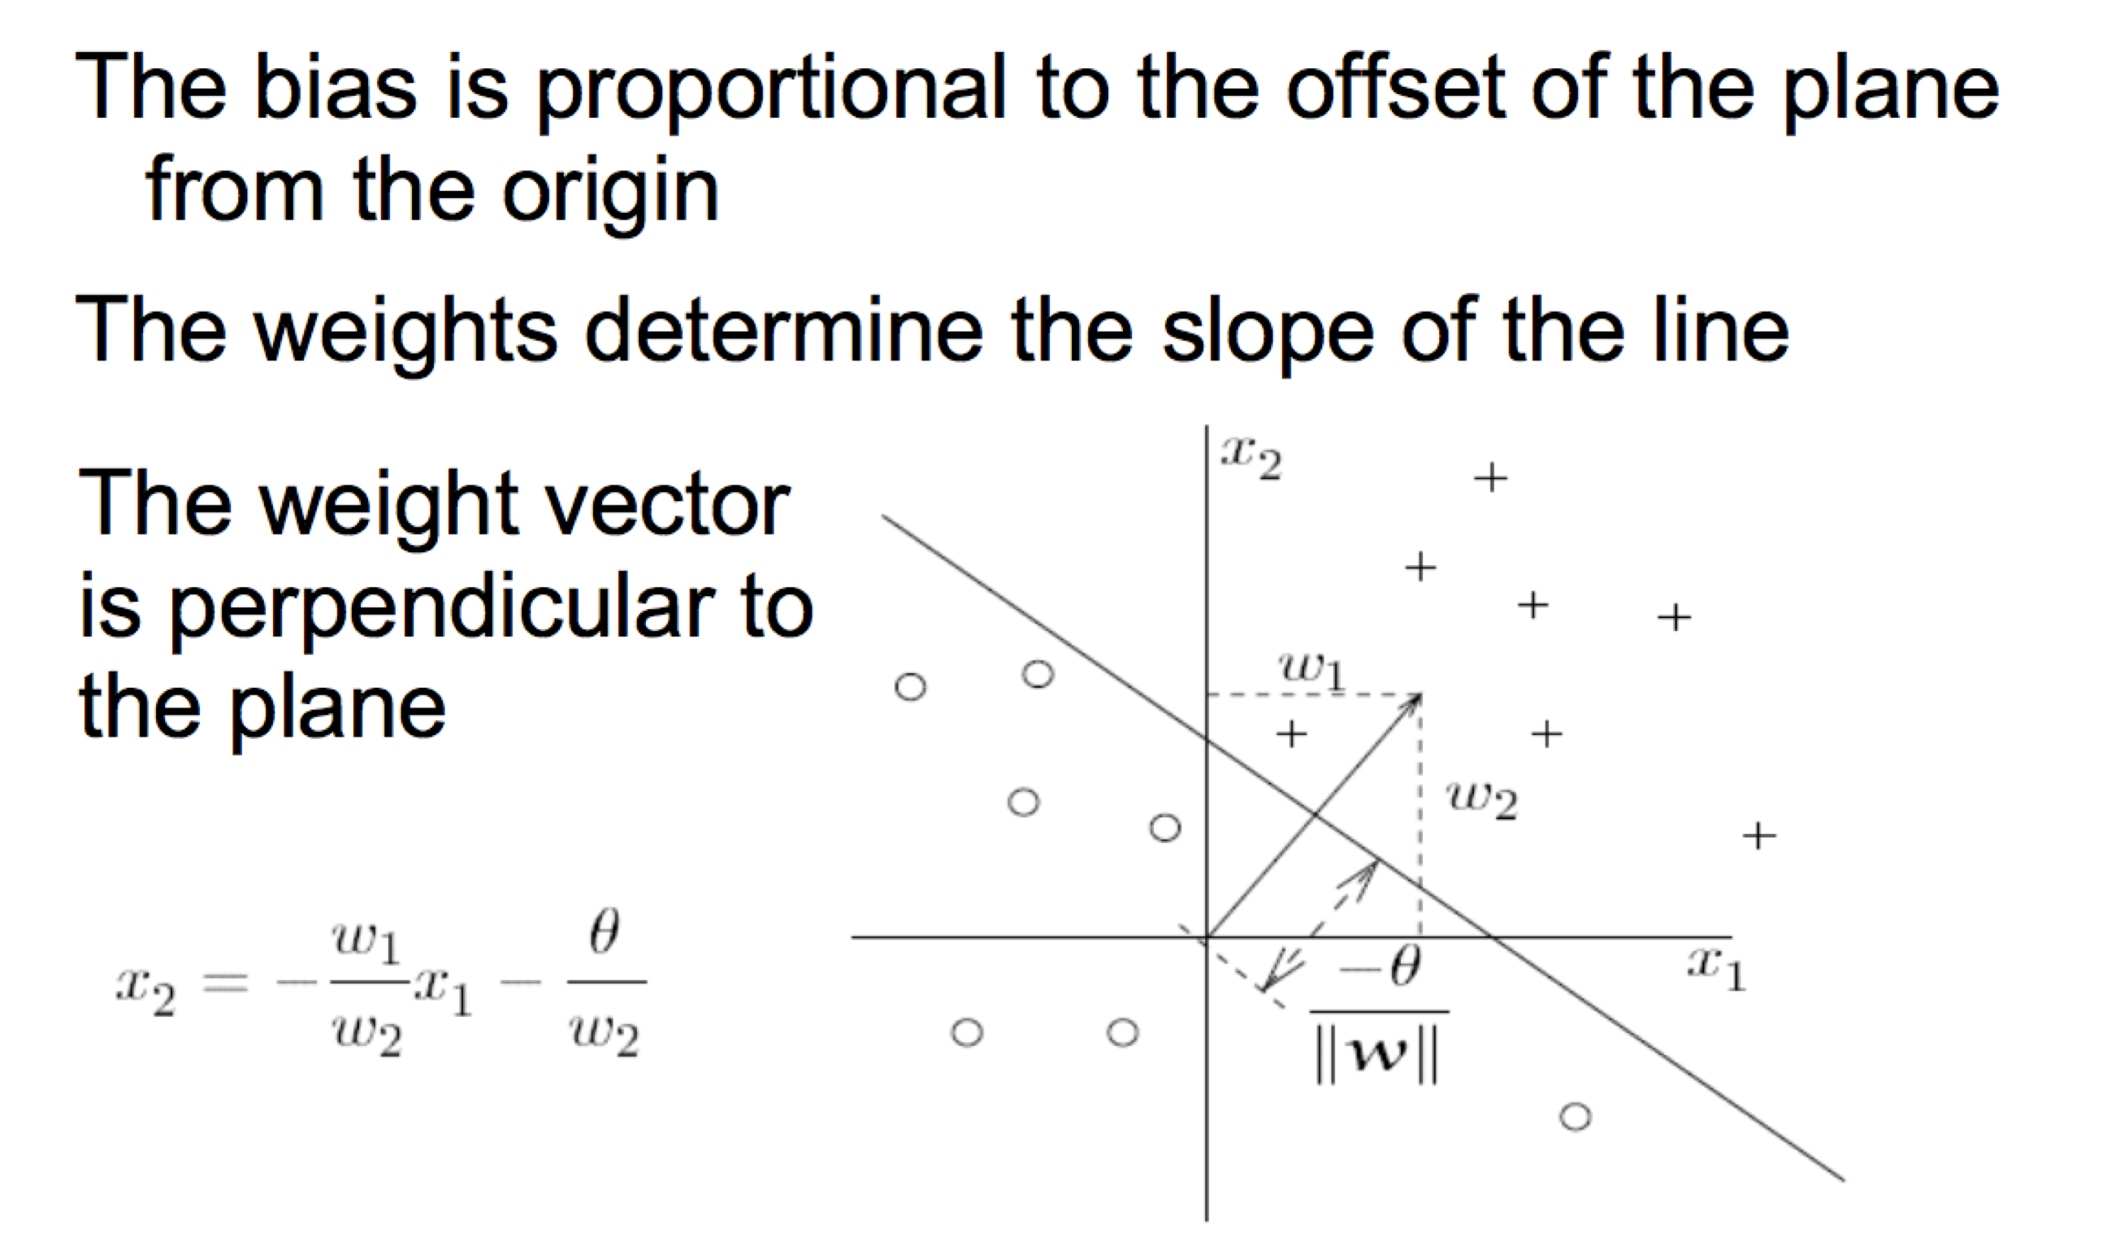

Perceptron

• The idea of linear threshold classifier is used in the model of a perceptron.

• Inspired by bio-computing model of a neuron in brain

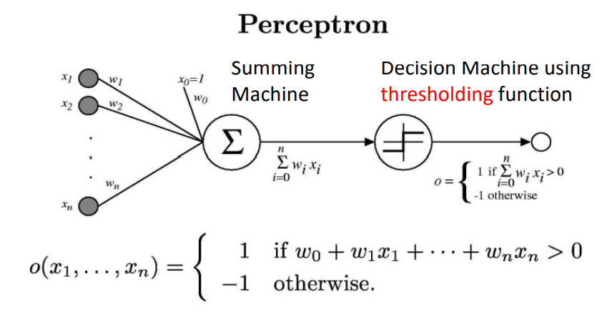

Sometime we’ll use simpler vector notation:

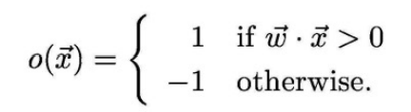

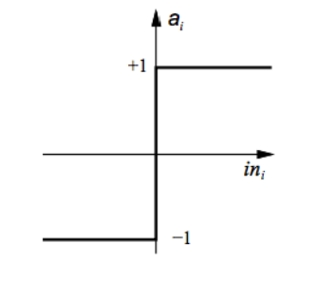Linear Classification

• The hypothesis can be represented as: h(x) = s(g(wT x))

where s is a function that outputs -1 or +1

What can s be?

s(x) = +1 if x >= 0

-1 if x < 0 It's called the sign function

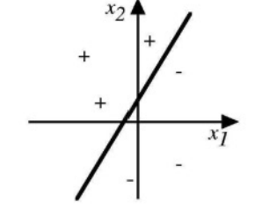Types of problems Perceptron can solve

• Linearly separable dataset only.

• If you use it with non-linear data, you will not get 0% training error. => You will not get a consistent hypothesis on non-linear dataset

• Let's see some examples of its representational power

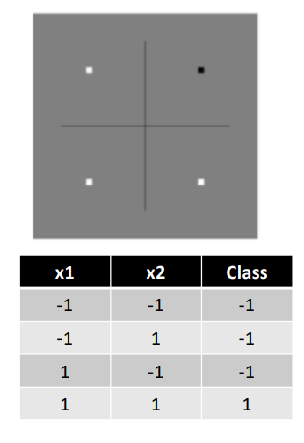Representative power

• Let's see if we can represent the AND function.

• Perceptron model:

if w1x1 + w2x2 > ϴ then Class = +1 else class = -1

• Let's assume w1 = w2 = 1. You can vary ϴ.

if x1 + x2 > ϴ then Class +1 else class = -1

• Find the value of ϴ

• Any number greater than 0 and less than 2 e.g. 1.5

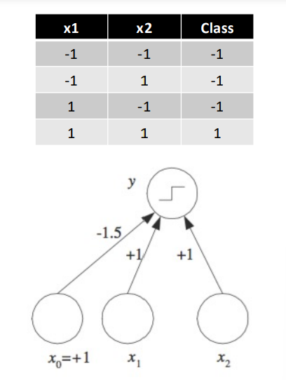Representative power

• Another way of representing AND.

• Perceptron model: if w 0 + w 1 x 1 + w 2 x 2 > 0 then Class = +1 else class = - 1 Notice: w 0 = - ϴ

• Let's assume w 1 = w 2 = 1. You are looking for w 0 such that : if w0 + x 1 + x 2 > 0 then Class +1 else class = - 1 • What is w 0 ? Any number less than 0 and greater than -2 e.g. -1.5 or -0.5

Representative power

• Let's see if we can represent the **OR** function.

• Perceptron model: if w 1 x 1 + w 2 x 2 > ϴ then Class = +1 else class = - 1

• Let's assume w 1 = w 2 = 1. You can vary ϴ. if x 1 + x 2 > ϴ then Class +1 else class = - 1.

• What is ϴ ?

• Any number less than 0, but greater than -2. Example: -0.5

Representative power

• Another way of representing OR.

• Perceptron model: if w 0 + w 1 x 1 + w 2 x 2 > 0 then Class = +1 else class = - 1 Notice: w 0 = - ϴ

• Let's assume w 1 = w 2 = 1. You are looking for w 0 such that : if w0 + x 1 + x 2 > 0 then Class +1 else class = - 1

• What is w 0 ? Any number greater than 0, but less than 2. Example: 0.5 or 1.5

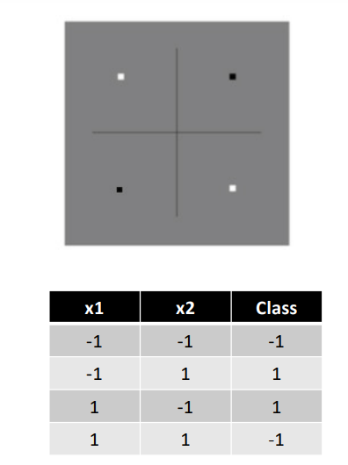Representative power

• Let's see if we can represent the XOR function.

• Perceptron model: if w1x1 + w2x2 > ϴ then Class = +1 else class = -1

• Let's assume w1 = w2 = 1. You can vary ϴ. if x1 + x2 > ϴ then Class +1 else class = -1

• What is ϴ ? Can't find any such value

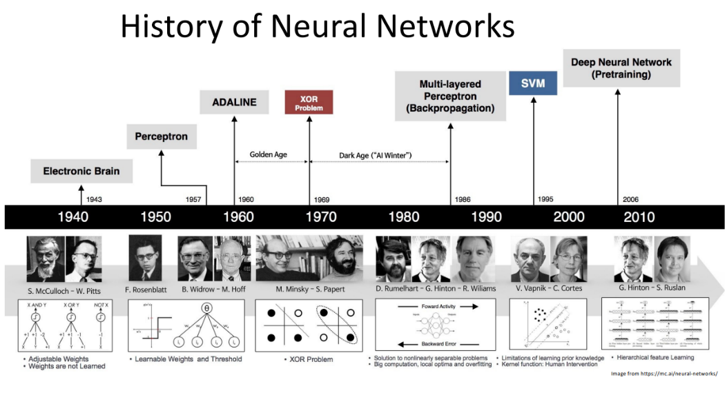

Canonical Representation

• In our framework, when do our hypothesis and actual value agree?

• Sign function plays a big role.

• Let's consider possible cases:

So, what do you conclude: (h * y) should be > 0 for correct prediction

Some textbooks write it as: g = wT x h = sign(w) Check sign(h * y) for correct prediction

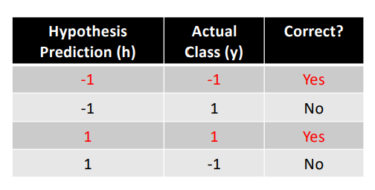

Perceptron

• So, the functional form of the hypothesis is given to you: g(x) = wT x • You classify a point based on sign(g) • But the big question: How do you find weights? • That's why companies are looking for you.

Learning Weights of a Perceptron

Perceptron Training Rule only works for linearly separable data.

• Two techniques available: (Tom Mitchell 4.4.2 and 4.4.3)

**1. Perceptron Training Rule – Change training weights according** to: 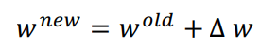

where 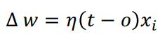

Start with random weights and apply above rule to each training example and modify each weight wi according to above rule.

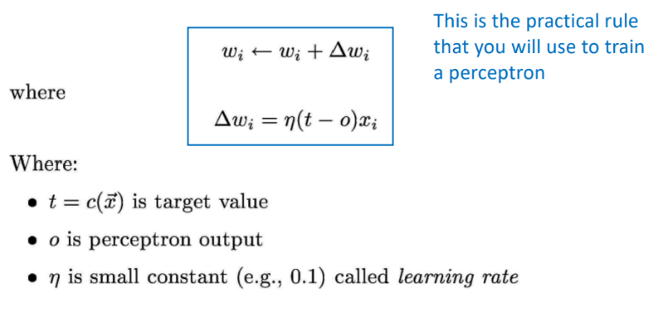 is the learning rate



t is the target value that you want (given for training examples)

o is the current output of the perceptron.

Note: t and o can only have values in the set {-1, +1}

Learning Weights of a Perceptron

This works even if the data is not linearly separable

Two techniques available: (Tom Mitchell 4.4.2 and 4.4.3)

**Gradient Descent Rule – First consider unthresholded output of the perceptron**:

o = w . x

Specify an error function: 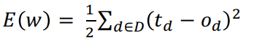where D is the set of all training examples.

Just like before, run the gradient descent algorithm on this function by starting with random weights.

Perceptron Training Rule

**Example:**

• Given: - A set of instances X1, X2, …, XD each containing n attributes i.e. Xi = * For LC, we assume the binary attributes can take values of +1 or -1 * - Labels for each instance y1, y2, …, yD (can be +1 or -1)

• Example: UTD Internship Problem

Can each attribute have different weight? I want to give twice the weight to work experience as GPA.

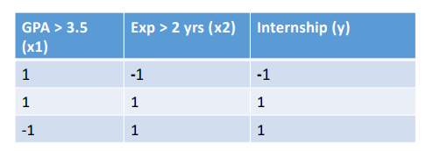

**Perceptron Training Algorithm**

Perceptron_Training_Algorithm(training_examples, ) {

Initialize weights vector w to some random value

Until convergence do {

For each training example {

Compute output o using activation function

For each linear unit (attribute) i, update using

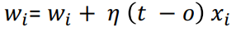

} } }

Convergence

Will it converge? Yes, provided: • Data is linearly separable. • The learning rate is small enough.

Example

• You initialize the weights vector as: w= −2 1 2 Assume a learning rate  = 0.5. You are given following data points and target values:

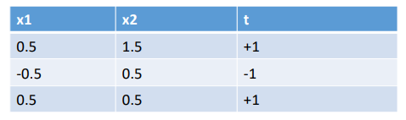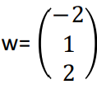

**Example**

• For first point, g(x) = sign(w.x) = sign(-2 + 0.5 +3) = +1 => no change needed since t(x) = g(x)

• For second point, g(x) = sign(w.x) = sign(-2-0.5+1.0) = -1 => no change needed since t(x) = g(x)

• For third point, g(x) = sign(w.x) = sign(-2+0.5+1.0) = -1 => Need to update weights

**Example**

• Updating weights. Start with Δw = 0; t - o = 1 - (-1) = 2

Δw0= 0.5 * 2 * 1 = 1

Δw1= 0.5 * 2 * 0.5 = 0.5

Δw2= 0.5 * 2 * 0.5 = 0.5

So new values will be:

w0 = -2 + 1 = -1.0

w1 = 1 + 0.5 = 1.5

w2 = 2 + 0.5 = 2.5

You can verify that this value of the weights vector will classify points correctly.

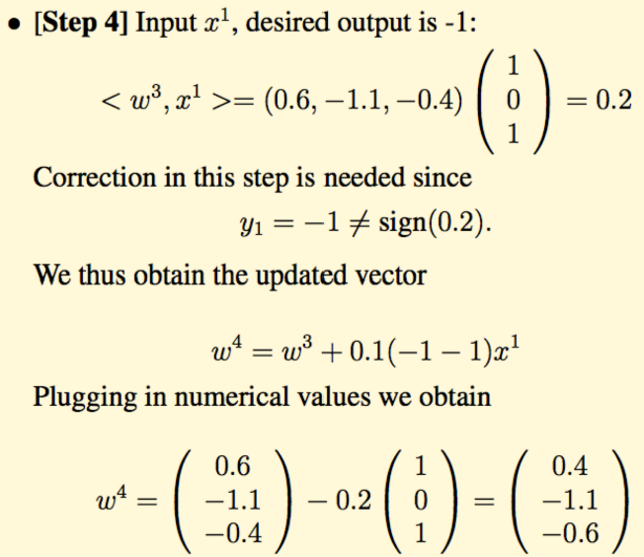**Example 2**

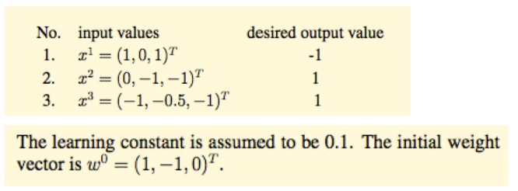

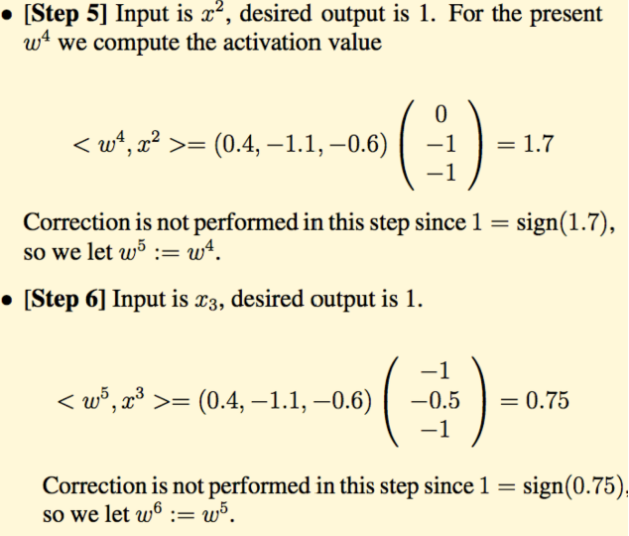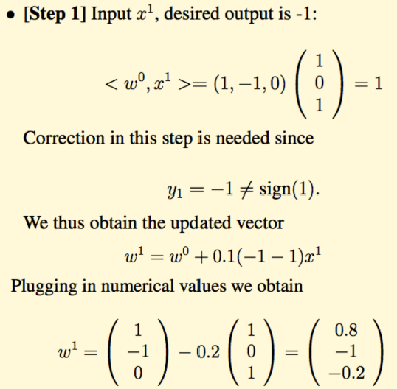

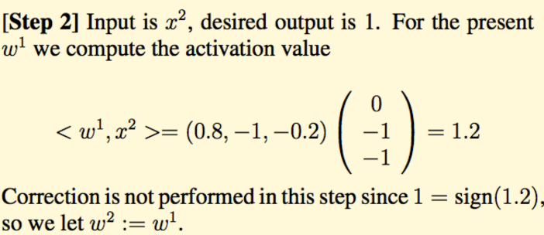

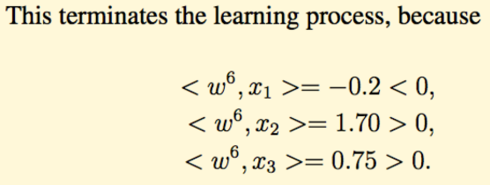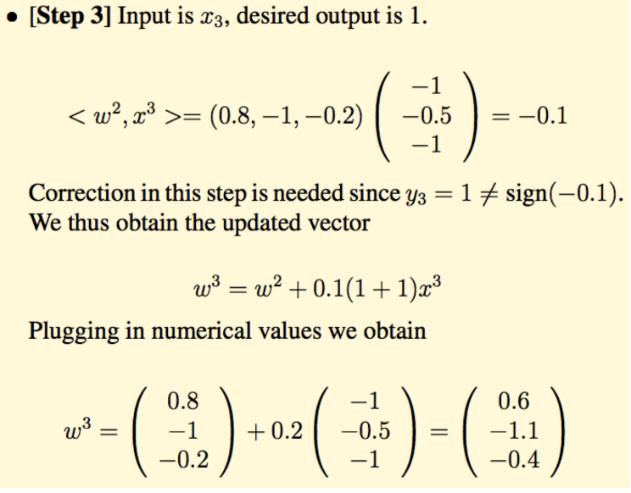

2. Gradient Descent

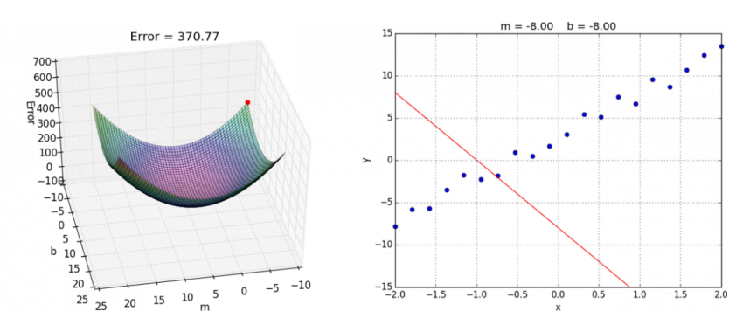

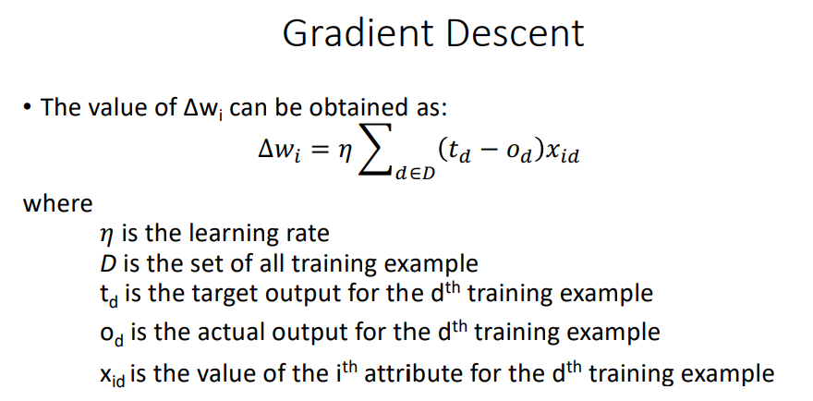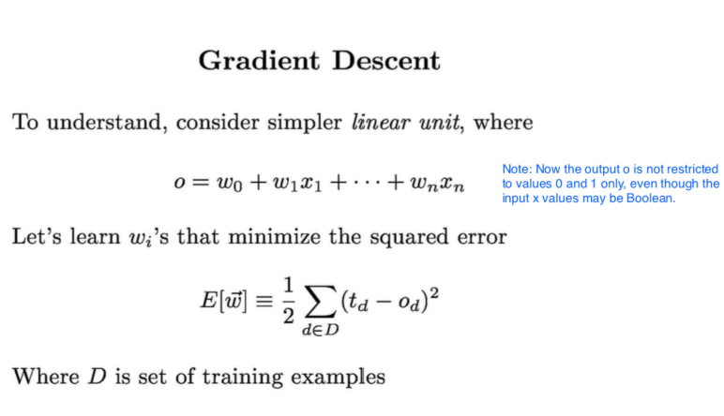

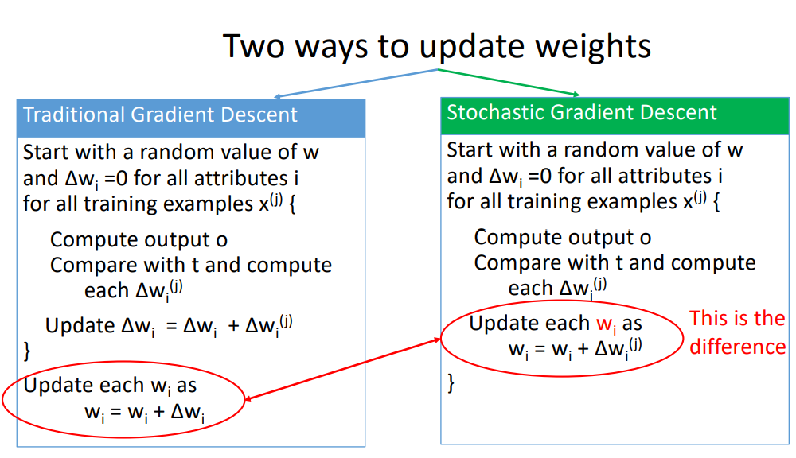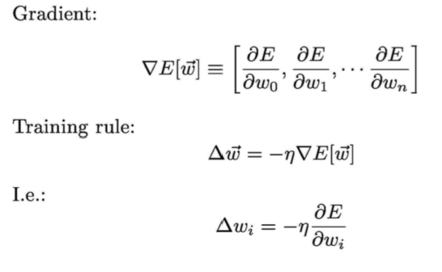

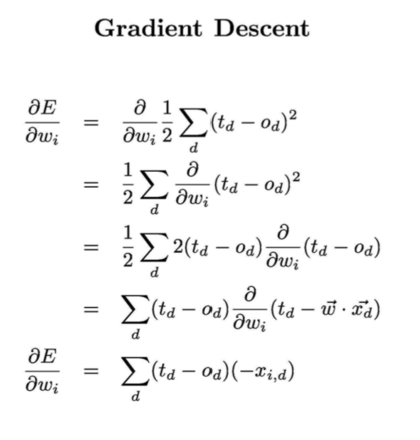

Difference

Traditional gradient descent can lead to:

1. Convergence to local minimum can be quite slow (many thousand of gradient descent steps)

2. If there are multiple local minima in the error surface, then there is no guarantee that the procedure will find global minimum.

Stochastic gradient descent can alleviate these problems. (Section 4.4.3.3 of Tom Mitchell)

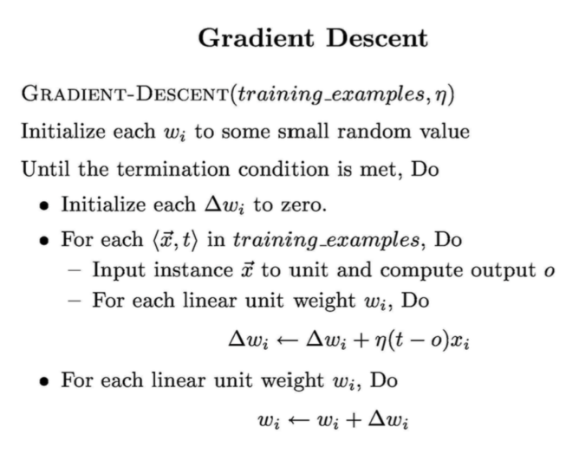

Thought Questions:

• Pros and Cons

- Only works with linearly separable data

- Is error driven

- Does it converge? If you input data that is not separable, what would happen?

- Efficient?

- Easy to visualize

- Can weight attributes

- Activation function concept is nice

What is next? • How do we extend it to non-linear datasets?

**Neural Net**

Extending Perceptron

• Perceptron only works with linearly separable data.

• How do we make it learn more complicated, non-linear datasets?

• Change the output function from step to a non-linear one.

• Strength in unity

• Combine multiple perceptron units

What is a NN?

• We saw earlier that a single perceptron can only separate linear data

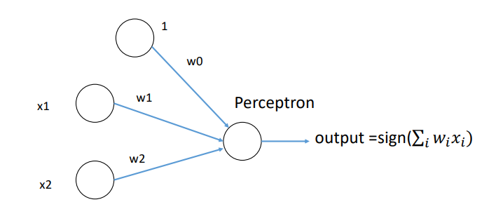

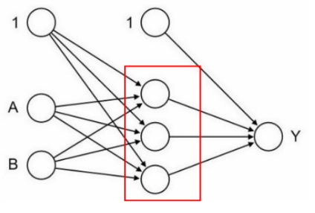What is a NN?

• What would happen if we create a network of perceptron.

• Initial input is fed to a set of nodes in the intermediate layer, known as hidden layer.

• Output from hidden layer can be sent to another hidden layer or output

Hidden Layers that perform transformation of input signals to outputs

Neural Network

• A set of perceptron joined together in multiple layers.

• The output can represent highly complex and nonlinear functions.

• By constructing this network, we use a combination of simple perceptron to build a powerful classifier.

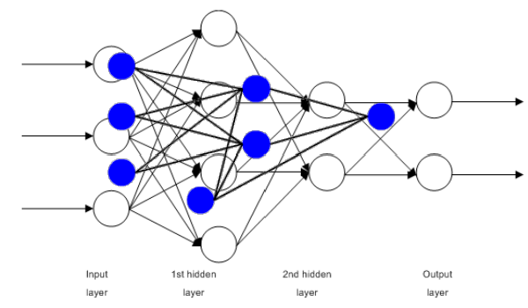

Properties of NN

• A large number of very simple neuron-like processing elements.

• A large number of weighted connections between the elements.

• Highly parallel, distributed control.

• An emphasis on learning internal representations automatically.

ANN as universal approximator

• We can approximate any Boolean function and almost all continuous functions with a multi-layer perceptron.

• Let's check the XOR function: Remember: x1 **XOR** x2 = (x1 **AND** NOT x2) **OR** (NOT x1 **AND** x2)

ANN as universal approximator

• Let's check the XOR function: Remember: x1 **XOR** x2 = (x1 **AND** NOT x2) **OR** (NOT x1 **AND** x2)

• In the diagram, step activation function is used everywhere.

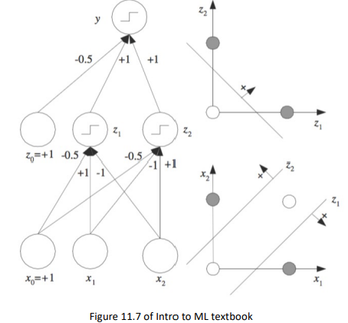

Applications of NN

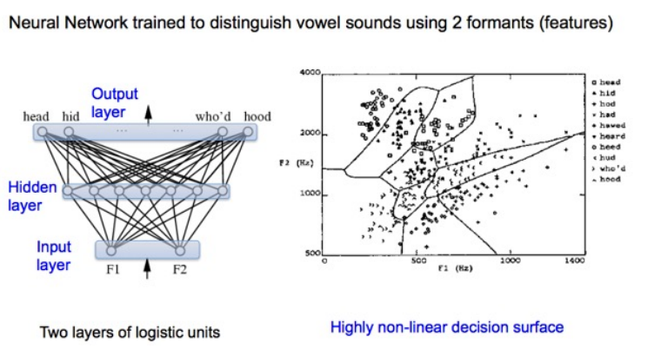

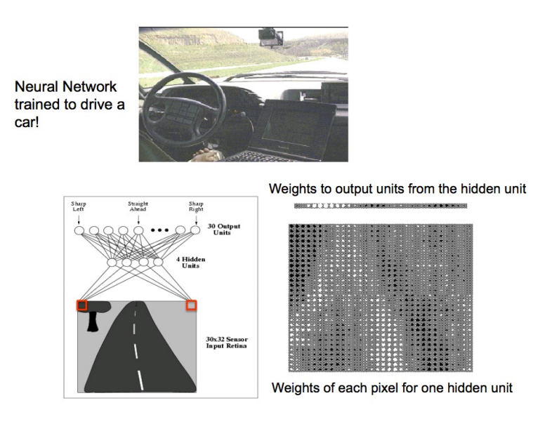

Training a NN • All this sounds great, but.. • How do I train this complex network? • Let's see.

Artificial Neural Network (ANN)

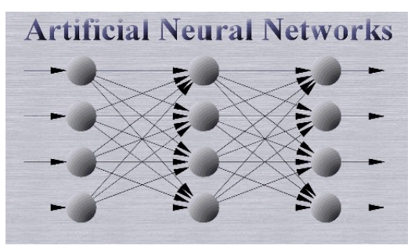• A group of perceptron joined together to achieve powerful results.

• Multi-layered processing.

• Each layer and unit has to be trained.

• Once trained, it can achieve great results.

Perceptron

• Let's revise to make sure we still remember the perceptron.

• It has only one decision unit.

Perceptron

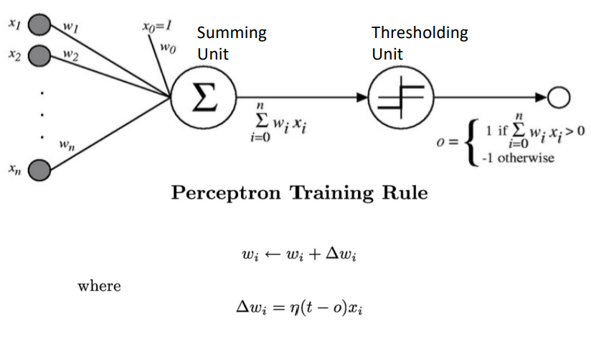

How to build a Neural Net

• Remember for a perceptron, there was a summing unit and a linear decision or activation unit. It's called threshold function

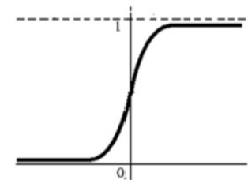• The linear unit works for linearly separable data, but to make it work with other data, we need a non-linear activation unit.

• Sigmoid activation function: 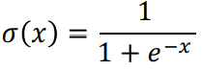

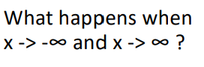

How to build a Neural Net

• Remember for a perceptron, there was a summing unit and a linear decision or activation unit.

• The linear unit works for linearly separable data, but to make it work with other data, we need a non-linear activation unit.

• In NN, we will create units that have a non-linear unit applied to the output of the summing unit.

Sigmoid activation function is applied to net Derivative of sigmoid unit

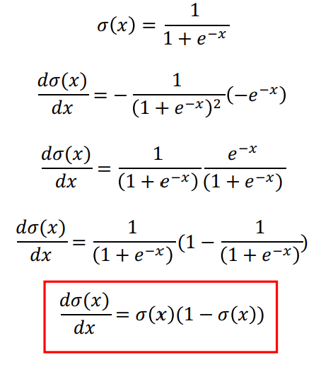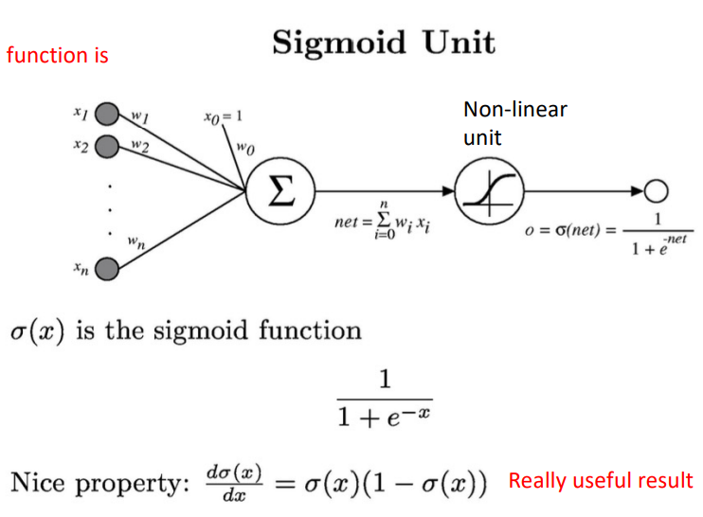

We can derive gradient descent rules to train

. One sigmoid unit

. Multiplayer networks of sigmoid units -> Backpropagation

Backpropagation Algorithm

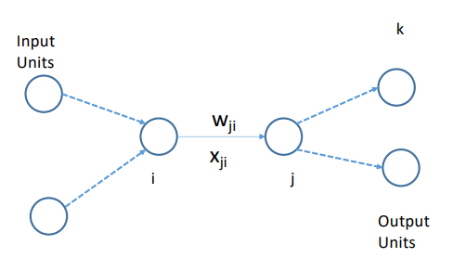• Consider the network shown on right and two intermediate nodes i and j

• Error for example d is:

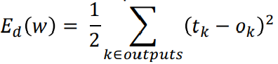

for all output units find squared error and sum

• Weight delta (from last class): How does wji affect E d ?

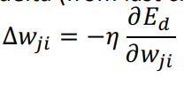

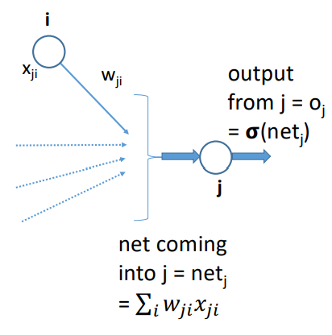Backpropagation Algorithm

• Let's try to compute 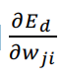

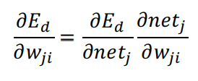

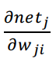is easy to compute: 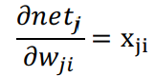

What about 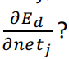

Backpropagation Algorithm

Two cases: - j is an output unit - j is a hidden unit

Value of 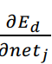 will be different for the two above cases.

Backpropagation Algorithm

Case I: j is an output unit

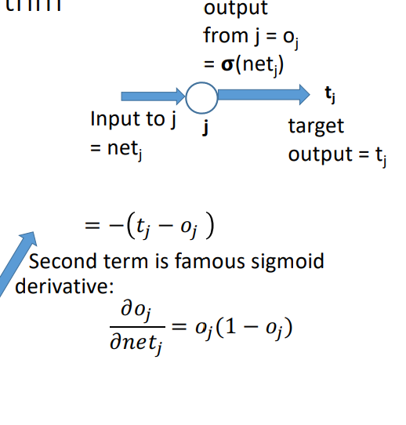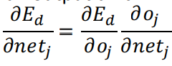

We know that error for data d is:

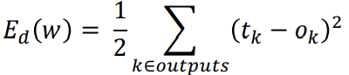

Differentiating wrt oj :

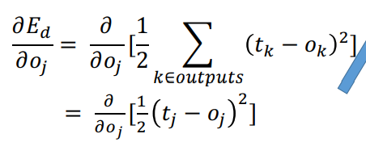

Backpropagation Algorithm

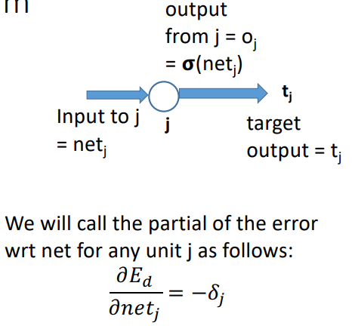Case I: j is an output unit: Putting it all together:

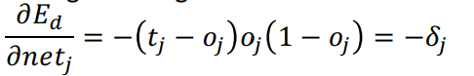

Let's plug this back in Δwji:

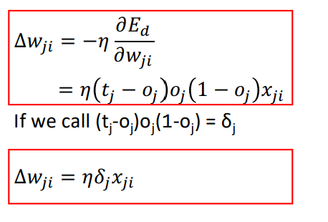

Backpropagation Algorithm

Case II: j is a hidden unit: Note that netj can influence the error only through downstream units:

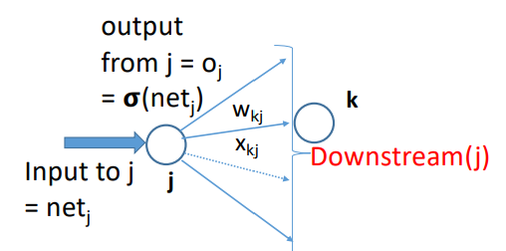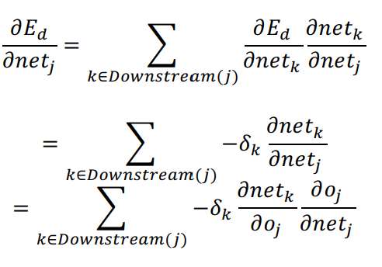

Backpropagation Algorithm

Case II: j is a hidden unit:

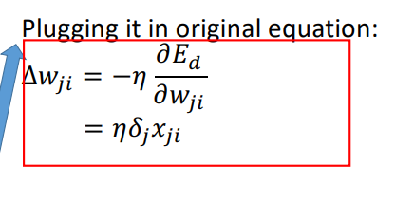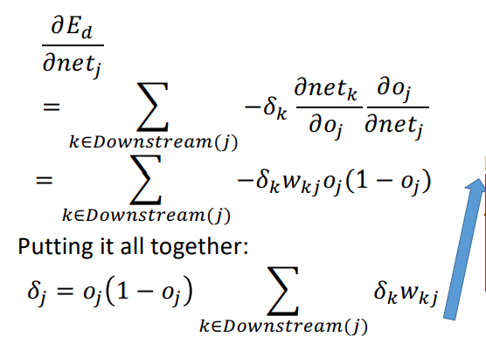

Backpropagation Summary

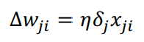

• Case I: j is output layer node:

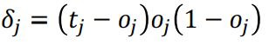

where xji is the weight of edge from i th node to j th node, where j is the output node.

• Case II: j is hidden layer node:

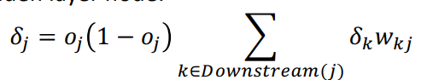

Unit j sends its output to Downstream(j) units. δk is the delta for the unit k which is part of Downstream(j).

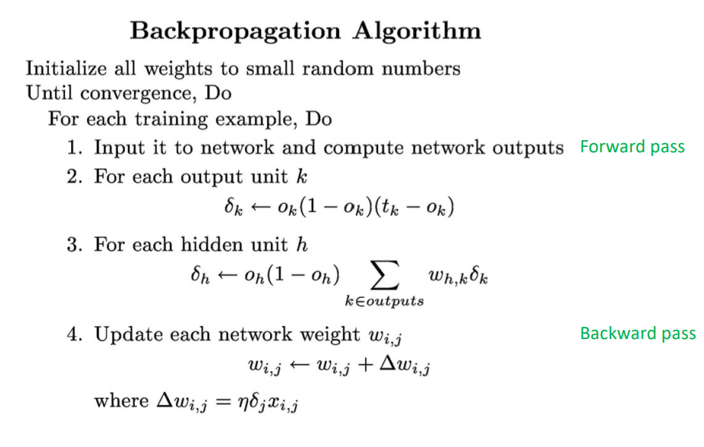

Example:

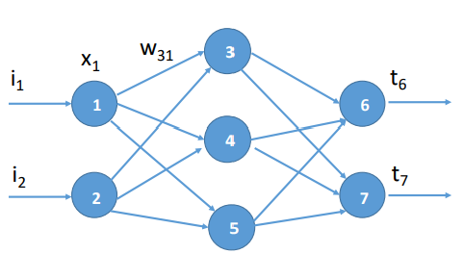

Assume random value for all weights on network:

Forward Pass: Compute all outputs of the nodes. Find δ for output nodes

Backward Pass: Use the value of forward deltas to compute backward deltas Update weights.

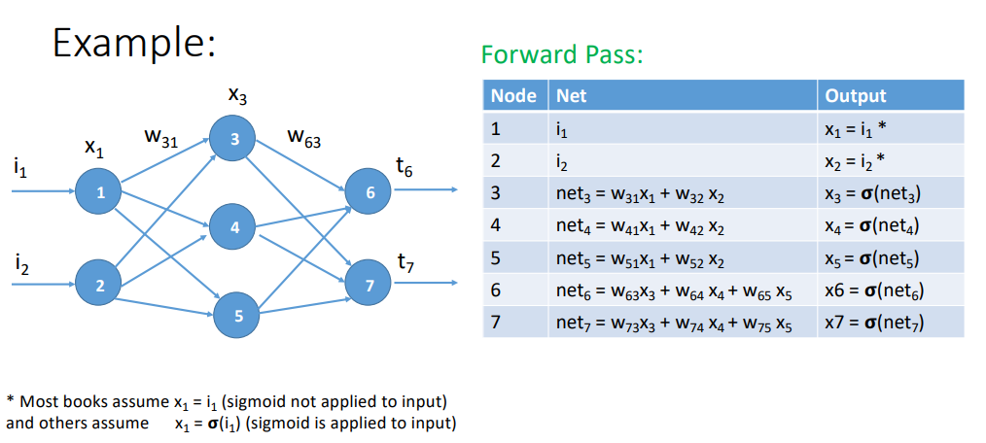

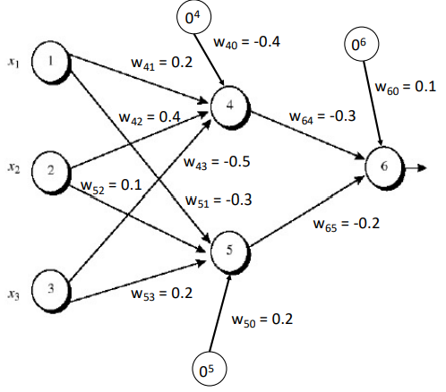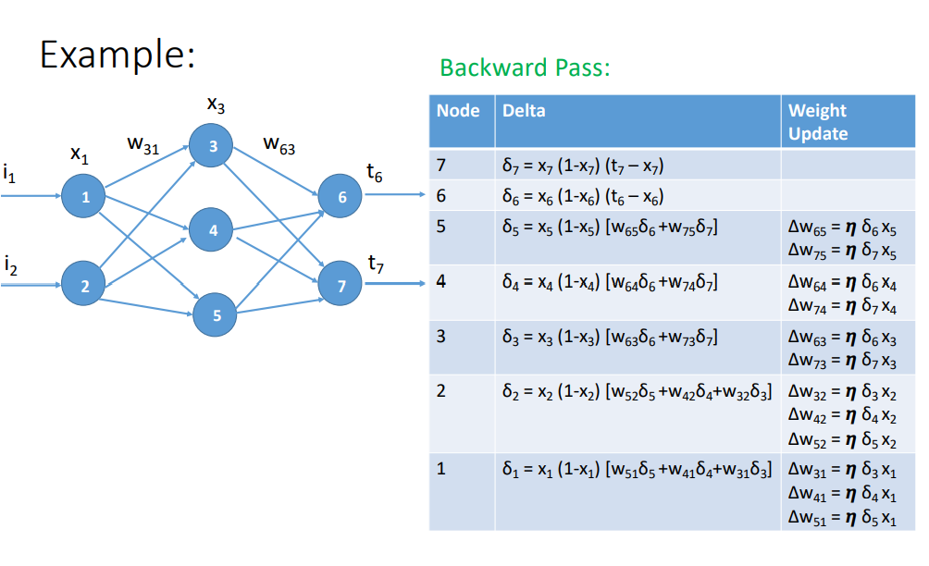

Worked Out Example

• The input to the ANN is (1, 0, 1) and target output is 1. i1 = 1, i2 = 0, i3 = 1, and t6 = 1

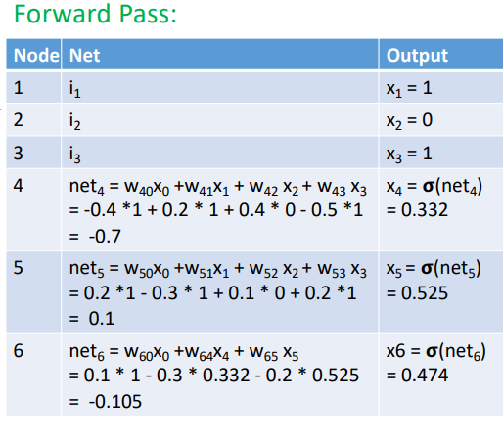• Run one forward and one backward pass on the ANN

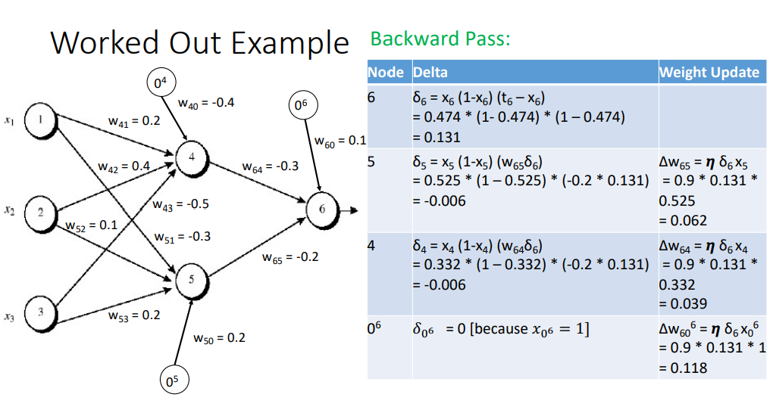

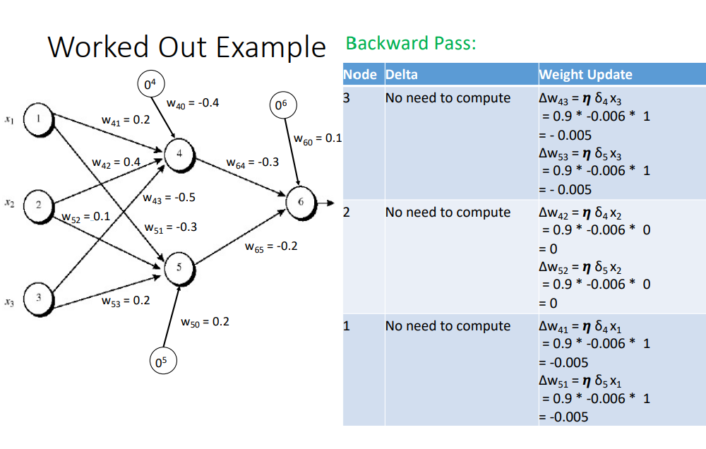

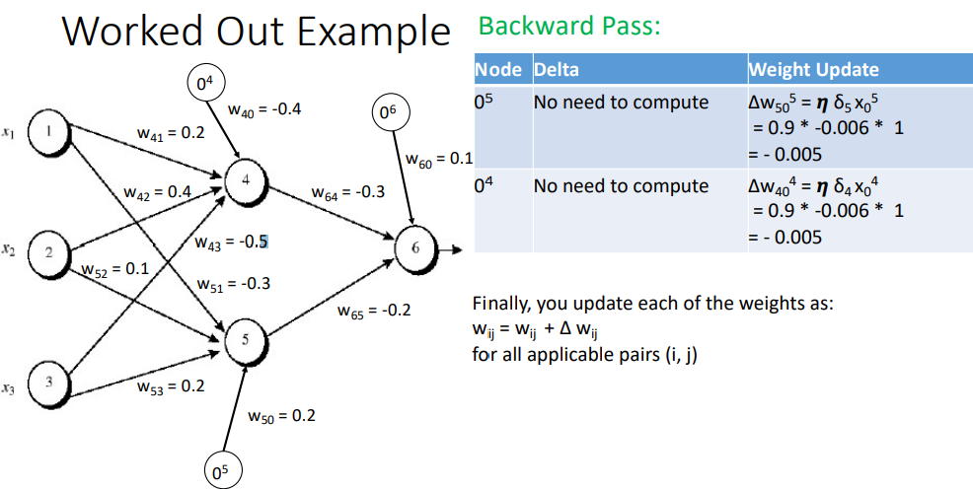

Finally, you update each of the weights as: wij = wij + Δ wij for all applicable pairs (i, j)

More on Backpropagation

• Gradient descent over entire network weight vector

• Easily generalized to arbitrary directed graphs

• Will find a local, not necessarily global error minimum

- In practice, often works well (can run multiple times)

• Often include weight momentum α

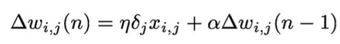 The update at step n depends on step n-1

• Minimizes error over training examples

- Will it generalize well to subsequent examples?

• Training can take thousands of iterations + slow!

• Using network after training is very fast

Expressiveness of Neural Nets

Boolean functions:

• Every Boolean function can be represented by network

with single hidden layer • But might require exponential (in number of inputs) hidden units

Continuous functions:

• Every bounded continuous function can be approximated with arbitrarily small error, by network with one hidden layer

• Any function can be approximated to arbitrary accuracy by a network with two hidden layers

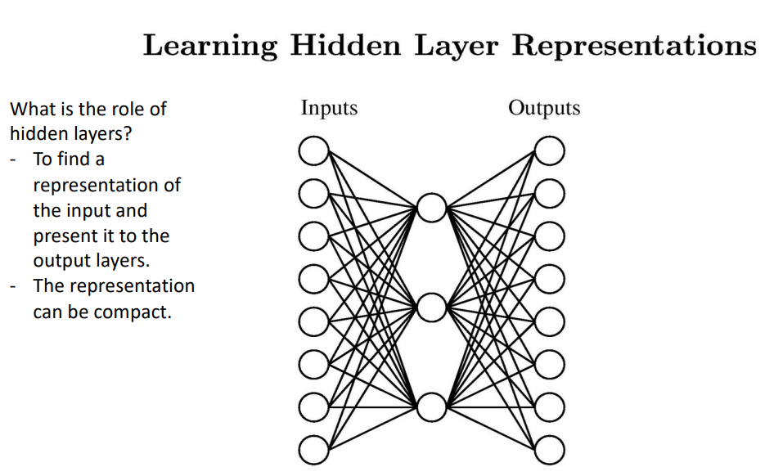

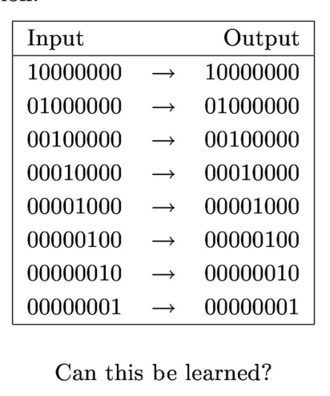What is the role of hidden layers? - To find a representation of the input and present it to the output layers. - The representation can be compact.

A target function

Can the NN learn this function?

- Well, it's just the identity function

- Yes, with one hidden layer.

- The hidden layer will try to find a compact representation of the input

- Let's run the backprop algorithm on it and see what weights we get.

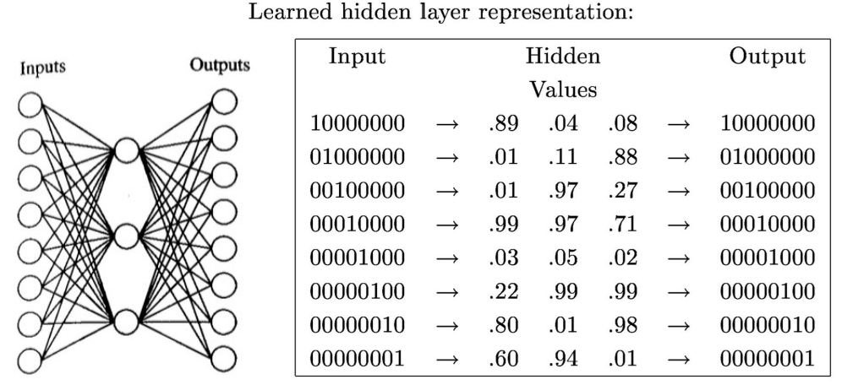

You can represent numbers 1 to 8 using 3 Boolean bits as (001) to (111)

Note: The weights do not necessarily correspond to human interpretation. The NN has its own encoding mechanism

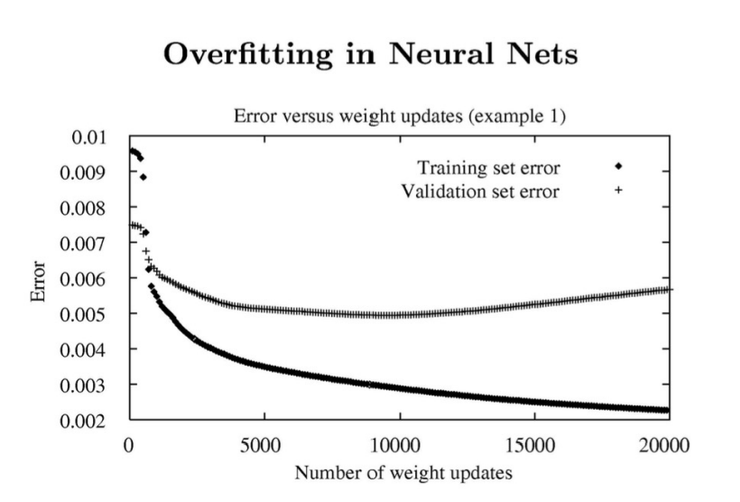

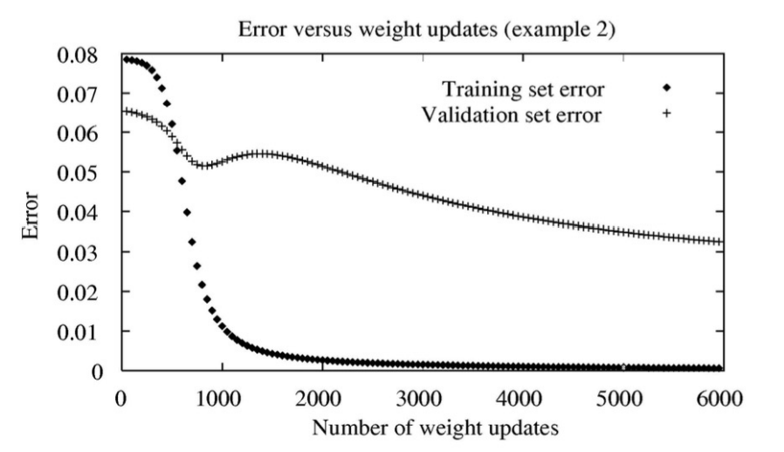

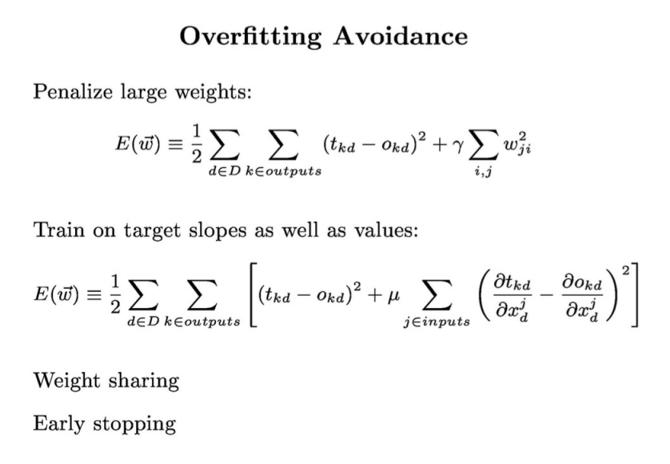

Regularization Coeff (factor)

**Probability Refresher**

Sample Space of an Experiment

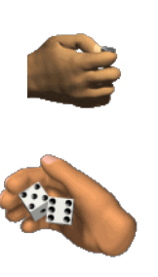• A random experiment is one whose outcome cannot be predicted with certainty.

e.g. Toss of a coin, roll of a dice, etc.

• **Sample space** (S) represents the set of all possible outcomes of the experiment.

e.g. Toss of a coin = {H, T}

Roll of a single dice = {1, 2, 3, 4, 5, 6}

Roll of two dice = { 11, 12, …, 16,

21, 22, ..., 26,

...,

61, 62,..., 66 }

Sample Space and Event

• An event (E) is a subset of S (sample space).

• Example:

- Tossing a coin: S = {H, T} E = {H} is an event.

- Tossing a coin twice: S = {HH, HT, TH, TT}

E = {HH, HT} is an event which describes the set which has the first outcome as heads

- Tossing a dice:

S = {1, 2, 3, 4, 5, 6}

E = {2, 4, 6} is an event which describes the set in which the number is even.

Random Variable

• Supposed to **each outcome** in the sample space, we associate a **value**.

e.g. for heads, +1 and for tails -1 for even rolls of dice +1 and for odd rolls of dice -1

• Such a variable is known as a random variable.

• Formal definition: A **random variable** is a function that assigns a real number to each outcome in the sample space of a random experiment.

• It is generally denoted by X. If X takes a value x, it is wriUen as: X = x

Random Variable

• If we restrict the random variable to the Boolean set, it may be defined as a function f:

f is a function defined over S as follows: f: S -> {0, 1}

f maps every value in S to either 0 (failure) or 1 (success)

Examples of Random Variables:

• Suppose each experiment is tossing of 4 coins. You do this experiment multiple times

Results:

{HHHT}

{HTHT}

…

If you count the number of heads in each experiment, it would be a random variable (X) X could have values from 0 to 4.

• Each element of the sample space would map to one value of X

Examples of Random Variables:

• Suppose each experiment is sampling 100 people from a population and measure their heights.

If you measure the average of the heights of the 100 samples, you would get a random variable (X). It would be a continuous variable.

Each element of the sample space would map to a value of X

Random Variable

• Each random event A has a probability P(A) associated with it.

• It defines the fraction of the sample space in which A is true.

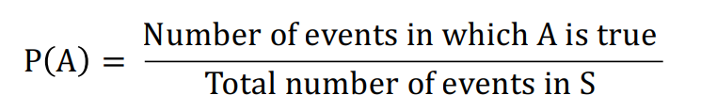

e.g. in case of toss of a dice, probability of even number:

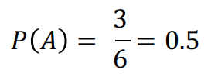

Useful Theorem

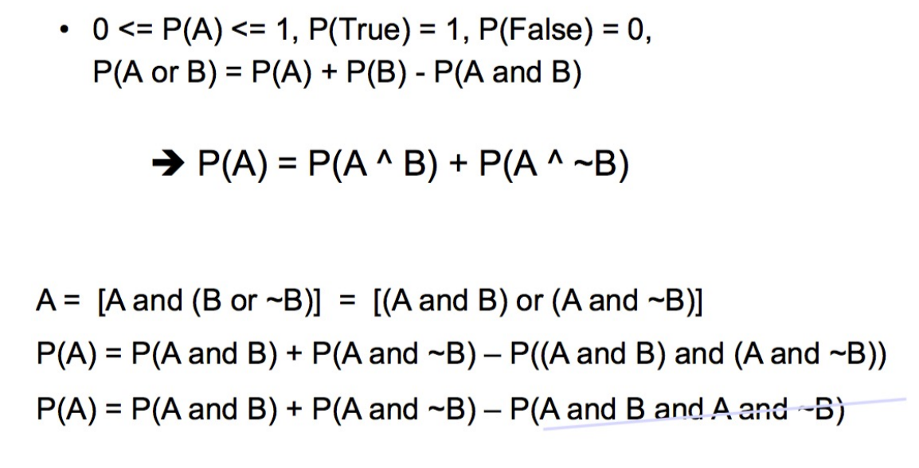

Definition of condition Probability

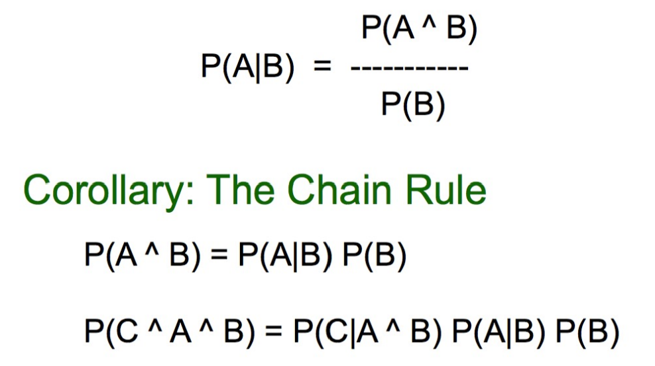

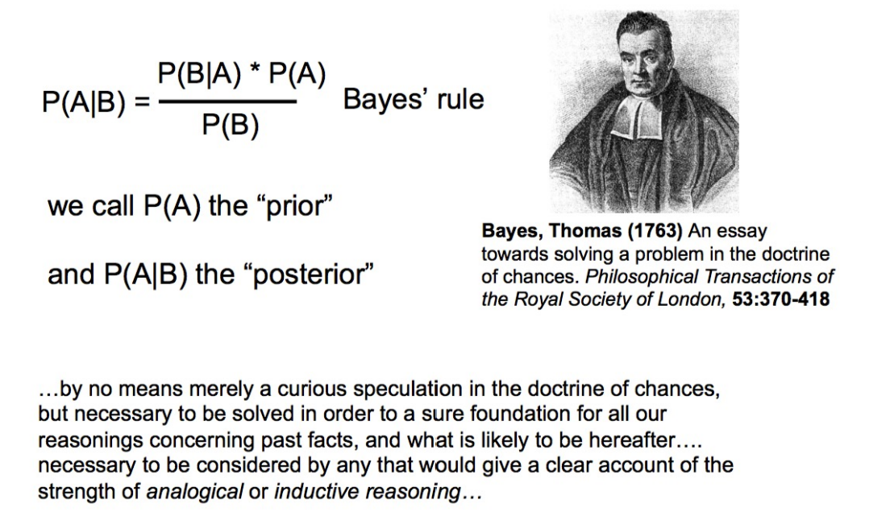

Applying Bayes Rule

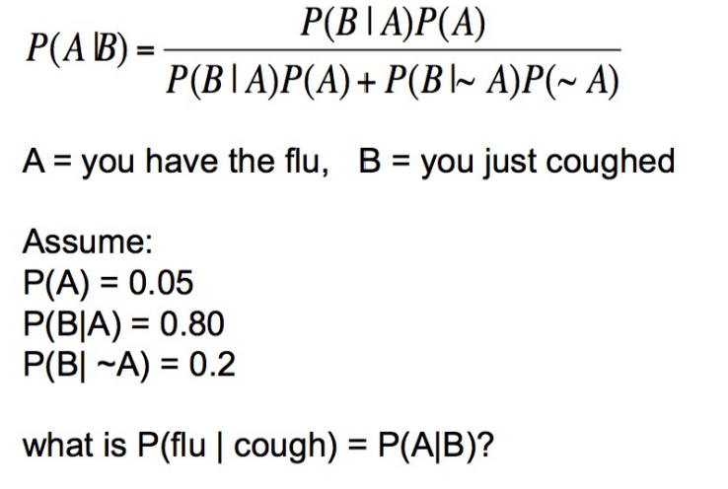

What does all this have to do with function approximation?

After all, that’ what we are looking for.

Function approximation by probability

• Our aim is to approximate the class separating function

F: X -> Y

X is the set of attributes and Y is the class.

• In case of probabilistic reasoning, we approximate it with the conditional probability

P(Y | X)

we find the probability of each class, given the data i.e. P(Y = 1| X) and P(Y = 0 | X).

• How do we find the probability of class given the data?

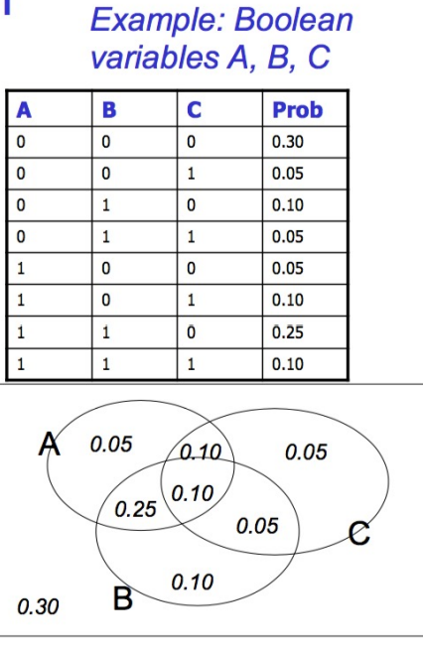• Need a joint distribution

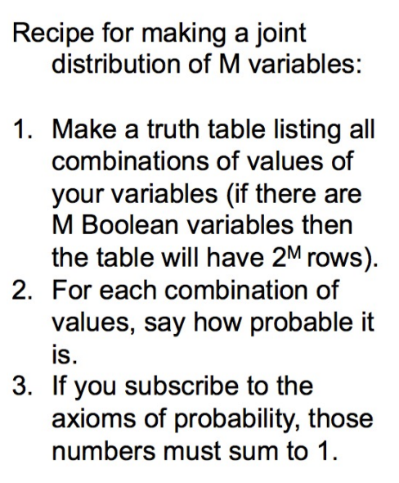The joint distribution

Using the joint

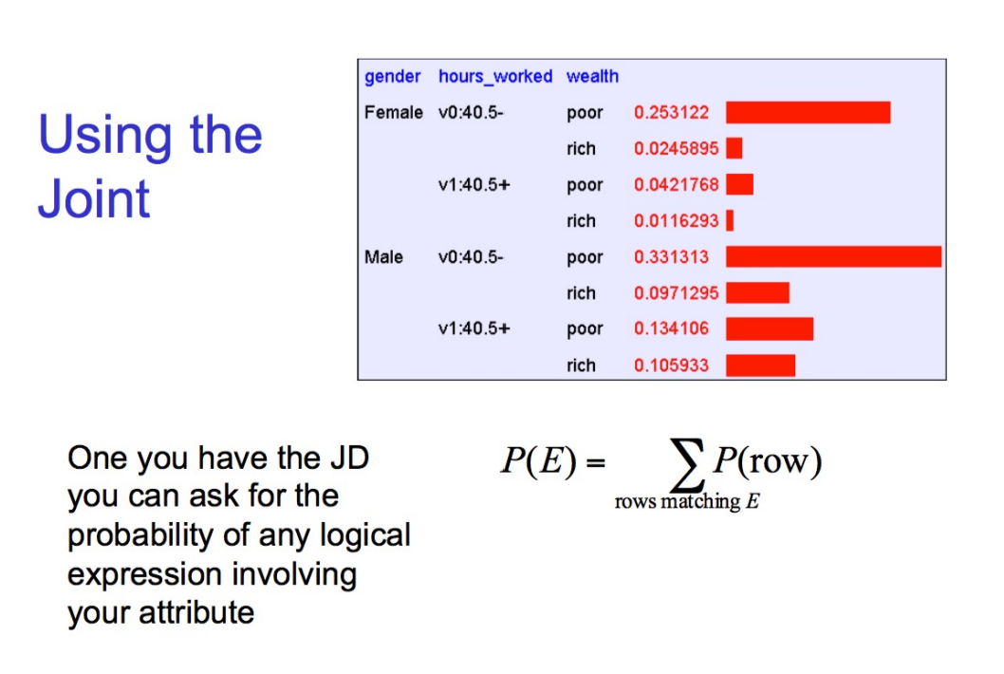

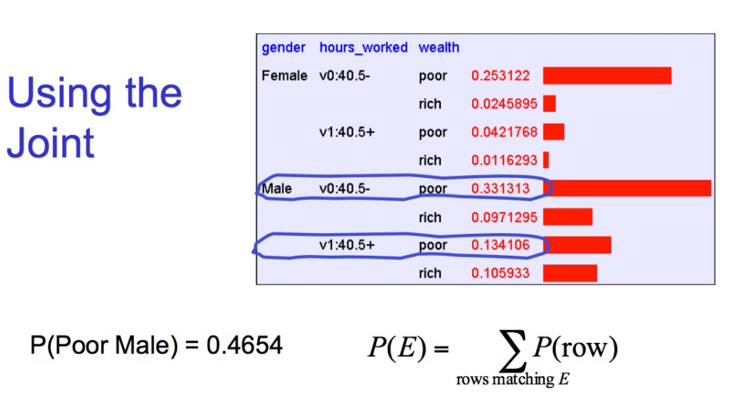

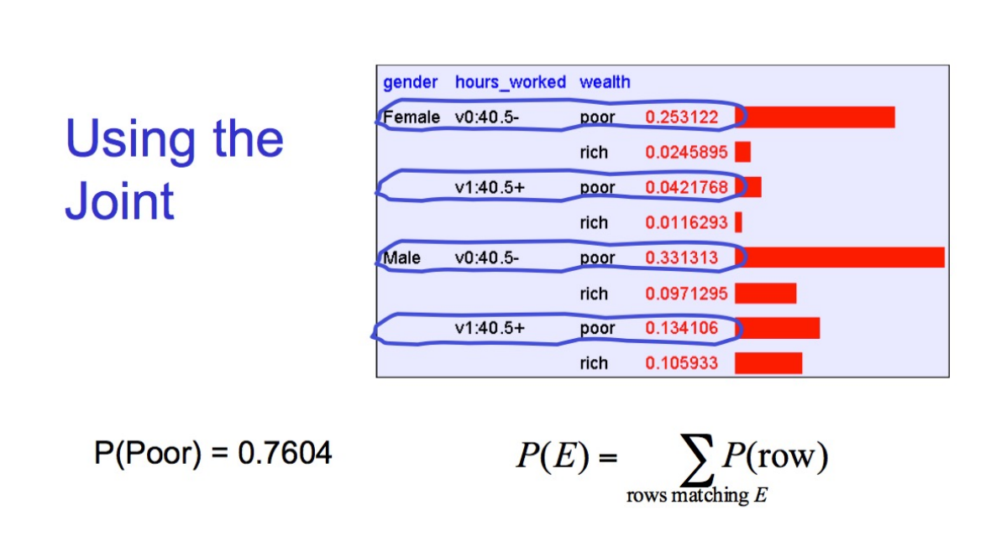

Inference with the Joint

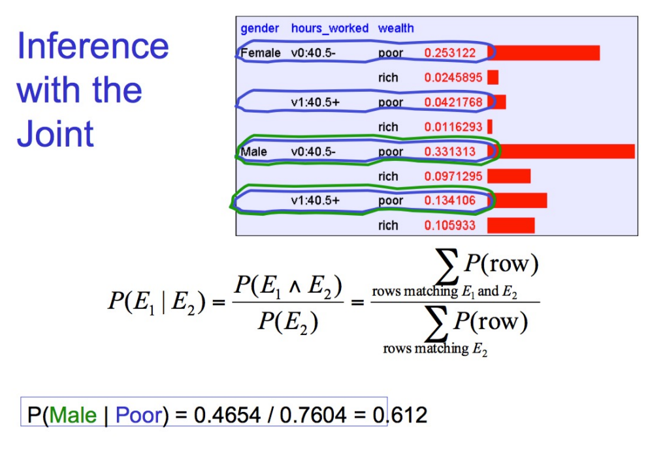

Learning and Joint Distribution

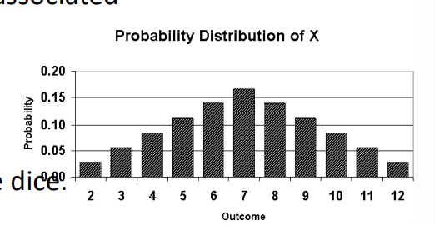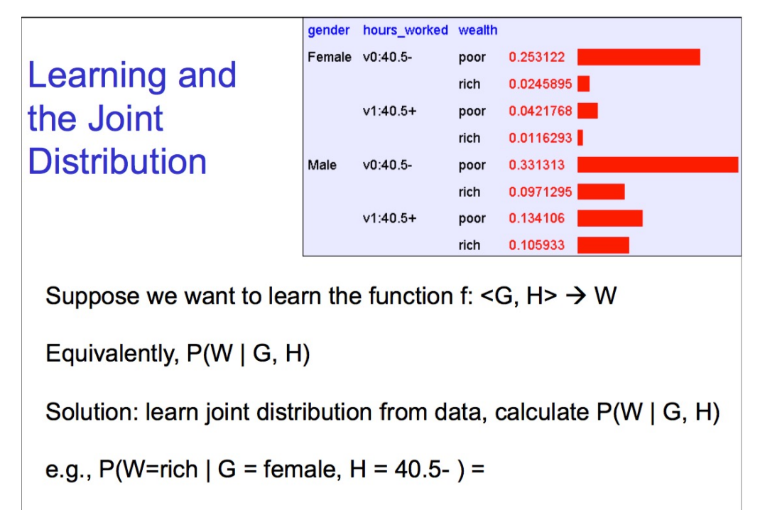

Let's get back to random variables

• Each random variable X has a domain **D(x)** associated with it. It is the set of outcome

values possible. e.g. for a dice D(x) = {1, 2, 3, 4, 5, 6} for a Boolean outcome D(x) = {0, 1}.

• For a pair of dice, D(x) = {11, …., 66}. Suppose X is the sum of the outcome of the dice. X can range from 2 to 12. Each value of X has a different probability.

• A plot of the random variable and probability values is called the **probability distribution** plot and the function is called **probability distribution function (pdf) or probability mass function (pmf).**

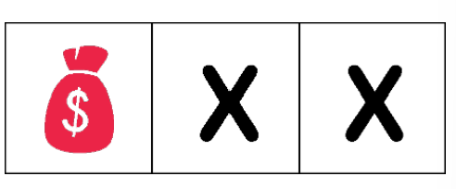Example:

• Imagine there are 3 doors – one of them has a treasure, the other 2 nothing.

• Each one is equally likely to be selected. Once you open a door, you don't open it again.

• Define random variable X as the number of doors needed to open before finding the treasure.

X can have values {1, 2}. Find the probability distribution of X.

P(X = 1) = 1/3

P(X = 2) = (2/3) * (1/2)

-- Assume a person is smart enough to figure it out after two attempts – J

Example 2

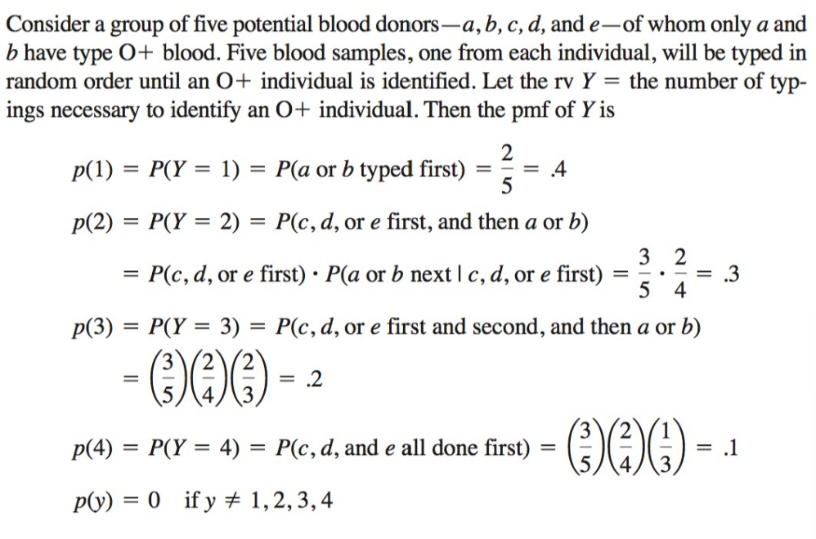

Binary Variables

• Let's focus on the case where the random variable X can only take two values {0, 1}. • X is said a Boolean random variable.

• For every outcome in the sample space, you associate 0 (failure) or 1 (success).

• Example: - Coin toss – Heads = 1, Tails = 0

- Lottery - Winning Number = 1, Rest of the numbers = 0

Expected Value and Variance

• Expected value of a **discrete** random variable under P:

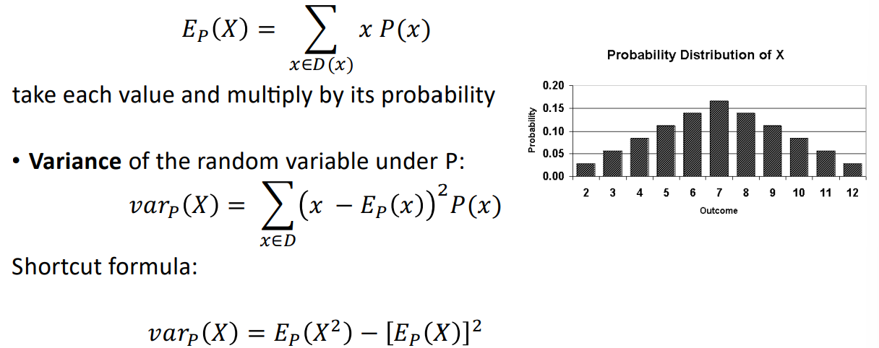

Expected Value and Variance

• Expected value of a **continuous** random variable under a **continuous** probability function f:

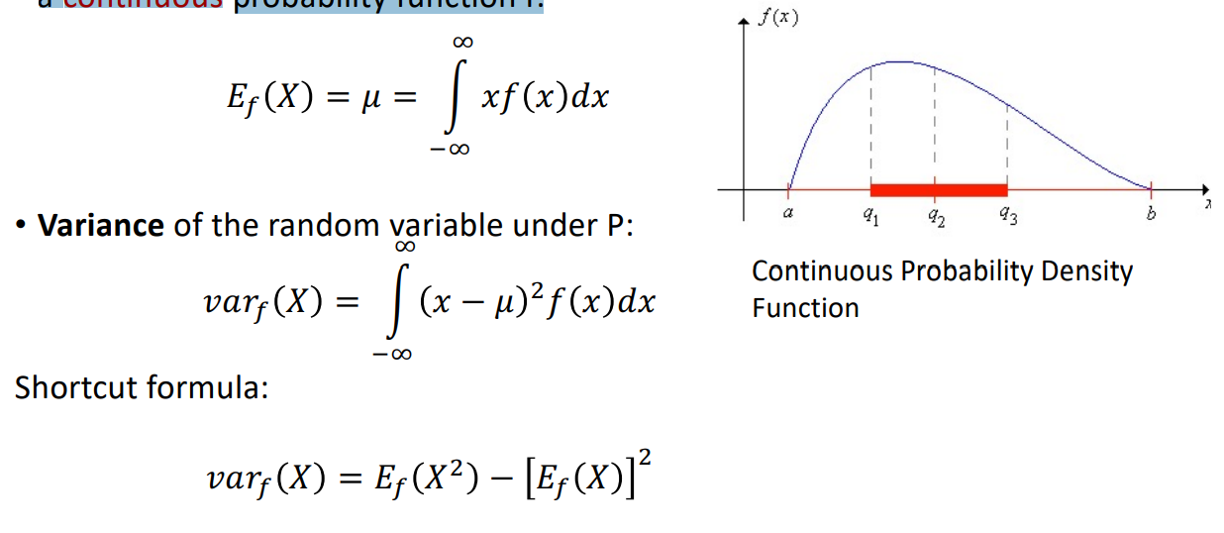

Example:

You draw one card from a standard deck of playing cards. If you pick a heart, you will win$10. If you pick a face card (K, Q, J), which is not a heart, you win $8. If you pick any other card, you lose $6. Do you want to play? Explain.

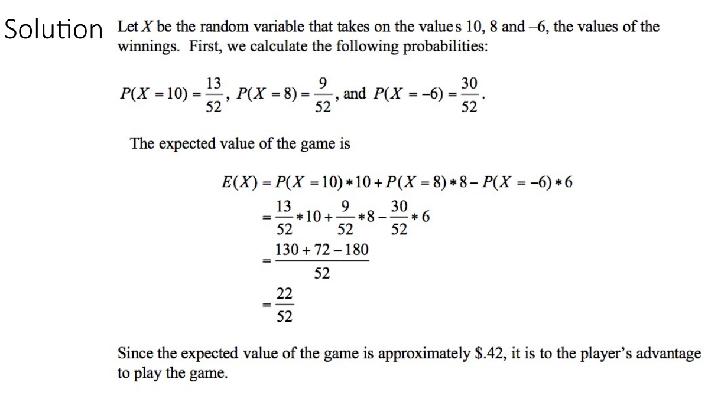

Binary Variables

• Consider coin flipping which has 2 outcomes (heads = 1 and tails = 0) If you know probability of heads, you know the distribution. Let's say

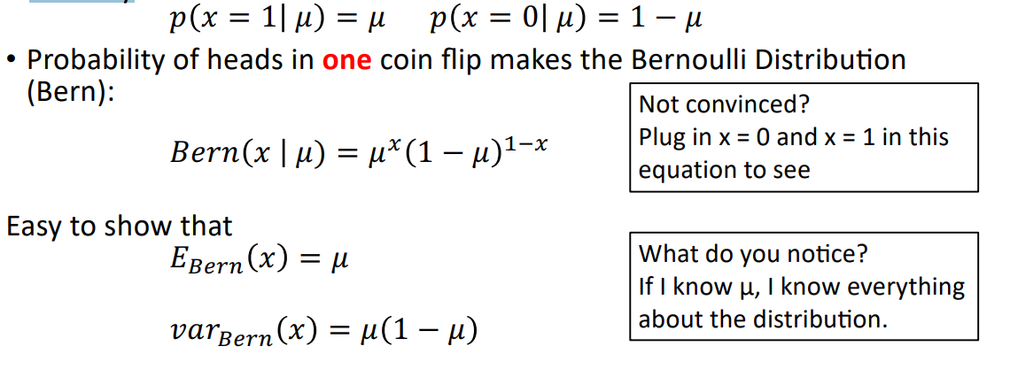

Binomial Distribution

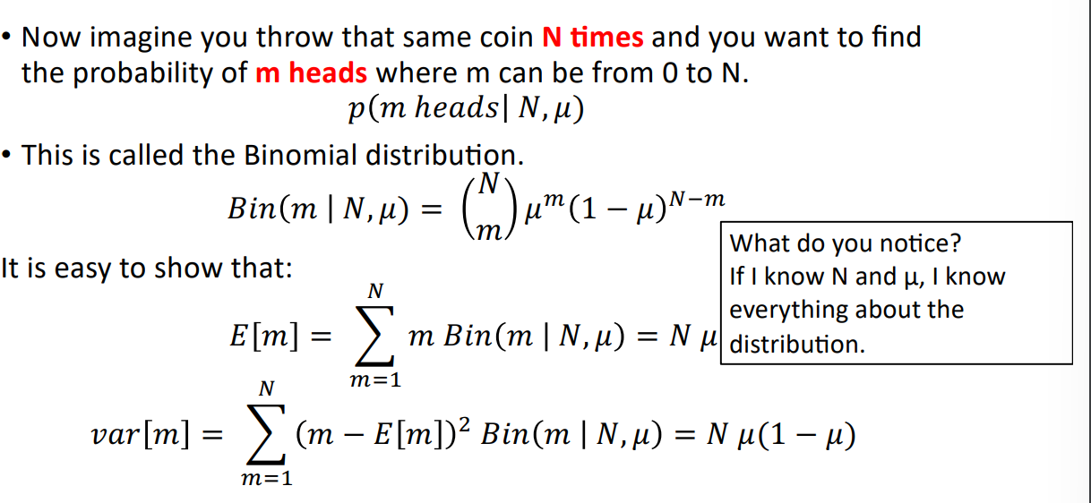

Uniform Probability Distribution

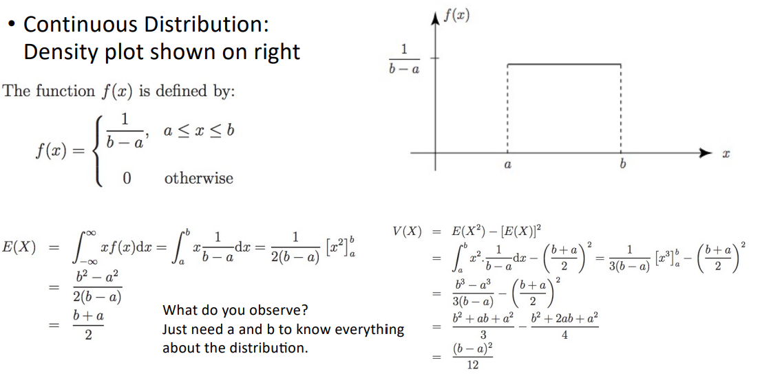

Naïve Bayes Classification

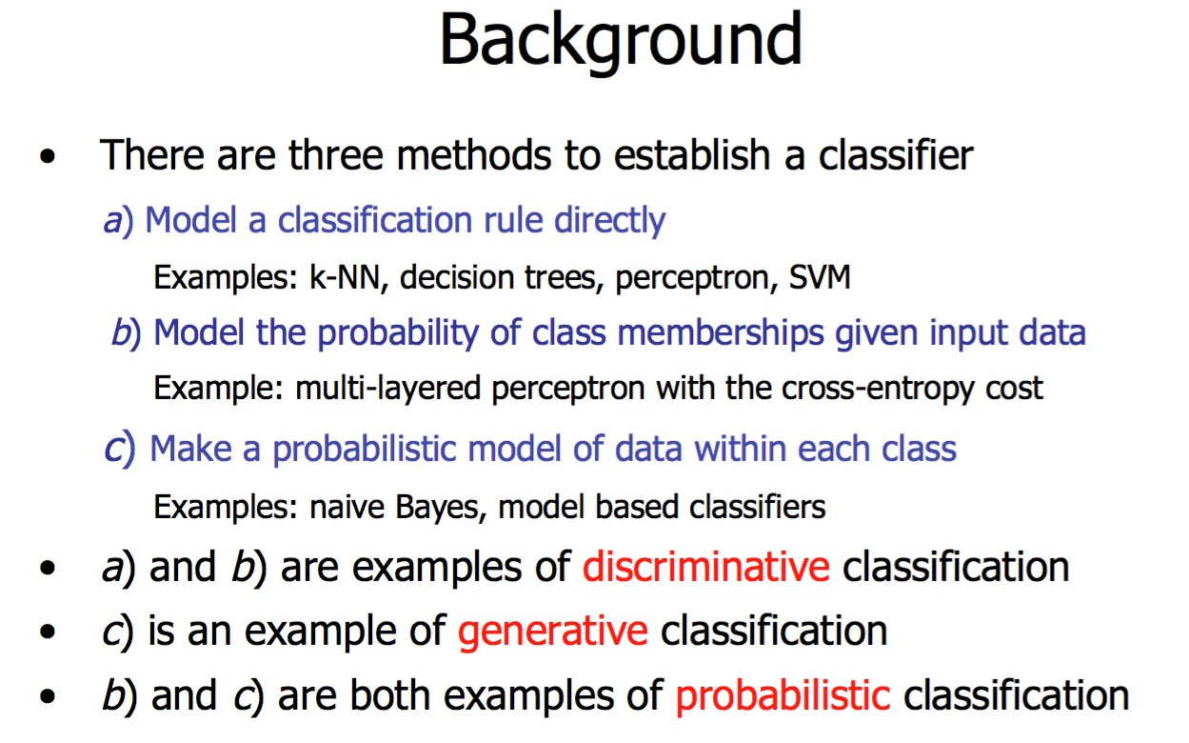

Probability Basics

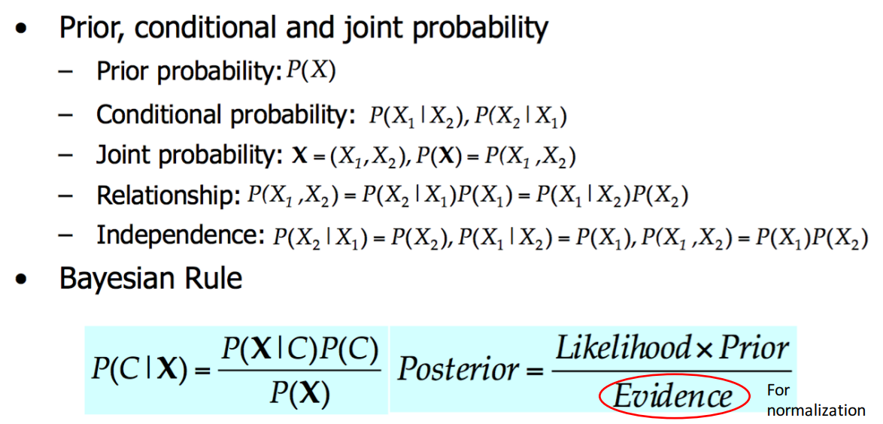

A side note:

probabilistic inference H = “Have a headache” F = “Coming down with Flu” P(H) = 1/10 P(F) = 1/40 P(H|F) = 1/2

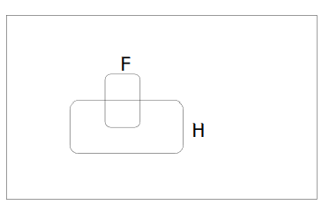

One day you wake up with a headache. You think: “Drat! 50% of flus are associated with headaches so I must have a 50-50 chance of coming down with flu” Is this reasoning good?

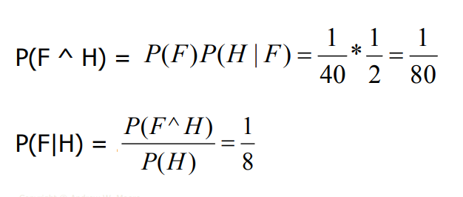

Bayes classifier

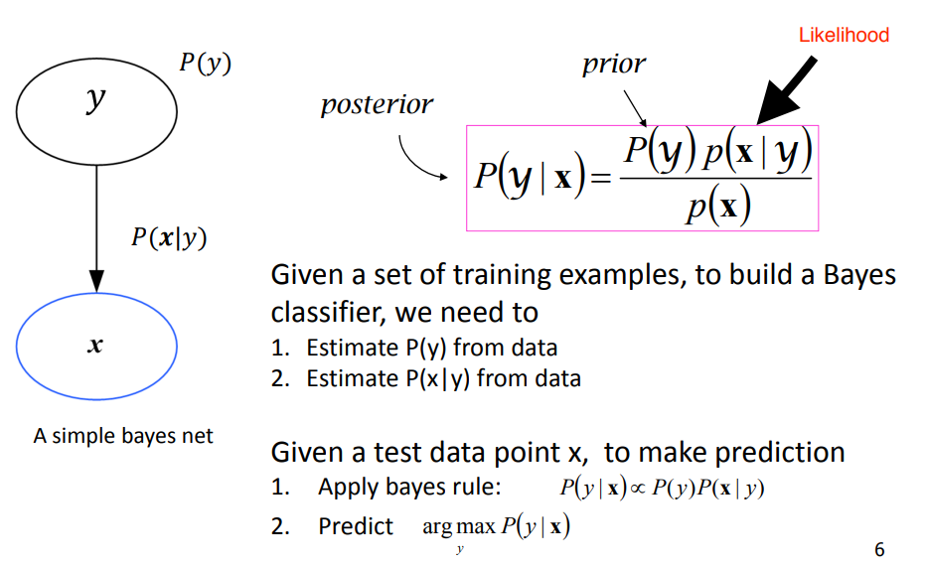

Maximum a Posteriori (MAP)

• Given data D and a set of classes C = {c1, c2, …, cn}, the most probable class is the one having the highest value of posterior probability:

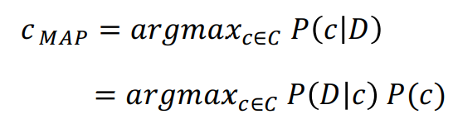For all the classes, find the value of / 0 ! /(!), the class with the highest value is the most likely class, given the data D.

Bayes Classifiers in a nutshell

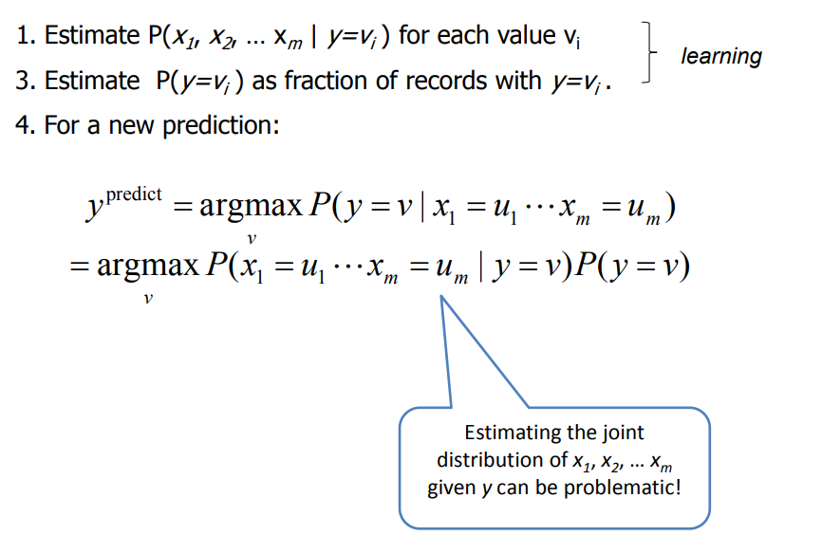

Example: Spam Filtering

• Assume that our vocabulary contains 10k commonly used words & tokens‐‐‐ we have 10,000 attributes • Let’s assume these attributes are binary

• How many parameters that we need to learn?

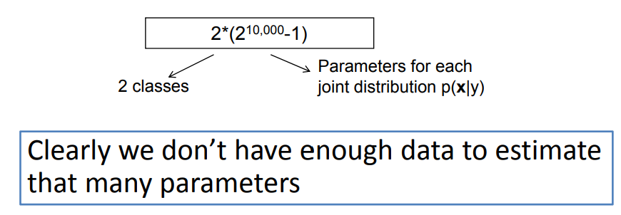

The Naïve Bayes Assumption

• Assume that each attribute is independent of any other attributes given the class label

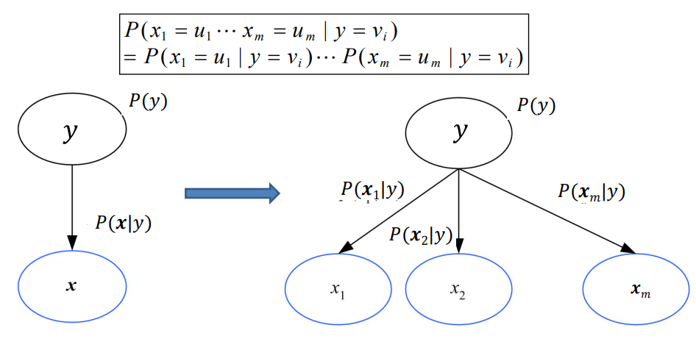

Naïve Bayes Classifier

• By assuming that each attribute is independent of any other attributes given the class label, we now have a Naïve Bayes Classifier

• Instead of learning a joint distribution of all features, we learn p(xi|y) separately for each feature xi

• Everything else remains the same

Naïve Bayes Classifier

• Assume you want to predict output y which has nY values v1, v2, … vny.

• Assume there are m input attributes called x=(x1, x2, … xm)

• Learn a conditional distribution of p(x|y) for each possible y value, y = v1, v2, … vny,, we do this by:

– Break training set into nY subsets called S1, S2, … Sny based on the y values, i.e., Si contains examples in which y=vi

– For each Si, learn p(y=vi)= |Si |/ |S|

– For each Si , learn the conditional distribution each input features, e.g.

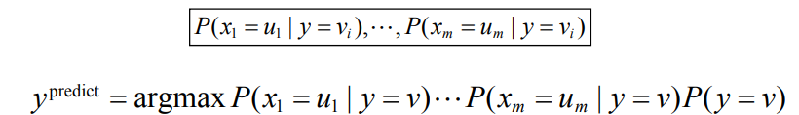

Naïve Bayes

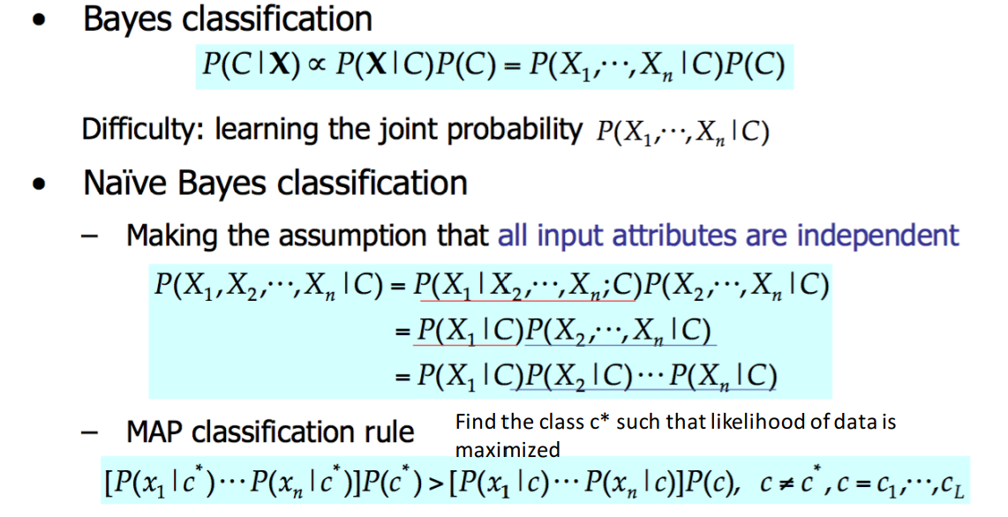

Naïve Bayes Classifier

• Based on MAP rule

• Extremely simple yet powerful

• Idea: Given a dataset, find which class is most likely i.e. which class has highest posterior.

• This means you have to find the posterior for every class and then find the one that gives the max value.

• Computationally simple.

Naïve Bayes

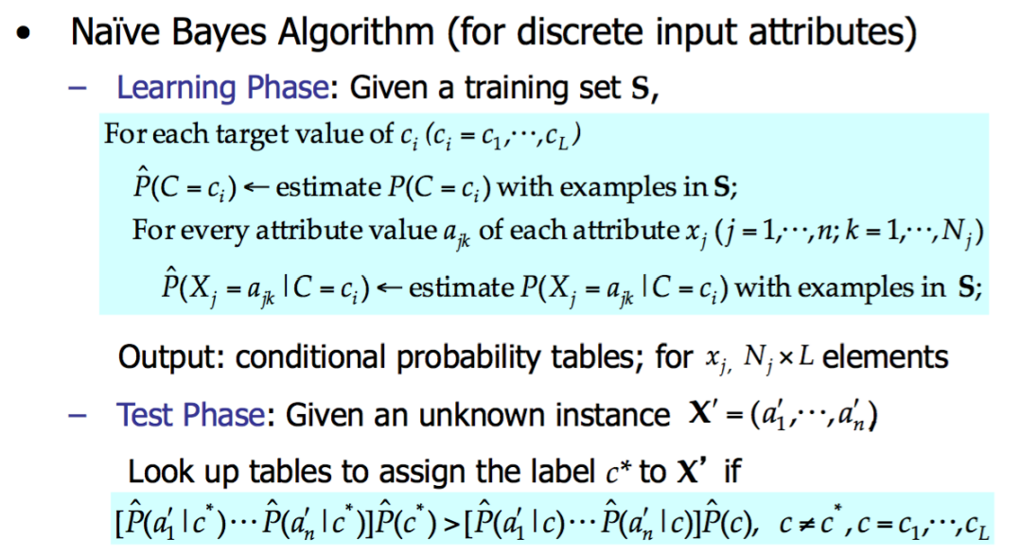

Example:

Play tennis

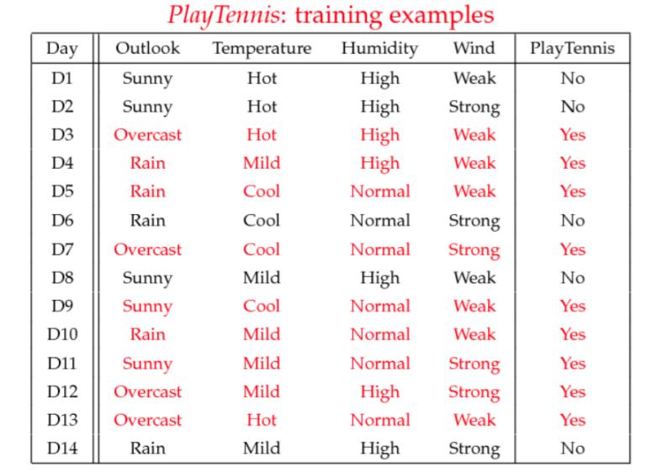

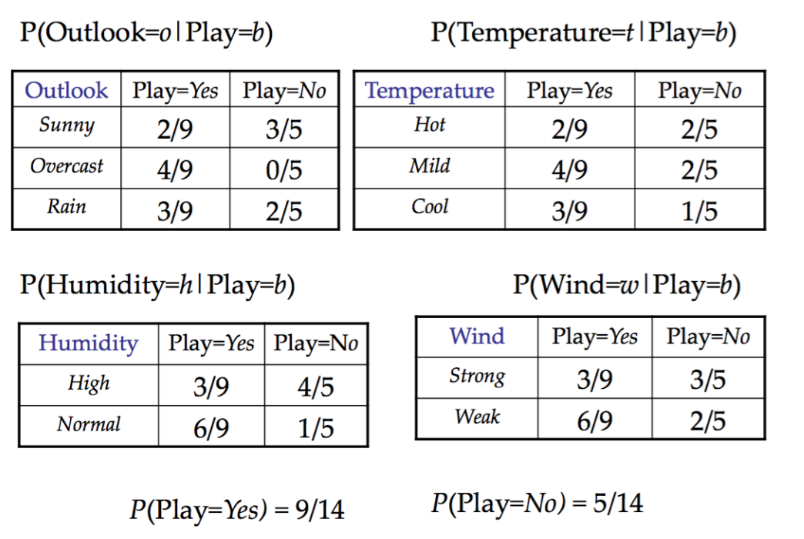

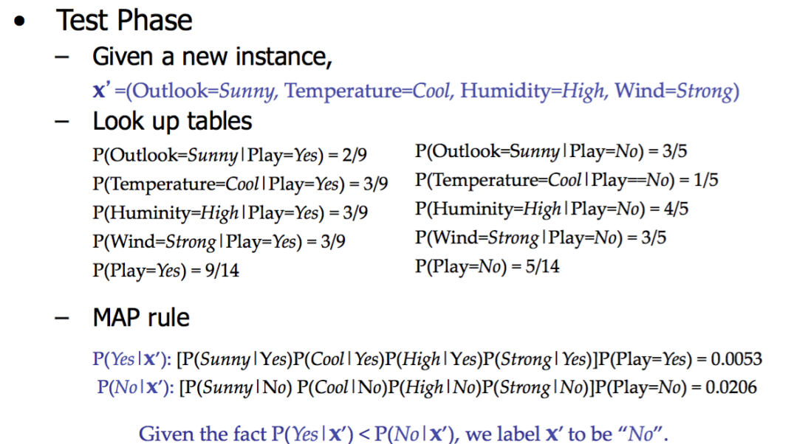

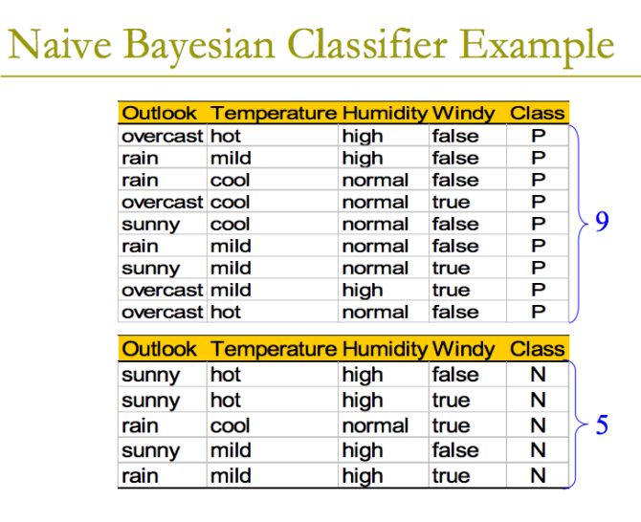

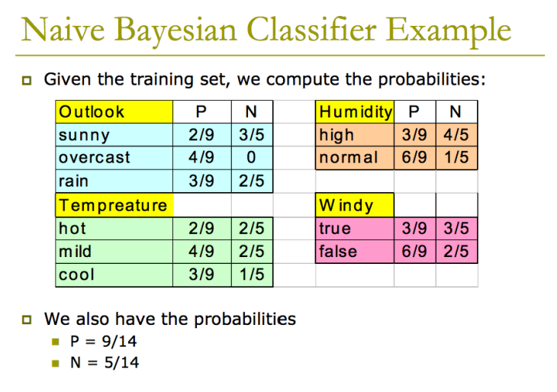

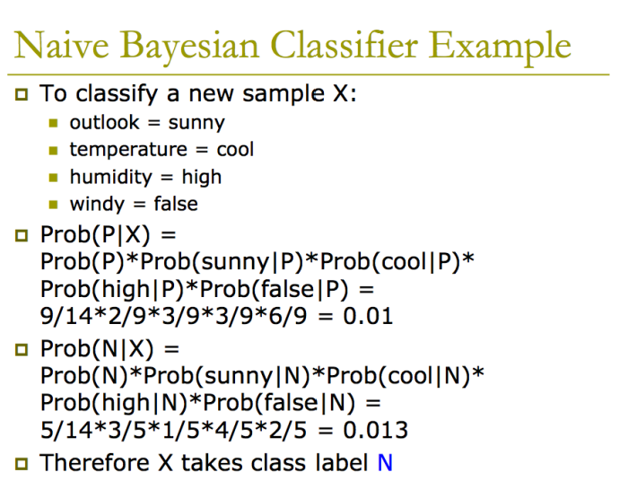

Laplace Smoothing

• With the Naïve Bayes Assumption, we can still end up with zero probabilities

• E.g., if we receive an email that contains a word that has never appeared in the training emails

– P(x|y) will be 0 for all y values

– We can only make prediction based on p(y)

• This is bad because we ignored all the other words in the email because of this single rare word

• Laplace smoothing can help

P(X1=1|y=0)

= (**1+** # of examples with y=0, X1=1 ) /(**k+** # of examples with y=0)

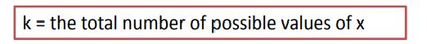

• For a binary feature like above, p(x|y) will not be 0

Relevant Issues

